ChainSight: A Cloud-Based Support System for Southern Mindoro Maritime School Inc. with Blockchain Technology

A Capstone Project Submitted to the Faculty of Information Technology Department of John Paul College, MG Andaya Compound,
Odiong, Roxas, Oriental Mindoro

In Partial Fulfillment of the Requirements of the Degree
BACHELOR OF SCIENCE IN INFORMATION TECHNOLOGY

Submitted By:

KEN I. MORANTE
EMMAN G. BUSTILLO
KHENT P. MANALO

January 2026
Chapter I
INTRODUCTION
Project Context
Today, in the Modern and tech-driven world, educational institutions such as schools are increasingly demanded to meet the escalating expectations of students, parents, and administrators. However, quite a few of these institutions are still following the same old ways of grading manually, recording behavior on paper, and making announcements via social media or basic SMS without having noticed that those systems are too slow, prone to error, and do not support real-time communication which is now a necessity for school communities. These shortcomings may cause timely intervention to be missed, data mismanagement, and a lack of meaningful involvement of parents.
This research presents ChainSight to overcome such problems, a contemporary digital platform that runs on school information system. It uses blockchain technology for the security of student records and a simple Averaging Method for grade calculation. Apart from that, this platform keeps track of the students' behavior and school announcement sending, thus, parents receive real-time updates through SMS and push notifications to stay informed about their children's academic and behavioral progress.
As a result, the implemented system through the combination of automation and secure data storage with smart analytics intends to foster communication, trust, and the empowerment of educators and families. This study is consistent with the College Research Agenda by addressing the need for data-driven solutions in schools and focusing on innovation in educational technology.
The research heavily relies on Literature, in particular the Technology Acceptance Model having the user adoption of novel tools as its main focus, Systems Theory helping to understand the harmonious work of different components of a school system and Diffusion of Innovations Theory examining the gradual dissemination of new ideas.
The need for a solution of the kind of ChainSight is also mooted by the previous studies. Research made by Smith (2025) demonstrated that student performance increased when parents were given timely updates of students' progress. Johnson (2025) mentioned that many schools are still struggling to reach out to families effectively mostly due to the use of outdated systems. Harris (2025) indicated that the use of real-time notifications brought about several benefits. Garcia (2025) emphasized the delay caused by basic SMS tools. William (2025) further explained that many schools miss minor instances of misbehavior because their current systems not only fail to log them accurately but also are too slow to share them thereby leading to the prompt detection of such instances.
All the things together point strongly enough that schools are in dire need of radically better tools now. ChainSight was created by offering an exceptionally safe real-time platform to manage information effectively and to provide the entire school community with a very high level of connectivity. With technology as a means, schools can drastically improve communication and, therefore, student outcomes making sure that no important update is allowed to slip through the cracks unnoticed.
Objectives of the Study
Enhancing the efficiency, security, and transparency of the academic and administrative processes at Southern Mindoro Maritime School Inc. are the general objectives of ChainSight. The system plans to do this by using cloud computing for accessibility and scalability and blockchain technology for data integrity and immutability.
Specifically, this study aims to:
- Design and develop a system that stores grades, attendance, and certificates on blockchain using cryptographic hashes to ensure immutability, transparency, and verifiability of academic records.
- Create role-based access control for administrators, teachers, students, and parents, with role-specific dashboards and permissions to manage and view academic information.
- Build a system to record and manage grades (prelim, midterm, final), track attendance, calculate final ratings, and maintain blockchain-backed audit trails for all academic transactions.
- Develop modules for managing academic years, semesters, courses, subjects, classes, course materials, and library resources within a unified system.
- Design communication tools for announcements and messaging, and grading workflows to support academic collaboration.
- Develop reporting and analytics dashboards that generate insights on academic performance, system statistics, and blockchain transaction monitoring, presented through an intuitive user interface.
Scope and Limitation of the Study
This study focuses on developing and implementing ChainSight, a cloud-based student management support system with blockchain technology for Southern Mindoro Maritime School Inc. The functional scope covers academic record management, including grade recording (prelim, midterm, final), attendance tracking, performance calculation, and student enrollment. The system integrates blockchain through SHA-256 hashing for grades, attendance, and certificates, with transaction recording, certificate verification, and audit trails. It includes a multi-role access control system for Administrators, Teachers, Students, and Parents, each with role-based dashboards and permissions. The system also manages curriculum and resources, including academic years, semesters, courses, subjects, classes, course materials, and a digital library. Communication features include announcements and internal messaging. Analytics and reporting provide performance insights, system statistics, and blockchain transaction monitoring.
The system is deployed as a cloud-based web application on Railway platform (paid subscription) for reliable hosting and deployment, accessible via internet browsers with responsive design for desktop and mobile devices. The technical scope uses Laravel 12 (PHP 8.2+) for the backend, React 19 with TypeScript for the frontend, and a relational database. Blockchain implementation currently uses SHA-256 cryptographic hashing with simulated blockchain storage, with Polygon blockchain integration planned. The institutional scope targets Southern Mindoro Maritime School Inc., serving administrators, faculty, enrolled students, and parents/guardians, specifically for maritime education programs.
The study acknowledges several limitations. The blockchain implementation uses simulated blockchain technology (SHA-256 hashing stored in the database) rather than a live blockchain network, and full Polygon integration is planned but not fully implemented in the initial version, so public verification via blockchain explorers is not yet available. The system is designed specifically for Southern Mindoro Maritime School Inc. and may require customization for other institutions, and it is tailored to maritime education programs and may not directly apply to other disciplines. Technical limitations include the requirement for a stable internet connection, dependence on Railway platform availability, and the exclusion of mobile application development (web-based responsive design only).
Functional limitations include the absence of financial management and payment processing, student admission and enrollment application processing, integration with external systems such as government databases or third-party services, and advanced LMS features such as video conferencing, assignments, online activities and online exams. Security considerations note that while blockchain provides immutability, system security also depends on proper access control, and private key management for blockchain transactions requires careful handling and is not fully automated.
The research scope focuses on system development and implementation rather than comprehensive user acceptance testing across all user groups, and long-term performance and scalability testing beyond the development period is not included. Data limitations include the use of sample/test data during development, and real-world data migration from existing systems and historical data integration are not covered in the initial implementation. Time and resource constraints are limited to the academic capstone project timeline, with limited resources for extensive user training and system documentation beyond basic user guides. Additional third-party service integrations beyond the Railway cloud hosting platform are limited to available free-tier or development resources.
Significance of the Study
This study is significant for the following reasons:
To Southern Mindoro Maritime School Inc. The system addresses the need for secure, efficient academic record management. By implementing blockchain-secured academic records, the institution gains tamper-resistant storage of grades, attendance, and certificates with cryptographic verification. The cloud-based platform on Railway enables centralized access and reduces reliance on manual processes. The curriculum and resource management modules support organized academic operations, while analytics provide insights for decision-making.
To Administrators. The multi-role access control system enables secure, role-based management of academic data. The analytics and reporting capabilities provide real-time insights into student performance, attendance rates, and system statistics. Blockchain transaction monitoring supports audit and accountability. The centralized platform streamlines administrative tasks related to academic years, semesters, courses, and subjects.
To Faculty Members. The automated academic performance tracking system simplifies grade recording and calculation (prelim, midterm, final) and attendance tracking. Role-based access ensures authorized grade entry. The curriculum management features help organize course materials and class assignments. Communication tools (announcements and messaging) support interaction with students and administrators.
To Students. The system provides web-based access to grades, attendance records, and certificates. Blockchain-backed certificates offer verifiable credentials. The academic performance tracking enables real-time monitoring of progress and ratings.
To Parents and Guardians. The parent portal provides access to their children's academic records, including grades, attendance, and certificates, improving transparency and engagement.
To the Academic and Research Community. This study demonstrates the practical application of blockchain technology in educational management, specifically for securing academic records through cryptographic hashing and transaction recording. It contributes to research on blockchain adoption in education and provides a case study for institutions considering similar implementations.
To Future Researchers. The study provides a foundation for further research on blockchain integration in student management systems, including scalability, cost-effectiveness, and integration with other educational technologies. The documented implementation serves as a reference for future development.
Overall, this study addresses the need for secure, efficient, and transparent academic record management through blockchain technology, directly supporting the defined objectives of blockchain-secured records, multi-role access control, automated performance tracking, curriculum management, communication, and analytics within the specified scope.

Conceptual Framework
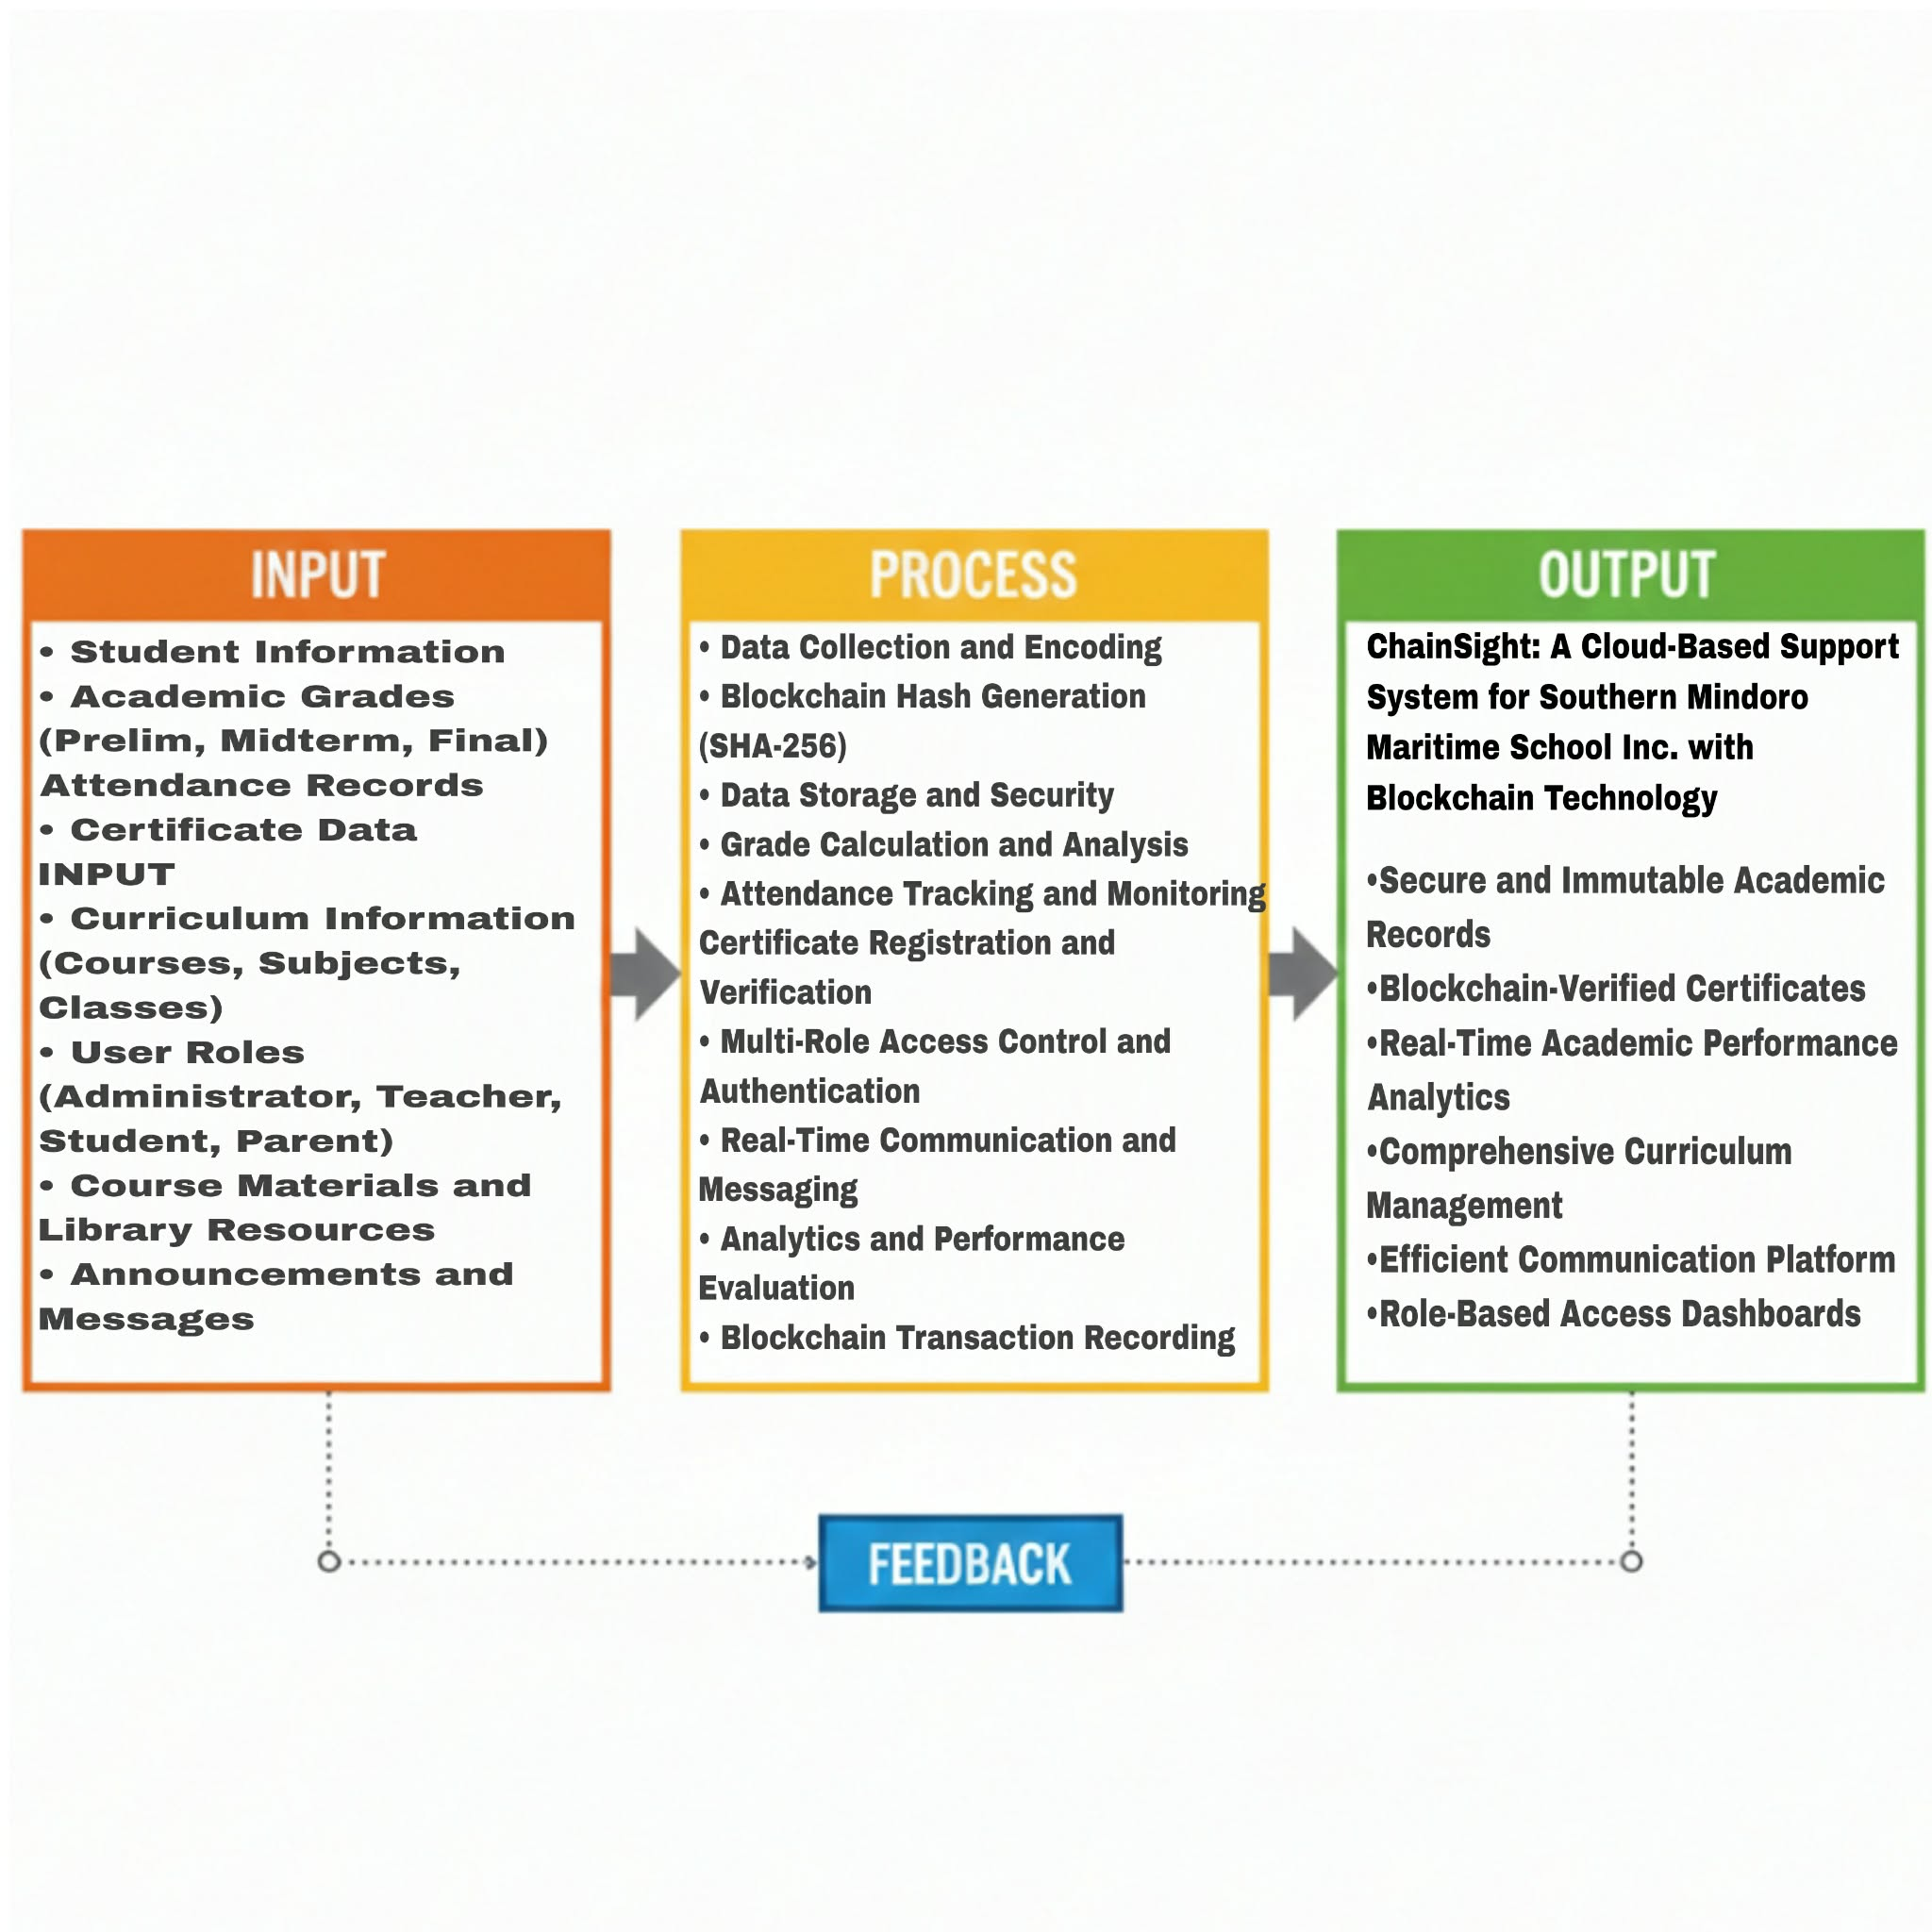
The figure below shows the input, process, and output of the development of our project.

Figure 1. Conceptual Framework

Figure 1. This presents the conceptual framework of the study to be carried out. The Input Process Output (IPO) diagram depicts the working of the system. The input is the information of the students which entails the following: Student Information, Student Grades, Behavior Reports, School Announcements, and User Roles for ChainSight.
The process depicts the steps that include: Data Collection and Encoding, Data Storage and Security through the use of blockchain, Grade Analysis by the Averaging Method, Behavioral Monitoring, Real-Time Communication through notifications, and User Access and Interaction within the ChainSight platform. This organized procedure is intended to convert the input data.
The output is ChainSight: A Cloud-Based Support System for Southern Mindoro Maritime School Inc. with Blockchain Technology, a secure and integrated solution. Users' feedback will serve as a means to further the system's development and refinement.
Definition of Terms
This section clarifies important terms used throughout this study to ensure a common understanding of their meaning within the context of ChainSight.
- Blockchain- is a rather vague term for a highly secure and decentralized digital ledger that stores and verifies student-related records in a somewhat unusual manner. Data that is academic and behavioral are left unchanged thus a lot of transparency is being made and at the same time trust is being picked up by the different parts of the system.
- Data analytics - It means that the digging into student performance, behavior, and communication metrics is done very deep, and quite often trends and patterns that are not obvious are found. Nowadays, data analytics is used by educators to make more informed evidence-based decisions, which, in this study, is a rather successful way.
- Student behavior - Student actions are recorded and minor infractions are tracked quite frequently through a strange process in which the behavior of students is monitored. In this way teachers document these events live and they save them in a safe way by means of blockchain technology.
- Grade Reporting - is mainly an automated process that compiles academic results for quick sharing of students' scores both online and internally. Teachers have the ability to upload grades and create digital report cards which are readily accessible to students and parents via the internet nowadays.
- Announcements - Generally, you will find community announcements containing information about school events or other updates that have been posted quite frequently on the internet nowadays. The system notification features are used to quickly and widely inform the users about the announcements that have been done.
- Parents - Parents nowadays are able to through a secure login keep up with their children's academic performance as well as behavioral records and also, they can view various school-related updates. This basically promotes transparency of the school to the parents and makes parents very much involved in their children's lives.
- Student Information System - This term denotes a comprehensive digital ecosystem managing student’s academics behavior and communication data altogether in one singular platform remarkably.
- User Roles - Categories of users exist within system such as Admins and Students each having specific access and permissions ensuring data gets shared rather responsibly.
- Notification System In a very effective way, notifications send alerts rapidly to users and are, in fact, a key turning point of this complex platform. For example, notifications can be updates on student grades or changes in behavior and, at the same time, a myriad of school announcements sent via SMS or push notifications.
Chapter II

REVIEW OF RELATED LITERATURE/SYSTEM

This chapter presents the related literature and systems that the researchers considered to strengthen the importance of the present study. It also presents the synthesis of the art to fully understand the research for better comprehension of the study.

Related Literature
According to Smith (2025), real-time communication through mobile alerts significantly improves parental engagement, especially when used to inform behavior and academic performance. This reinforces the need for real-time systems in education.
According to Garcia (2025), found that many barangay-level schools in the Philippines still rely on manual SMS systems, which cause delays in communication due to spotty internet connectivity and slow manual processing.
According to Johnson (2025), observed that while schools have started to digitize, they still fall short in delivering secure and timely academic reports. Blockchain can address this shortfall by preserving data integrity.
According to Ahmed and Rahman (2024), blockchain has proven to be effective in sending secure notifications and announcements in academic settings. Their work shows that a tamper-resistant notification log strengthens trust between schools and parents.
According Harris (2025), emphasized the effectiveness of push notifications in the school setting, especially in time-sensitive situations like behavioral infractions or emergency announcements.
According to Ahmed, Hermal, & Rahman (2024), showcased the value of machine learning in improving operational outcomes in aquaculture by predicting species suitability. The relevance lies in using Decision Tree algorithms for actionable insights in education, mirroring predictive applications.
According to Garcia and Villanueva (2023), the application of predictive analytics in student monitoring helped identify at-risk students using academic and behavioral data. Their system utilized decision tree algorithms to recommend interventions, improving student outcomes significantly.
According to Lopez and Santiago (2022), the use of a digital monitoring tool in a public school helped track behavioral violations and attendance issues. The integration of analytics allowed the school administrators to generate reports on student behavior, which helped guide disciplinary actions and support systems.
According to Philippine Science High School (2024), blockchain technology was used to secure school announcements and academic notices. The system ensured According to the Wela School System (2024), the use of push notifications can transform a school into an instant communication hub for its stakeholders, consequently improving event attendance and engagement, reducing reliance on paper-based notices, and benefiting the overall school community.
Based on the Batangas State University (2021) report, the development of an announcement and notification system for students and parents facilitated real-time communication about school events and student performance, promoting student accountability and parental engagement, particularly during online and modular learning.
According to the International Journal of Educational Technology in Higher Education (2025), SMS and push notifications play a significant role in reducing student procrastination by enhancing engagement, self-regulation, and timely task completion.
Based on the research of Takahashi & Suzuki (2022), parents reacted to push notification alerts much quicker than when they received emails or printed memos in case of school emergencies in Japan.
Based on the research by Santiago & Cruz (2023), the implementation of digital behavior monitoring systems coupled with parental notifications in a public high school in Quezon City resulted in a 28% reduction in student discipline cases within one semester, emphasizing the effectiveness of real-time monitoring.
According to the provided text, limiting permission to publish updates only to authorized users increased the reliability and trustworthiness of the school's communication content.
According to the Learning Analytics overview (2025), systems employing analytics (such as dashboards and predictive models) are very effective for the early identification of students at risk, offering personalized interventions, and supporting teachers' work.
Based on the research of Martinez & Torres (2024), the use of Decision Tree algorithms to forecast the academic success of high school students in Spain achieved high precision and gave insightful information, aligning with the goal of analytics.
According to the findings of Navarro & Reyes (2024), a Decision Tree model assessed for predicting academic risk for senior high schools in the Philippines was able to achieve more than 80% accuracy, serving as a good example of using machine learning for timely school intervention.
Based on the research of Orji and Vassileva (2022), decision tree and random forest algorithms were the most successful in forecasting student performance based on motivational factors compared to other algorithms, leading to the conclusion that tree-based models are robust educational analytics tools.
According to the research of Abd Elrahman, Soliman, Taloba, and Farghally (2022), decision tree and random forest models were used to predict student performance based on interaction with eTextbook data, thus enabling early intervention through performance classification.
According to the report by Ahmed, Nipa, Bhuyian, Mushfique, Shahin, Nguyen, and Farid (2024), a decision tree model used to analyze demographic and academic variables successfully achieved high accuracy in predicting student outcomes, establishing it as a very practical analytics tool for higher education.
Based on the research reported in Redalyc (2020), the decision tree model was successful in secondary education performance prediction, achieving 80.11% training accuracy and 81.4% validation accuracy, which corroborates its effectiveness.
According to Zahruddin, Kamarudin, Jusoh, Abdul Fataf, and Hidayat (2023), Malaysian university student performance prediction involved models such as decision tree, neural networks, and k-nearest neighbor, where significant demographic predictors were identified.
According to a systematic review by Shafiq, Marjani, Habeeb, and Asirvatham (2022), predictive analytics methods like student retention models and classification algorithms are vital tools for early identification of at-risk students, enabling targeted intervention.
According to the Learning Analytics framework (2025), predictive analytics offers many benefits to educational institutions, such as early warning, personalized learning routes, and decision-making support.
Based on Learning Analytics tools (2025), platforms such as BEESTAR INSIGHT and Student Success System offer educators instant access to data and risk prediction, which is instrumental in supporting student success.
According to the article by Tan & Rivera (2023), the implementation of a blockchain-enabled document verification system in a state university in Mindanao showed increased trust and data integrity, making a strong case for the use of blockchain in academic systems.
Based on Cerberus (Tariq, Haq, and Ali, 2019), a blockchain-based credential verification system had a significant impact on efficiency, data privacy, and the reduction of fraudulent academic credentials through the implementation of smart contracts.
According to EduCTX (Turkanović, Hölbl, Košič, Heričko, and Kamišalić, 2017), a worldwide blockchain-powered platform for higher education credits exists that makes academic records decentralized and easily verifiable across different institutions.
Based on the opinions of Reddit users (r/BlockchainStartups, 2025), blockchain can provide secure and verifiable academic records through immutable digital documentation, which in turn makes credential verification faster, safer, and more reliable.

Related System
Pisay-DigiCert (PSHS Blockchain Student Records): A local system in the Philippines that implements blockchain technology to allow safe, remote transcript access and verification with the goal of fighting document forgery and saving time.
T.I.P. Blockchain-Powered Digital Certificates: A local Philippine project at the Technological Institute of the Philippines, which embraces blockchain technology for academic credentialing to make digital certificates tamper-resistant and easily verifiable.
Mapúa University CARDINAL Plus & SIM Notification: An integrated system at Mapúa University that employs an RFID-based student card for campus access and tracks attendance, and a feature for sending mobile alerts to parents is added.
"Unlocking the Future: Blockchain in Education" (Bitcoin Academy PH): A publication or discussion from a local organization that delves into the possible use of blockchain technology in the educational institutions across the Philippines.
Philblocks Solution: A concept or a project that moves the traditional paper-based student records of the Philippines onto a blockchain to address the security issues and to improve the data integrity.
BitPinas and Coingeek Coverage on Pisay-DigiCert: These refer to the publications that have documented the real-world implementation of the Pisay-DigiCert project, thereby providing a practical instance of how blockchain can be utilized in Philippine education.
Blockchain Student Alliance (PH EdTech): An entity dedicated to a local university through the EdTech sector in the Philippines that promotes the use and learning of blockchain technologies in higher education institutions and the educational technology sectors.
EDCOM II Digital Transformation Mandate: A policy or legislative act in the Philippines that calls for the digitization of the education sector, especially the adoption of secure systems and data analytics in schools.
Philippine Science High School Portable Credentials: This is related to a technology that employs blockchain to establish digital student documents that are secure, verifiable and can be shared with other entities easily.
Academic LMS + Blockchain in Chinese Virtual English Teaching: It denotes a hybrid example where a Learning Management System (LMS) is combined with blockchain technology, most probably for securing academic records or validating student progress in a virtual learning environment.
Florida SMS School Alert System Proposal (2007): It was the first large-scale idea in the US to implement a system for sending real-time school emergency and general announcements alerts to parents via SMS.
Singapore Roll Call SMS System: An SMS alert system for school attendance that works perfectly and raises automatic notifications to parents when their child is marked absent is an example of success.
Maryland Primary School SMS Notification: A quick alert system in Malaysia, which had replaced the traditional paper notices with SMS messages for school announcements and student updates.
RFID Access & Logs in Mapúa: It refers to a system that utilizes multi-functional student cards affected by RFID technology to record the students' movements and can be linked to a track and trace system for monitoring purposes.
Baker’s Monitoring Protocol App: A mobile application on Android, designed for a particular educational classroom observation method, as an example of how the use of mobile applications can be relevant when it comes to the systematic tracking and recording of student behavior.
Push Notification Evolution (Wired): This is a resource that offers understanding about the creation of a proper push notification system, thus helping in the development of corre alert systems that are both time-efficient and do not interrupt the user excessively.
PBIS Behavior Data Systems: A concept that utilizes data collected from entire schools for the execution of Positive Behavioral Interventions and Supports (PBIS), which is connected with your system that requires the monitoring and recording of students' behavior.
Good Behavior Game Apps: These are mediator systems that employ gamification strategies to motivate and monitor good behavior among students and at the same time, provide a base for the designing of a behavioral tracking feature.
DepEd LIS / EBEIS Student Data Systems: The national systems administered by the Philippine Department of Education for student records, that set out the data management practices context in the country.
EduCTX Blockchain Credentialing: An international initiative that incorporates blockchain technology to build a decentralized platform for easily-verifiable academic records and micro-credentials, as a worldwide benchmark for your project.

Synthesis
Analyzing literature from both local and international sources shows that education has been increasingly moving towards the use of digital platforms to monitor academic performance. Countless studies emphasize the advantages of real-time data sharing and the use of automated systems, which quickly enable schools to respond efficiently, thus leading to better student outcomes.
An earlier initiative was able to employ different kinds of technology such as SMS-based notifications, online gradebooks, and push alert systems to keep parents updated to some extent. Most of these mechanisms were put together in a makeshift manner and were reviewed through user-centric methodologies with ISO 25010 and other similar standards as a basis for software quality. These methodologies have been instrumental in helping developers to be very much user satisfaction-oriented and performance-oriented while also taking into account aspects like security and general usability.
By far the most recent changes are the ones where educational institutions are offered blockchain-powered services that assure, for instance, that the students' records will be very safe and that there will be no unauthorized changes to them. At the same time, a wide range of data analytical instruments is modernized. They are being employed to not only uncover behavioral trends of students but also to identify academic performance variations quite accurately. The majority of systems that operate in this field still put a heavy emphasis on only one aspect of education, such as behavior monitoring, grade tracking, or making announcements, rather than creating an integrated solution.
Elements from earlier studies, such as the use of real-time notifications and the incorporation of blockchain technology for securing records, are now being combined in a single platform accompanied by substantial performance dashboards. The research is designed to address the issue of fragmented technologies in schools by unifying the tracking of behavior and academic reporting within one secure, analytics-driven system. A quite contemporary solution is pretty much unfolding comprehensively, catering to the requirements of today's educational institutions.
CHAPTER III

METHODOLOGY

This chapter discusses the research strategy, procedures, and the system phases that the proponents used during development. This section also presents the strategies that the researchers utilized to gathering and assessing the information prerequisite to understand the objectives of the study, project processes, and its implementation.

Development Method
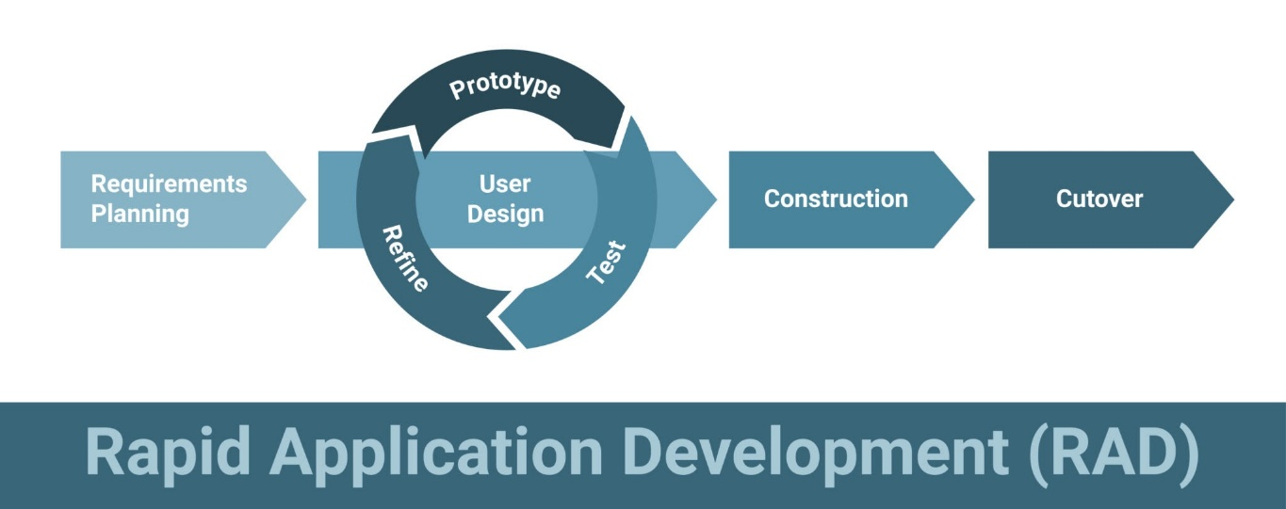
Figure 2. Rapid Application Development Model for ChainSight
Figure 2 With the help of the RAD model, the process of the ChainSight application development is shown. The beginning of the process is Requirements Planning, defining the scope and objectives of the blockchain-based platform for managing student grades, academic records, and certificate verification, being done collaboratively with stakeholders including administrators, teachers, students, and parents. The results of this lead to the Analysis and Quick Design phase where initial UI mockups and high-level architecture for ChainSight are prepared, including the database schema for academic data management, blockchain integration architecture for securing grade records, and user interface layouts for different user roles.In the middle of the ChainSight project, the RAD model is represented by the iterated Prototyping cycle.
The functional modules, i.e., grade management system with prelim, midterm, and final grade submission capabilities, blockchain-based cryptographic hashing for grade immutability, assignment management for teachers to create and grade student submissions, announcement dissemination system for school-wide communications, and certificate generation with blockchain verification, are quickly developed and then subjected to Demonstration for stakeholders.
Feedback obtained from these demonstrations is then used to Refine the prototypes in the following cycles, ensuring that the platform meets user needs appropriately and addresses usability concerns, system performance optimization, and security enhancements.After the iterative prototyping, a formal Evaluation of the refined ChainSight platform is carried out, which involves assessing its usability, reliability, and security through software quality assessment models.
Upon Customer Approval from the school community, the project enters the Development phase, where the final, production-ready version of ChainSight integrating blockchain technology for immutable grade records, certificate generation and verification, comprehensive academic management features, and role-based access control for administrators, teachers, students, and parents is created.
Testing ensures the platform's functionality and security through rigorous efforts including unit testing, integration testing, and system testing. In the end, deployment enables administrators to manage academic records, teachers to submit grades and create assignments, students to view their grades and submit assignments, and parents to monitor their children's academic progress through ChainSight, which has now become accessible to all stakeholders.

Requirement Planning
The Requirements Planning phase establishes the scope and objectives of the blockchain-based grading system for managing student grades, academic records, and certificate verification. This phase emphasizes collaborative work with stakeholders, including administrators, teachers, students, and parents, to gather comprehensive requirements. Through stakeholder meetings, workshops, interviews, and surveys, the development team identified needs, problems, and expectations, which helped define the scope and objectives of the platform. Key stakeholder inputs included core features such as the grading system with blockchain integration for immutability, student grade management, certificate generation and verification, and real-time notifications. This collaborative approach ensured that the system addresses the actual needs of all user groups while maintaining alignment with institutional requirements.

Analysis and Quick Design for ChainSight
Following the Requirements Planning phase, the Analysis and Quick Design phase involves reviewing stakeholder input and drafting a high-level system design. This phase outlines the solution architecture and prepares for the prototyping phase. Initial UI mockups and high-level architecture diagrams are prepared to visualize the system structure, user interfaces, and data flow. The design considers the integration of blockchain technology for securing grade records, the database schema for managing academic data, and the user interface layouts for different user roles (administrators, teachers, students, and parents). This preliminary design serves as a blueprint for the subsequent prototyping phase, ensuring that development efforts are aligned with the established requirements and objectives.

Prototyping Cycle Phase
The Prototyping Cycle Phase represents the iterative stage where the development team quickly produces initial versions of the chainsight. The process begins with mockups and wireframes for the user interface, progressing to working prototypes. The initial prototype focuses on core functionalities, starting with a simple grade management module that integrates blockchain technology for ensuring data immutability. Subsequent prototypes expand to include additional features such as student grade tracking, certificate generation and verification, blockchain transaction monitoring, and real-time notifications. Throughout this phase, stakeholders review prototypes and provide feedback, enabling continuous adjustment and improvement. This iterative approach ensures that the system remains user-oriented and efficient, with each prototype iteration incorporating lessons learned from previous versions and stakeholder feedback.

Demonstration
During the Demonstration phase, the development team presents the blockchain grading platform to various stakeholders, including administrators, teachers, students, and parents. This stage provides a visual and practical experience of the system's functionalities, including grade management, blockchain integration for immutability, certificate verification, and notification systems. Direct interaction with the prototype allows stakeholders to experience the system firsthand and provides opportunities for immediate feedback collection. This feedback is crucial for identifying usability issues, missing features, and areas requiring improvement. The demonstration phase serves as a validation checkpoint, ensuring that the system meets stakeholder expectations before proceeding to full-scale development and deployment.

Refine
After gathering feedback from demonstrations, the blockchain grading platform undergoes final tweaks and upgrades during the Refine phase. Stakeholder feedback helps identify areas for improvement in both the user interface and backend systems, including the grading system, blockchain integration, and overall system performance. Bugs and technical issues are identified and resolved to ensure security and stability. The refinement process addresses usability concerns, optimizes system performance, and enhances the overall user experience. By upgrading the system based on user feedback, the platform reaches a production-ready state, ensuring that it is formally evaluated and ready for release. This phase is critical for ensuring that the final system meets quality standards and user expectations.

Construction
The Construction phase involves converting the refined prototype into a production-ready system. This phase includes final development work, code optimization, system integration, comprehensive testing, and performance tuning. All system components are integrated, and the database is fully populated with the necessary schema and relationships. Security measures are implemented, including authentication and authorization mechanisms, data encryption, and blockchain transaction security. Quality assurance activities, including unit testing, integration testing, and system testing, are conducted to ensure system reliability and functionality. Documentation, including technical documentation and user manuals, is prepared to support system maintenance and user training.

Cutover
The Cutover phase represents the final stage of the RAD model, involving the deployment of the system to the production environment and the transition of users to the new system. This phase includes system deployment, data migration (if applicable), user training, support setup, and go-live activities. Administrators, teachers, students, and parents are trained on how to use the new blockchain grading system. Monitoring tools are set up to track system performance and identify any issues that may arise. The system is officially launched, making it available for use by all stakeholders. Post-deployment support is established to address any issues and ensure smooth system operation.

Evaluations
After prototyping and refinement, a thorough evaluation confirms the system's effectiveness, reliability, and impact. The evaluation process includes software quality assessment using established quality models to inspect the platform's security, performance, usability, and maintainability. User acceptance testing is conducted to ensure that the system meets stakeholder requirements and expectations. The evaluation phase validates that the Chainsight successfully addresses the identified needs and provides the intended benefits, including secure grade management, immutable record-keeping, and efficient certificate verification.

Gantt Chart
The Gantt chart for the ChainSight project is a visual presentation of the project timeline along with the progress of different phases. The chart is a neat and organized depiction of the project schedule which is very helpful in progress tracking by the team, deadline management, and ensuring delivery on time. The chart will be elaborated with the main phases like Requirement Planning, Analysis and Quick Design, and the iterative Prototyping Cycle, showing their start and end dates. The following phases, i.e., Evaluation, Customer Approval, Development, Testing, and Deployment, will also be outlined to make sure that each task is done in time to keep the project going and to confirm the on-time launch of the ChainSight system.

Development Method |  | April | May | June | July | August | September | October | November | December | January (2026)
1. | 2. Planning
1.1 Brainstorming
1.2 Project Concept
1.3 Assigned Task
1.4 Data Gathering
3. | 4. Analysis and Quick Design
2.1 Analyze system requirements
2.2 Identify key features
2.3 Creating user interface
5. | 6. Prototyping
3.1 Choosing prototyping approach
3.2 Initial prototype
3.3 Making Diagrams
3.4 Creating Hardware Functionalities
7. | 8. Demonstration
4.1 Hardware integration
4.2 Software demonstration
4.3 Developing use cases
9. | 10. Development
5.1 Coding
5.2 Debugging
11. | 12. Refine
6.1 Review prototype based on user feedback
6.2 Refine design/prototype
6.3 Prioritize improvements based on
impact
7. Testing
7.1 Test the hardware functionalities
7.2 Ensure system meets specific
requirements
7.3 Fix bugs encountered while testing
8. Evaluating
8.1 Evaluating the questionnaires
8.2 Tabulating Results
9. Deployment
9.1 Documentation
9.2 Implementation
9.3 Maintenance
Legend: Done To be done
Table 1. Gantt Chart
A Gantt chart for the ChainSight project is a visual tool that graphically represents the project timeline and key milestones. The chart will display the start and finish dates for each phase of the proposed system, from Requirement Planning to Testing and Deployment. By including specific dates for each task, the Gantt chart provides the research team with the assurance that the system will be completed on schedule. This tool is essential for managing deadlines and keeping the project on track for a timely delivery.
Requirement Specifications
The following shows the hardware and software requirements used in the project development.
Features | Description
Averaging  Method | This feature automatically calculates student final grades using a weighted averaging method. The system computes final ratings based on preliminary grades (30%), midterm grades (30%), and final grades (40%), with automatic pass/fail determination based on a 75% threshold.
School  Announcements | This feature allows administrators and teachers to create, publish, and manage school-wide announcements. Announcements can be targeted to specific audiences (All, Teachers, Students, or Parents), scheduled for future publication, and set with expiration dates.
In-App  Notifications | This feature provides real-time in-application notifications to users within the system interface for actions such as grade updates, attendance records, and system messages.
Blockchain  Integration | This feature secures student records, attendance logs, and certificates by storing their cryptographic hashes on a tamper-proof, immutable blockchain (Polygon Mumbai Testnet), ensuring data integrity and providing an audit trail for all academic transactions.
Role-Based  Access | This feature provides different levels of access for administrators, teachers, students, and parents, ensuring that each user can only view and manage their designated information.
Table 2. Functional Requirements
The table above shows the important features of the system. The system features make the system useful and functional in the operations of chainsight.

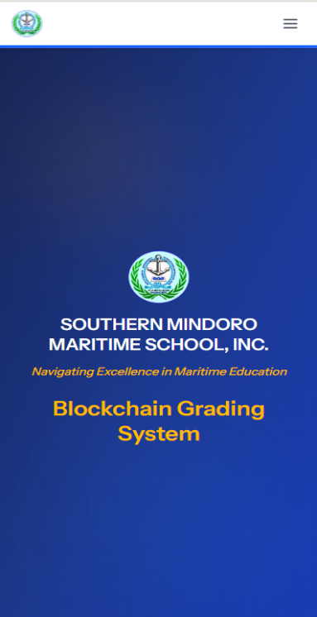
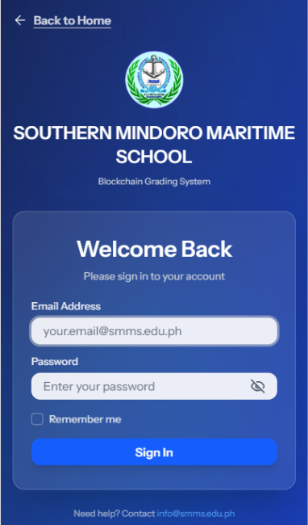
User Interface

Figure 3. User Interface
Figure 3 shows two mobile screens for the Blockchain Grading System of Southern Mindoro Maritime School, Inc. The left screen is the splash page, featuring the school logo, name, tagline "Navigating Excellence in Maritime Education," and the system title "Blockchain Grading System" on a dark blue gradient background.
The right screen is the login interface, with a white card containing email and password fields, a "Remember me" checkbox, and a "Sign In" button. The header includes the school logo and name, with a "Back to Home" link at the top. Support contact information appears at the bottom. Both screens use a consistent dark blue gradient theme with the school's branding elements.

Hardware Interface
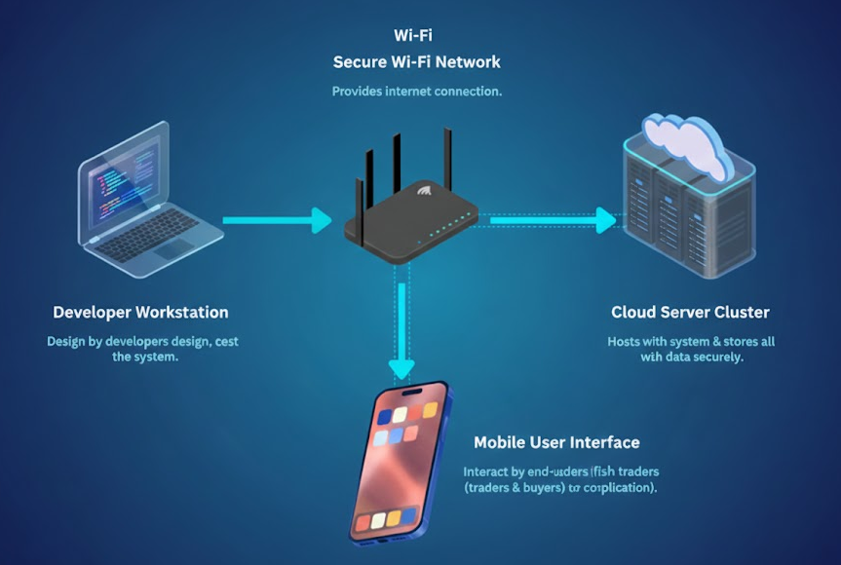
Figure 4. Hardware Interface
Figure 4 shows the hardware interface of the Chainsight, with four components connected via a secure Wi‑Fi network: a Developer Workstation (laptop) for development and testing; a Secure Wi‑Fi Network (central router) providing connectivity; a Cloud Server Cluster (server stack with cloud icon) hosting the application and storing academic records with blockchain integration; and a Mobile/Web User Interface (smartphone) where administrators, teachers, students, and parents access the system. The Developer Workstation connects to the Secure Wi‑Fi Network, which connects to both the Cloud Server Cluster and the Mobile/Web User Interface, showing how developers, cloud infrastructure, and end users interact through the central network.

Software Interface
For the ChainSight, the home interface is the main place where users can access real-time information on student grades, attendance records, and school announcements. This interface is blockchain-secured, which helps protect against data tampering.

Administrators and teachers can securely log in to the portal. After signing in, teachers see a dashboard where they can enter student grades, record attendance, post school announcements, and manage course materials. To reduce manual errors, the system automatically uses the Averaging Method for computing final grades (weighted: 30% preliminary, 30% midterm, 40% final). School administrators have a snapshot view of the entire school data and can make decisions more quickly.

Students access the interface with their school credentials. After logging in, they are redirected to a personalized dashboard where they can view their computed grades, track their attendance performance, access course materials, and receive school announcements in real time. This keeps them informed about their academic progress.

Parents and guardians access the platform through a separate portal login. Their interface enables them to monitor their child's academic progress, attendance records, and school updates. In-app notifications inform parents about important events and grade updates.

Every change within the system is protected by blockchain technology, ensuring data integrity and preventing unauthorized modifications. By incorporating the Averaging Method, grade calculations are consistent and transparent, building trust between students, parents, teachers, and school administrators.

Security Requirements
The ChainSight platform security requirements are designed to protect student data, grades, attendance records, and school announcements from unauthorized access and manipulation. Because it handles sensitive educational records, the system uses multiple layers of security to provide confidentiality, integrity, and availability.System access is restricted by roles, so administrators, teachers, students, and parents have access only to features relevant to their roles.

For example, teachers can enter and update grades, but all grade entries are automatically secured on the blockchain with cryptographic hashes that cannot be altered after registration. Students and parents can view records but cannot make edits. This division of permissions reduces the risk of data misuse and ensures accountability.

Technical Background
The capstone project "ChainSight: A Blockchain-Secured Platform with Averaging Method Analysis for Student Grades and Announcements" is built with reliable and secure technologies for managing school information. The system uses blockchain to prevent tampering with student records. When grades, attendance records, or announcements are stored, they are secured with cryptographic hashes on the blockchain, making unauthorized changes detectable and ensuring transparency and trust for educators and parents.

For grade computation, the system uses a weighted averaging method: preliminary grades (30%), midterm grades (30%), and final grades (40%). Automating this process reduces manual calculation errors and saves time, while providing students and parents with immediate access to accurate academic results for effective progress tracking.

The system is designed to be accessible and easy to use, with role-specific interfaces for administrators, teachers, students, and parents. Access is controlled by role, ensuring sensitive information is only visible to authorized users. To improve communication, ChainSight provides in-app notifications so parents can be updated about important announcements and their child's academic performance.

Hardware Specifications
ChainSight: A Cloud-Based Support System for Southern Mindoro Maritime School Inc. with Blockchain Technology was designed and developed using the following smartphone specifications.
Hardware | Minimum Specifications | Recommended Specifications
Smartphone | Android 10, 4GB RAM | Android 13, 6GB RAM or higher
Laptop/Desktop | Intel Core i3, 4GB RAM | Intel Core i5/i7, 8GB RAM or higher
Display | 720p resolution | 1080p Full HD resolution
Storage | 64GB | 128 or 256GB
Internet Speed | 2 Mbps | 10 Mbps or higher

Table 3. Device Specifications
The table above shows the Device specifications for developing the Platform of ChainSight. This includes the processor, RAM

Hardware | Requirements
Processor | Intel Core i5 / AMD Ryzen 5 or higher
RAM | 8GB minimum
Storage | SSD, 256GB or more
Internet | Stable broadband connection

Table 4. Hardware Requirements
The table above shows the hardware requirements for developing the
ChainSight: A Cloud-Based Support System for Southern Mindoro Maritime School Inc. with Blockchain Technology.

Software Specification
ChainSight was designed using modern web technologies to ensure scalability, responsiveness, and performance.
Development Environment.
Component | Specification
Operating System | Windows 10 / Windows 11 (Recommended)
IDE | Visual Studio Code
Version Control | Git/GitHub
Table 5. Software Specifications

Technology Stack
Component | Technology
Frontend Framework | React.js, TypeScript
Frontend Integration | Inertia.js
Styling | HTML, CSS, Tailwind CSS
Backend Framework | Laravel (PHP)
Database | MySQL/PostgreSQL
Blockchain Integration | Web3.php (Polygon Mumbai Testnet)
Charts Library | Recharts
Build Tool | Vite
Authentication | Laravel Sanctum

Deployment Infrastructure
To ensure continuous availability and scalability, ChainSight is deployed using cloud-based hosting services:
Component | Platform | Purpose
Frontend, Backend & Database | Railway | Hosts the Laravel application with React/Inertia.js frontend, automatic SSL, database management, and continuous deployment from GitHub
Blockchain Network | Polygon Mumbai Testnet | Provides decentralized blockchain infrastructure for securing academic records with cryptographic hashes
Table 7. Deployment Configuration
System Analysis and Design
The system analysis and design of “ChainSight: A Cloud-Based Support System for Southern Mindoro Maritime School Inc. with Blockchain Technology” aims to create a secure, reliable, and easy-to-use platform for schools. It identifies the needs of administrators, teachers, students, and parents, ensuring that each has proper access to the information they need. By using blockchain technology (Polygon Mumbai Testnet) for data security, MySQL/PostgreSQL for storage, and Laravel (PHP) for server-side processing, the system provides accurate reports and insights through the weighted averaging method (30% preliminary, 30% midterm, 40% final), supporting better decision-making for academic management.
System Overview
This study was developed to make managing student records, grades, attendance, and announcements more secure and efficient. The system uses a web application built with Laravel (PHP) and a MySQL/PostgreSQL database to handle data, while blockchain technology (Polygon Mumbai Testnet) ensures that all records remain safe through cryptographic hashing. A weighted averaging method (30% preliminary, 30% midterm, 40% final) is applied to compute student grades accurately, and role-based access control allows administrators, teachers, students, and parents to securely view only the information meant for them.
System Architecture
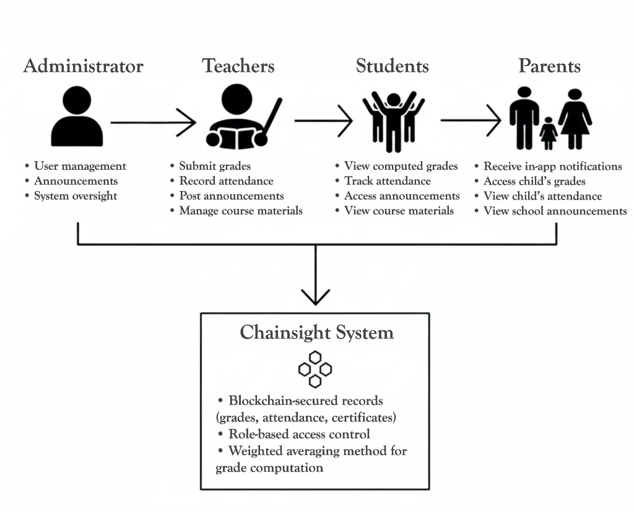
The figure shows the system architecture.

Figure 5. System Architecture
Figure 5 shows the ChainSight system architecture and interactions between user roles and the central system. The diagram shows four user roles: Administrators manage users and announcements; Teachers submit grades and record attendance; Students access computed grades, attendance records, and announcements via a student dashboard; Parents receive in-app notifications and access their child's academic information via a parent portal. All roles connect to the ChainSight system, which provides blockchain-secured storage for academic records, role-based access control, and automated grade computation using a weighted averaging method. The system ensures secure and appropriate data interaction for all users within the school community.

Use Case Diagram
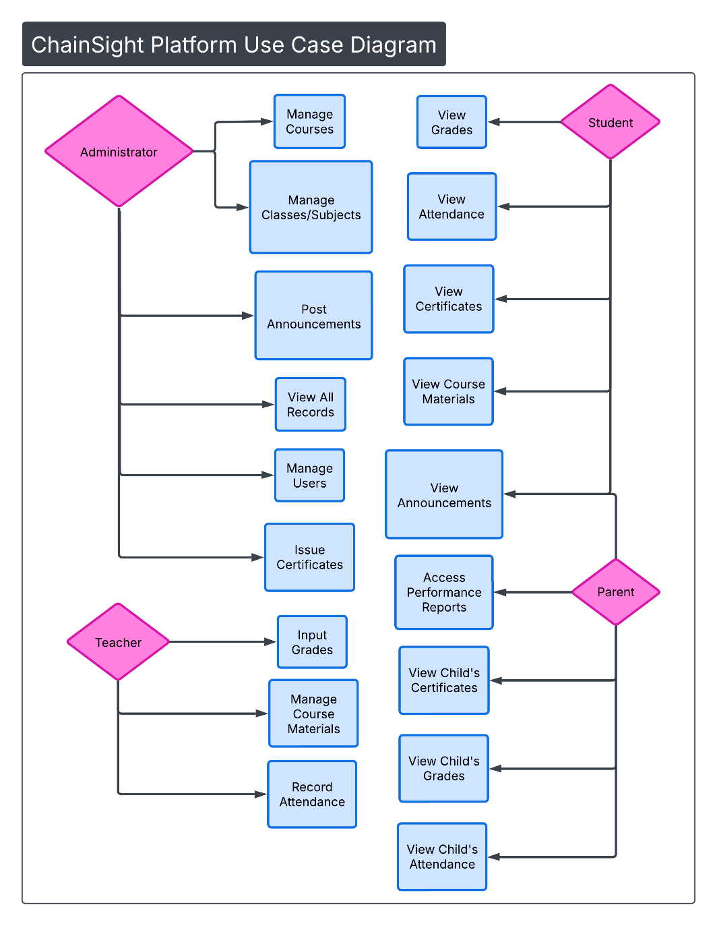
The use case diagram visually represents the interactions between users and the system, illustrating how different functionalities are utilized to achieve specific goals

Figure 6. Use Case Diagram
Figure 6 shows the use case diagram for "ChainSight: A Cloud-Based Support System for Southern Mindoro Maritime School Inc. with Blockchain Technology." The system involves four roles: Administrator, Teacher, Student, and Parent, each with distinct functionalities. Administrators manage courses, classes/subjects, users, and announcements, issue certificates, and view all records. Teachers input grades, record attendance, and manage course materials. Students view their grades, attendance, certificates, course materials, and announcements. Parents view announcements, access performance reports, and view their child's grades, attendance, and certificates.
Activity Diagram
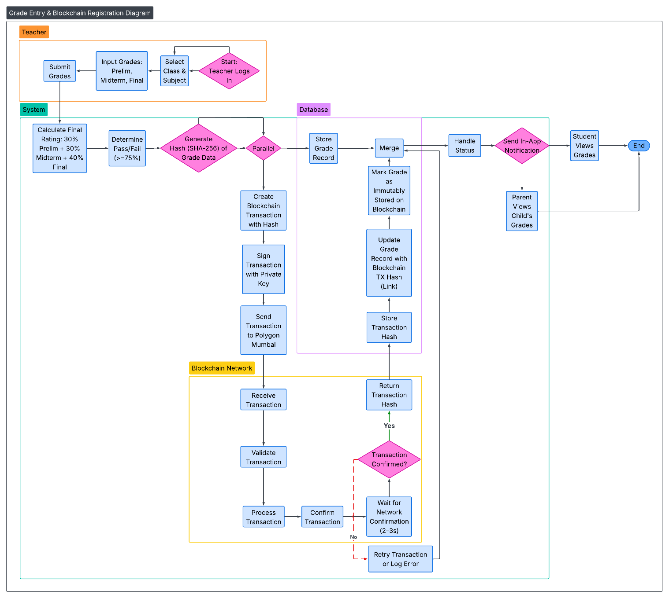
An activity diagram illustrates the program flow of control.

Figure 7. Activity Diagram
Figure 7 shows the ChainSight Platform activity diagram for the grade entry and blockchain registration process with live blockchain network integration. The diagram uses swimlanes for Teacher, System, Blockchain Network, and Database. The process starts when a teacher logs in, selects a class and subject, and inputs student grades. The system calculates the final rating using a weighted averaging method (30% prelim, 30% midterm, 40% final) and determines pass/fail status. A blockchain hash is generated and a transaction is created, signed, and sent to the Polygon Mumbai network. After network confirmation, the transaction hash is stored in the database and linked to the grade record, ensuring immutable storage on the blockchain. The process includes decision points for transaction confirmation and error handling, and ends with notifications sent to students and parents who can then view the grades.

Data Flow Diagram (DFD)
The data flow diagram explains how the project and its components work, and its relationship to each other, with the flow lines that indicated the process.
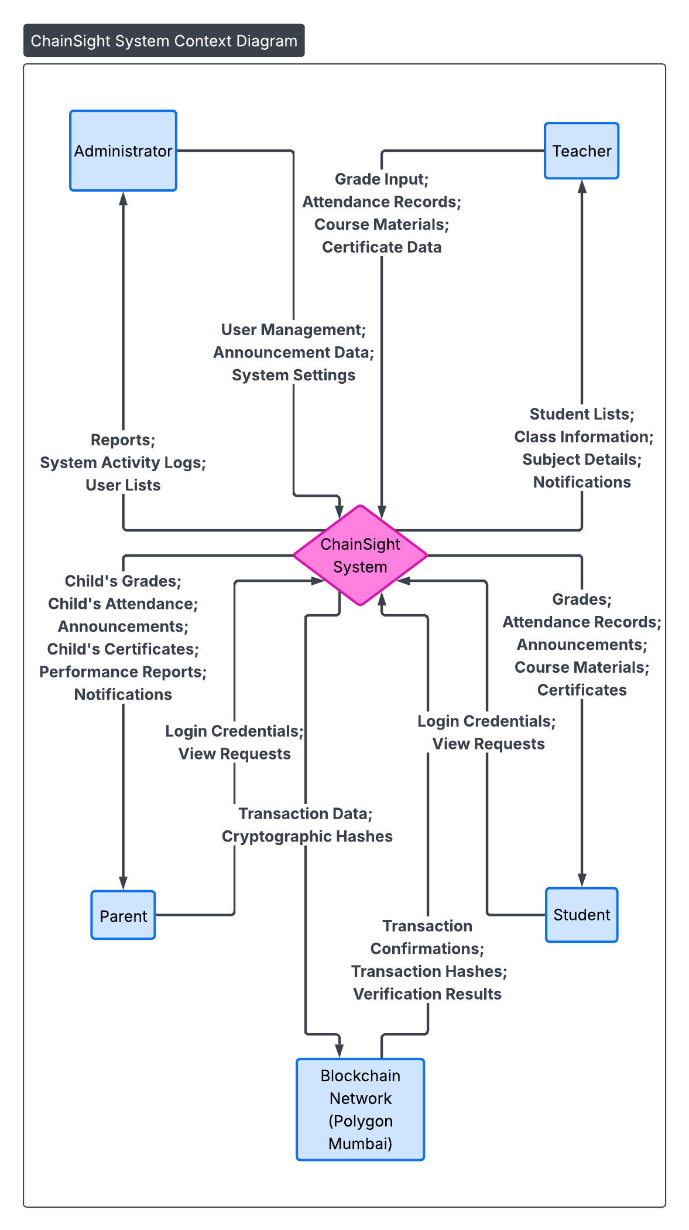
Figure 8. Context Diagram
Figure 8 provides a comprehensive visual representation of the entire system or process being analyzed for the ChainSight System, illustrating key components, interactions between subsystems, and the flow of data or information throughout the system.
Diagram 0
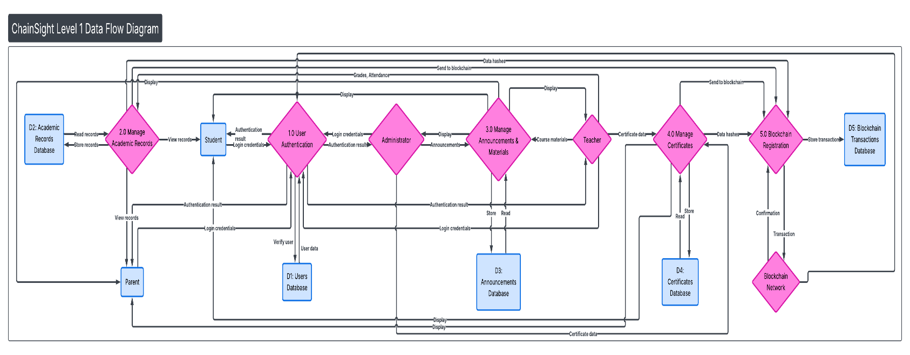
The figure shows the process of the project in more elaborated and well- structured.

Figure 9. Diagram 0

Figure 9 shows the Level 1 Data Flow Diagram for the ChainSight Platform, illustrating internal processes and data flows. The diagram uses a 3-column layout: external entities on the left (Administrator, Teacher, Student, Parent, Blockchain Network), five main processes in the center (User Authentication, Manage Academic Records, Manage Announcements & Materials, Manage Certificates, Blockchain Registration), and five data stores on the right (Users, Academic Records, Announcements, Certificates, Blockchain Transactions).

The flow begins with User Authentication (1.0), where all entities authenticate through the Users Database. Teacher input goes to Manage Academic Records (2.0), which stores grades and attendance and displays them to Students and Parents, while sending hashes to Blockchain Registration (5.0). Administrators and Teachers manage announcements and materials through process 3.0. Certificate management (4.0) handles certificate data and sends hashes to Blockchain Registration. The Blockchain Registration process (5.0) exchanges transactions with the Blockchain Network and stores transaction records.

This diagram shows how data flows through the ChainSight system from user input through processing to blockchain-secured storage.

Database Schema
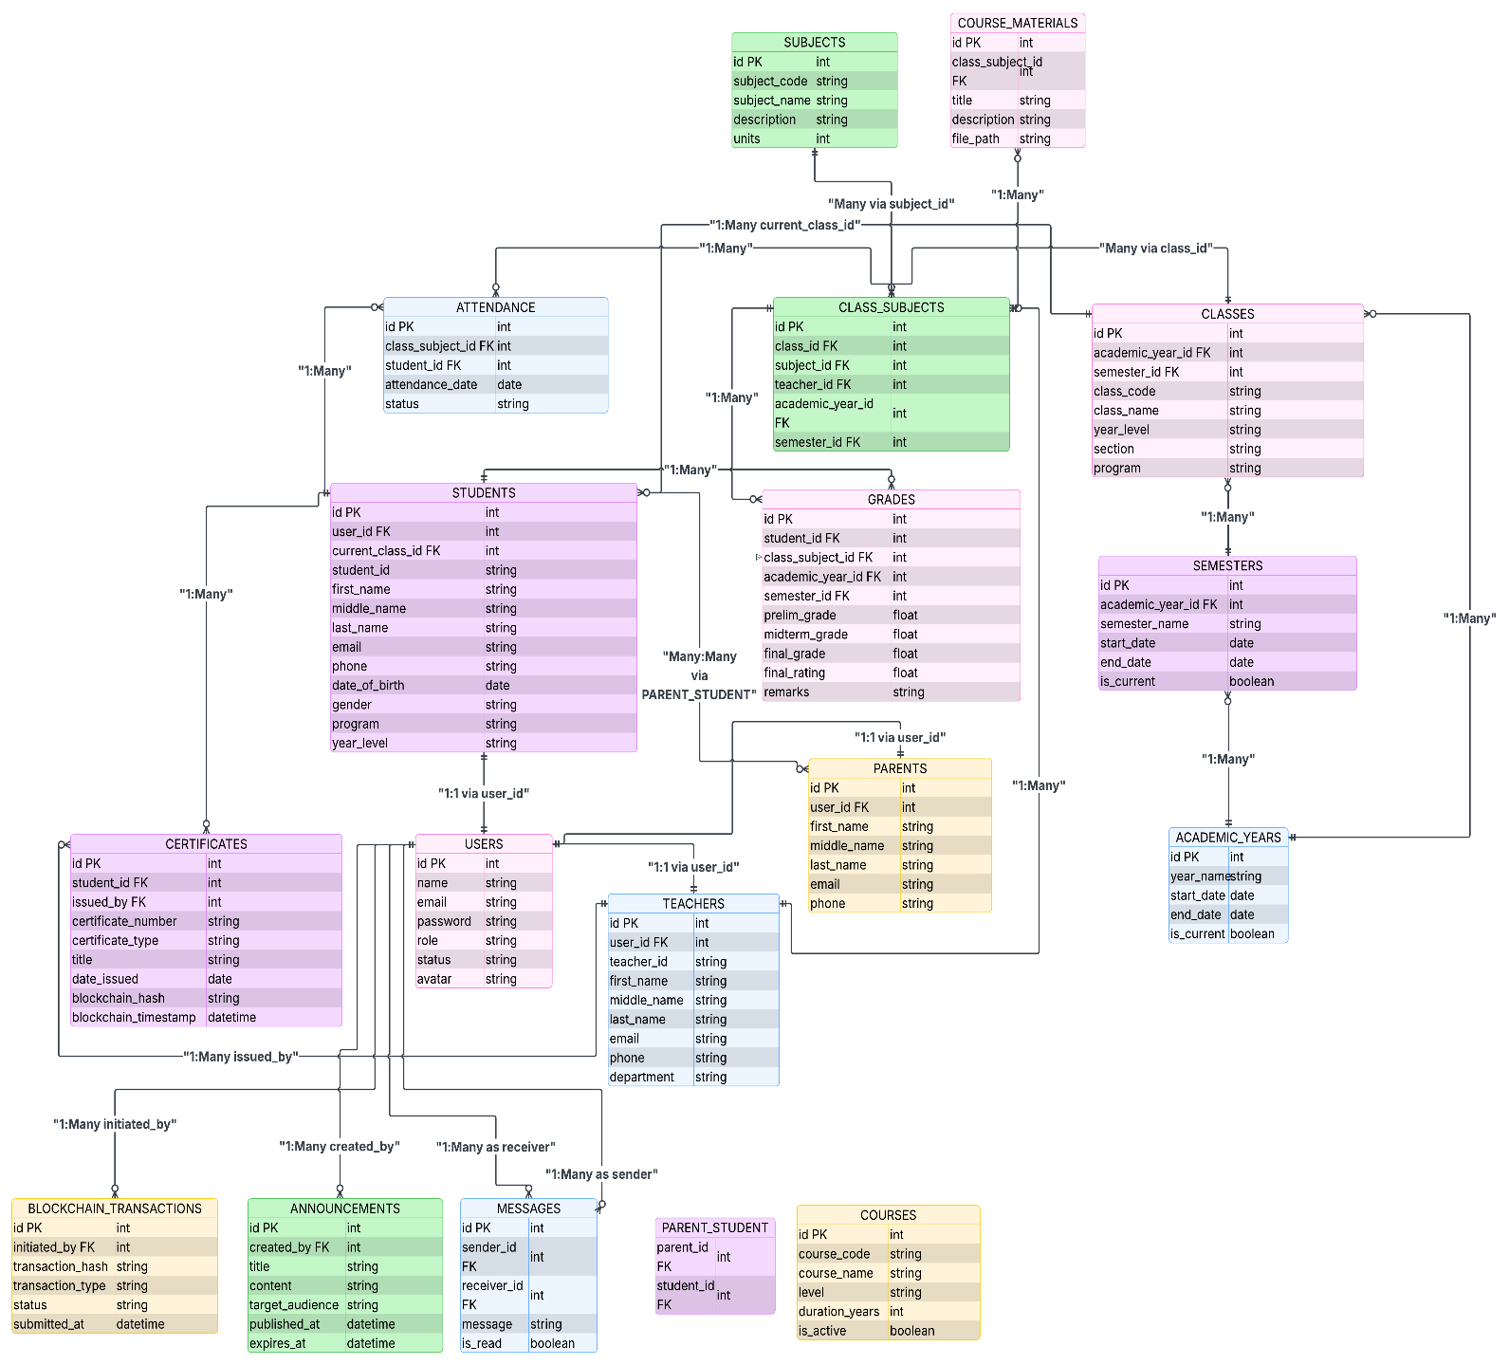
It defines how data are organized within a relational database.

Figure 10. Database Schema
The figure above shows the schema of the database of the system. This shows how
the data are organized and connected in a relational database.
Testing and Evaluation
To measure the efficiency and effectiveness of the study, different respondents were given an assessment to complete. The evaluation forms were distributed to the respondents who were selected through random sampling. The questionnaires include questions about the system's functionality, performance efficiency, compatibility, interaction capability, reliability, security, maintainability, flexibility, and safety. This stage is intended to test user acceptance and system performance. The standards used were from the ISO 25010 Quality Model, which was rated by 50 respondents. Moreover, the Unified Theory of Acceptance and Use of Technology (UTAUT) was employed to identify user acceptance and system performance.
Below is the list of the actual criteria that were used in the evaluation of the project.
Rating:
Strongly Agree (Lubos na Sumasang-ayon) – 4
Agree (Sumasang-ayon) – 3
Disagree (Hindi Sumasang-ayon) – 2
Strongly Disagree (Lubos na Hindi Sumasang-ayon) – 1
1 Functional Sustainability |  | 4 | 3 | 2 | 1
1.1 | The system includes all necessary functions for school operations, such as student enrollment, grading, and record-keeping. (Ang sistema ay naglalaman ng lahat ng kinakailangang function para sa operasyon ng paaralan, tulad ng pagpapatala ng estudyante, pagmamarka, at pagtatago ng mga rekord.)
1.2 | The system accurately records and reflects real-time updates to student information and academic records on the blockchain. (Tumpak na naitala at naipakikita ng sistema ang mga real-time na update sa impormasyon ng estudyante at mga akademikong rekord sa blockchain.)
1.3 | The blockchain features are suitable for generating verifiable digital credentials (e.g., diplomas or transcripts) that prevent forgery. (Ang mga tampok ng blockchain ay angkop para sa pagbuo ng mga nabe-verify na digital credentials tulad ng diploma o transcript na nakakapigil sa pamemeke.)

2 Performance Efficiency |  | 4 | 3 | 2 | 1
2.1 | The time taken to record a grade or update a student record on the blockchain is fast and within institutional limits. (Ang oras na ginugugol sa pagtala ng marka o pag-update ng rekord ng estudyante sa blockchain ay mabilis at nasa loob ng mga limitasyon ng institusyon.)
2.2 | The system loads quickly and runs smoothly on standard devices without consuming excessive hardware or network resources. (Ang sistema ay mabilis mag-load at gumagana nang maayos sa mga karaniwang device nang hindi gumagamit ng labis na kagamitan o network resources.)
2.3 | The system can handle a large number of simultaneous users during enrollment or grading periods without slowing down or crashing. (Kayang hawakan ng sistema ang malaking bilang ng magkakasabay na gumagamit sa panahon ng enrollment o pagmamarka nang hindi bumabagal o nagko-crash.)

3 Compatibility |  | 4 | 3 | 2 | 1
3.1 | The system successfully and securely communicates with external educational databases or government portals. (Ang sistema ay matagumpay at ligtas na nakikipag-ugnayan sa mga panlabas na educational database o mga portal ng gobyerno.)
3.2 | The blockchain backend runs smoothly alongside the web server and school database without resource conflicts. (Ang backend ba ng blockchain ay gumagana nang maayos kasabay ng web server at database ng paaralan nang walang resource conflicts.)
3.3 | The system's architecture is designed to easily integrate with new third-party APIs or external institutional services. (Ang arkitektura ng sistema ay dinisenyo upang madaling maisama sa mga bagong third-party API o mga panlabas na serbisyo ng institusyon.)

4 Interaction Capability (Usability) |  | 4 | 3 | 2 | 1
4.1 | New users (students, teachers, or staff) can quickly and easily learn how to navigate and use the system’s core blockchain features. (Ang mga bagong gumagamit ay mabilis at madaling matutunan kung paano mag-navigate at gamitin ang mga pangunahing tampok ng blockchain sa sistema.)
4.2 | The system’s interface is clear, logically organized, and visually appealing for both administrative and student views. (Ang interface ng sistema ay malinaw, lohikal na nakaayos, at visually appealing para sa parehong admin at estudyante.)
4.3 | The system provides clear status notifications when a transaction is being validated or "mined" on the blockchain. (Nagbibigay ang sistema ng malinaw na abiso ng status kapag ang isang transaksyon ay bini-verify o "minina" sa blockchain.)

5 Reliability |  | 4 | 3 | 2 | 1
5.1 | The system rarely experiences critical errors, failures, or unexpected shutdowns during normal school operations. (Ang sistema ay bihira lang nakararanas ng mga kritikal na error, pagpalya, o hindi inaasahang pag-shutdown sa panahon ng normal na operasyon ng paaralan.)
5.2 | The decentralized management system is available and ready for use at all times when needed by the institution. (Ang decentralized management system ay available at handang gamitin sa lahat ng oras kapag kinakailangan ng institusyon.)
5.3 | In the event of a network failure, the system can quickly and accurately restore all student records and blockchain transaction data. (Sa kaganapan ng pagpalya ng network, mabilis at tumpak na naibabalik ng sistema ang lahat ng rekord ng estudyante at data ng transaksyon sa blockchain.)

6 Security |  | 4 | 3 | 2 | 1
6.1 | The system ensures that student records are immutable and protected against unauthorized tampering once saved to the ledger. (Sinisiguro ng sistema na ang mga rekord ng estudyante ay hindi na mababago at protektado laban sa hindi awtorisadong pakikialam kapag naisave na sa ledger.)
6.2 | The system securely manages sensitive student data and private blockchain keys using robust encryption protocols. (Ligtas na pinamamahalaan ng sistema ang sensitibong data ng estudyante at mga private blockchain keys gamit ang matitibay na encryption protocols.)
6.3 | Only authorized school personnel are able to log in to the administrative interface and modify critical academic settings. (Tanging ang mga awtorisadong tauhan lamang ng paaralan ang kayang mag-log in sa administrative interface at magbago ng mga kritikal na academic settings.)

7 Maintainability |  | 4 | 3 | 2 | 1
7.1 | An issue in a single service can be isolated, debugged, and fixed without requiring a restart of the entire management system. (Ang isang isyu sa iisang serbisyo ay maaaring ihiwalay, i-debug, at ayusin nang hindi nangangailangan ng pag-restart ng buong management system.)
7.2 | The system provides sufficient and easy-to-access logs for developers to diagnose the cause of any reported failures. (Nagbibigay ang sistema ng sapat at madaling i-access na mga log para sa mga developer upang ma-diagnose ang sanhi ng anumang naiulat na pagpalya.)
7.3 | Individual modules (e.g., Enrollment or Grading) can be updated and tested independently of other blockchain services. (Ang mga indibidwal na module tulad ng Enrollment o Grading ay maaaring i-update at i-test nang hiwalay sa ibang mga serbisyo ng blockchain.)

8 Flexibility (Portability) |  | 4 | 3 | 2 | 1
8.1 | The system applications can be easily updated to newer framework versions without requiring major architectural rework. (Ang mga aplikasyon ng sistema ay madaling ma-update sa mas bagong bersyon ng framework nang hindi nangangailangan ng malaking pagbabago sa arkitektura.)
8.2 | Specific services can be deployed across multiple server instances independently to handle a sudden surge in user demand. (Ang mga partikular na serbisyo ay maaaring i-deploy sa maraming server instance nang hiwalay upang harapin ang biglaang pagdagsa ng mga gumagamit.)
8.3 | Is the system modular enough to allow switching to a different blockchain protocol with minimal changes to other services. (Ang sistema ba ay sapat na modular upang payagan ang paglipat sa ibang blockchain protocol na may kaunting pagbabago lamang sa ibang mga serbisyo.)

9 Safety |  | 4 | 3 | 2 | 1
9.1 | The system is modular enough to allow switching to a different blockchain protocol with minimal changes to other services. (Ang sistema ay sapat na modular upang payagan ang paglipat sa ibang blockchain protocol na may kaunting pagbabago lamang sa ibang mga serbisyo.)
9.2 | The system provides alerts that quickly identify and flag potential security risks or unauthorized access attempts. (Nagbibigay ang sistema ng mga alerto na mabilis na makakatukoy at makakapag-flag ng mga potensyal na panganib sa seguridad o pagtatangkang pumasok nang walang pahintulot.)
9.3 | If the connection to the blockchain network is lost, the system gracefully reverts to a safe operational state without losing data. (Kung nawala ang koneksyon sa blockchain network, maayos itong bumabalik sa isang ligtas na operational state nang hindi nawawalan ng data.)

2. Unified Theory of Acceptance and Use of Technology (UTAUT) Model
1. Performance Expectancy | 4 | 3 | 2 | 1
1.1 Using Chainsight helps me complete my academic or administrative tasks more quickly. (Ang paggamit ng ChainSight ay tumutulong sa akin upang mas mabilis kong matapos ang aking mga gawaing akademiko o administratibo.)
1.2 The system improves my efficiency in managing student records, grades, and announcements. (Pinapabuti ng sistema ang aking kahusayan sa pamamahala ng mga rekord ng mag-aaral, marka, at mga anunsyo.)
1.3 ChainSight helps me manage academic information
and school-related transactions more effectively.
(Tinutulungan ako ng ChainSight na mas maayos na
pamahalaan ang impormasyong akademiko at mga
transaksyong pang-eskwela.)
2. Effort Expectancy | 4 | 3 | 2 | 1
2.1 Learning to use Chainsight is easy for me.
(Madali para sa akin na matutunan kung paano gamitin ang ChainSight.)
2.2 The system is easy to understand and navigate.
(Madaling maunawaan at gamitin ang sistema.)
2.3 I can use the system without much effort.
(Nagagamit ko ang sistema nang hindi
nangangailangan ng malaking pagsisikap.)
3. Social Influence | 4 | 3 | 2 | 1
3.1 People important to me think that I should use
Chainsight. (Ang mga taong mahalaga sa akin ay
Naniniwalang dapat kong gamitin ang Chainsight.)
3.2 School administrators, teachers, or peers encourage
me to use the system. (Hinihikayat ako ng mga
administrador ng paaralan, guro, o kapwa gumagamit
na gamitin ang sistema.)
3.3 Using Chainsight is accepted and supported within
the school community. (Ang paggamit ng ChainSight
ay tinatanggap at sinusuportahan ng komunidad ng
paaralan.)
4. Facilitating Conditions | 4 | 3 | 2 | 1
4.1 I have the resources needed to use Chainsight.
(Mayroon akong mapagkukunan upang magamit ang
Chainsight.)
4.2 I have the knowledge necessary to use the system.
(Mayroon akong sapat na kaalaman upang magamit
ang Sistema.)
4.3 The system is compatible with my way of working.
(Ang Sistema ay angkop sa paraan ng pagtrabaho.)
5. Behavioral Intention | 4 | 3 | 2 | 1
5.1 I intend to use Chainsight regularly. (Nais kong
gamitin ang Chainsight nang regular.)
5.2 I plan to continue using the system in the future.
(Balak kong Ipagpatuloy ang paggamit ng Sistema
sa hinaharap.)
5.3 I would recommend chainsight to others.
(irerekomenda ko ang Chainsight sa iba.)

Statement of Hypothesis
- Hypothesis and Research Model
  - H1: Performance Expectancy was hypothesized to influence Behavioral Intention positively.
  - H2: Effort Expectancy was hypothesized to influence Behavioral Intention positively.
  - H3: Facilitating Conditions were hypothesized to influence Behavioral Intention positively.
  - H4: Social Influence was hypothesized to influence Behavioral Intention positively.
- Moderating Variables
  - H1a: Age was hypothesized to affect the influence of Performance Expectancy on Behavioral Intention.
  - H2a: Age was hypothesized to affect the influence of Effort Expectancy on Behavioral Intention.
  - H3a: Age was hypothesized to affect the influence of Facilitating Conditions on Behavioral Intention.
  - H4a: Age was hypothesized to affect the influence of Social Influence on Behavioral Intention.
  - H1b: Years of experience in using school information systems is hypothesized to moderate the influence of Performance Expectancy on Behavioral Intention.
  - H2b: Years of experience in using school information systems is hypothesized to moderate the influence of Effort Expectancy on Behavioral Intention.
  - H3b: Years of experience in using school information systems is hypothesized to moderate the influence of Facilitating Conditions on Behavioral Intention.
  - H4b: Years of experience in using school information systems is hypothesized to moderate the influence of Social Influence on Behavioral Intention.
  - H1c: User role in the school (Administrator, Teacher, Student, or Parent) is hypothesized to moderate the influence of Performance Expectancy on Behavioral Intention.
  - H2c: Role in the school is hypothesized to moderate the influence of Effort Expectancy on Behavioral Intention.
  - H3c: Role in the school is hypothesized to moderate the influence of Facilitating Conditions on Behavioral Intention.
  - H4c: Role in the school is hypothesized to moderate the influence of Social Influence on Behavioral Intention.
DIAGRAM
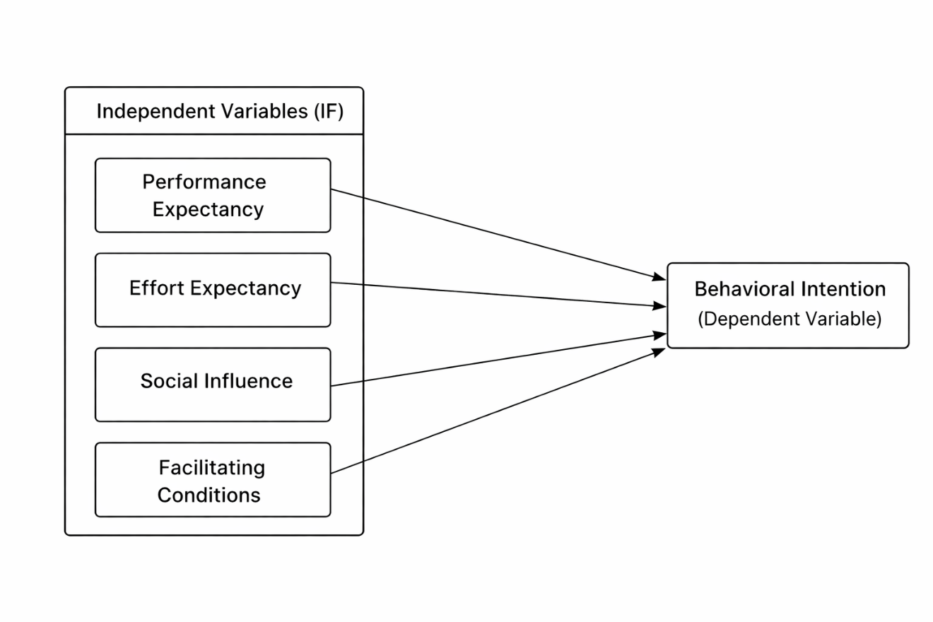

Mean Scale
The researchers calculated the evaluation result using the table below.
Scale | Statistical Limit | Verbal Interpretation
4 | 3.25 – 4.00 | Strongly Agree
3 | 2.50 – 3.24 | Agree
2 | 1.75 – 2.49 | Disagree
1 | 1.00 – 1.74 | Strongly Disagree
Table 6. Likert Scale
Table 6 shows the basics of how the system's rating was calculated. Four (4) is the highest score, and one (1) is the lowest.
Implementation Plan
The table shows the implementation plan in developing the ChainSight: A Cloud-Based Support System for Southern Mindoro Maritime School Inc. with Blockchain Technology.
Phase | Activities/Task | Responsibility | Duration | Deliverables
Planning | Planning for creating the system. | Ken I. Morante, Emman G. Bustillo, Khent P. Manalo | 2 weeks | The proponent planned a strategy how to create the system.
Analysis | Analyze the problem and find ways to solve it. | Ken I. Morante, Emman G. Bustillo, Khent P. Manalo | 2 weeks | The proponents create a solution to the given problem.
Gathering Information | Gathering  information that will be used to develop the required features of the system. | Ken I. Morante, Emman G. Bustillo, Khent P. Manalo | 4 weeks | The proponents collect information that will be used to construct the system.
Designing | Design and Create a Graphical User Interface and Physical Interface of the system. | Ken I. Morante, Emman G. Bustillo, Khent P. Manalo | 6 weeks | The proponents used the right and accurate design for creating the Graphical User Interface and  Physical interface.
Coding System & debugging | Coding of the system and debugging. | Ken I. Morante, Emman G. Bustillo, Khent P. Manalo | 6 weeks | Building and coding the system. The bugs of the system fixed, and the process, features and capability of the system will be tested.
Testing and Implementa  tion | Checking if the features of the system meet the required needs of the organization is satisfied, the system can now be implemented. | Ken I. Morante, Emman G. Bustillo, Khent P. Manalo | 4 weeks | Test the features of the system and if matches to the require needs of the organization the system is ready to implement.
Table 7. Implementation Plan
The table shows the implementation plan in developing the ChainSight: A Cloud-Based Support System for Southern Mindoro Maritime School Inc. with Blockchain Technology.
Chapter IV

RESULTS AND DISCUSSION

This chapter presents the system output, analysis, evaluation of the system, and implementation results. Additionally, it provides the results and a detailed discussion of the evaluation conducted on the system.
Presentation of the System Output
ChainSight is a web-based blockchain-secured platform for managing academic records at Southern Mindoro Maritime School Inc. It provides interfaces for administrators, teachers, students, and parents. Features include grade management with weighted averaging, attendance tracking, announcement management, certificate issuance with blockchain verification, course material management, and role-based access control. All academic records are secured on the blockchain (Polygon Mumbai Testnet) using cryptographic hashes to ensure data integrity and prevent tampering.
Client Side
The following figures show the activities and interfaces for system administrators, teachers, students, and parents to manage and access the ChainSight platform.
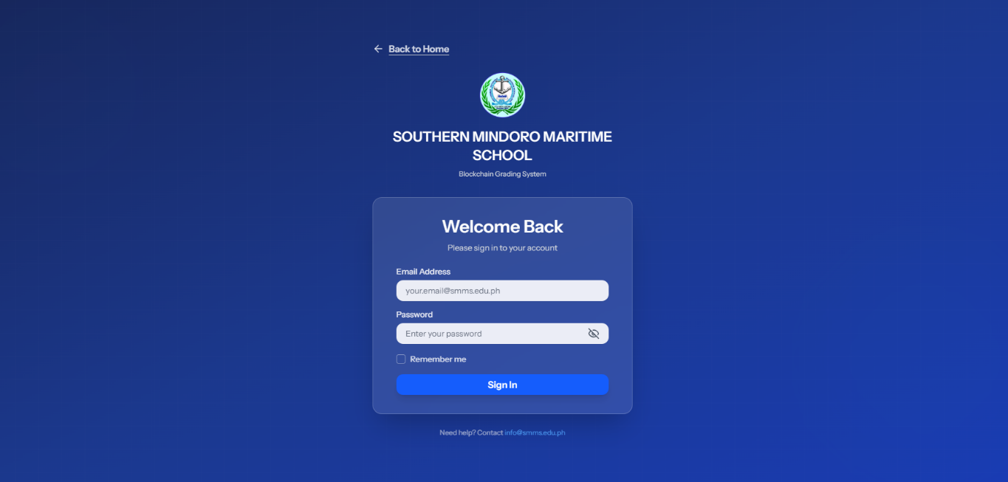
Figure 11. Admin Login
Figure 11 shows the administrator login page. Administrators enter their email address and password to access the system. This authentication ensures only authorized administrators can access the administrative dashboard and its features. As an additional security measure, passwords are encrypted using secure hashing algorithms (bcrypt) to protect administrative credentials from unauthorized access. The system also implements role-based access control, redirecting users to their appropriate dashboards based on their assigned roles.

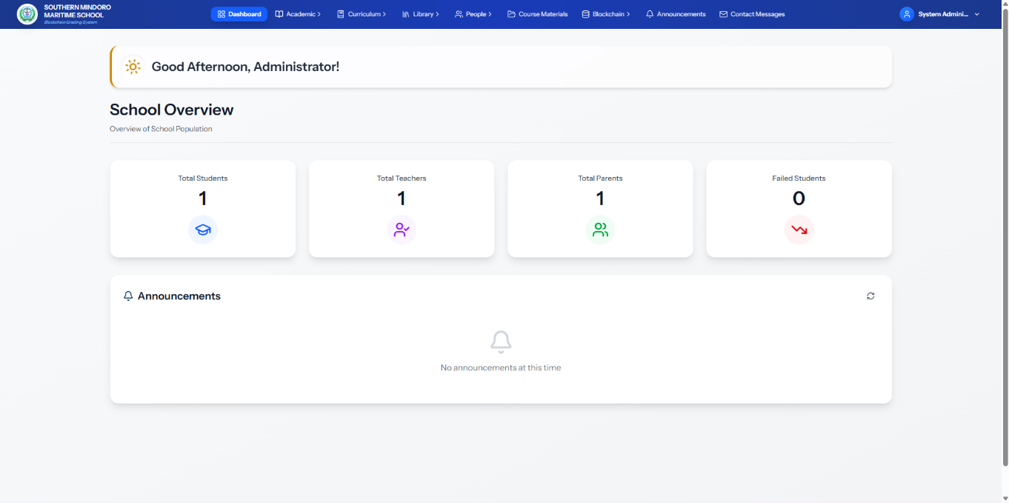
Figure 12. Administrator Dashboard
Figure 12 shows the administrator dashboard of the ChainSight platform. The interface provides an overview of the school's population statistics, including total students, teachers, parents, and students with failing grades. The dashboard includes navigation to academic management, curriculum, library, people management, course materials, blockchain transactions, announcements, and contact messages. The announcements section displays school-wide announcements. This dashboard serves as the central control panel for administrators to monitor and manage the academic system.
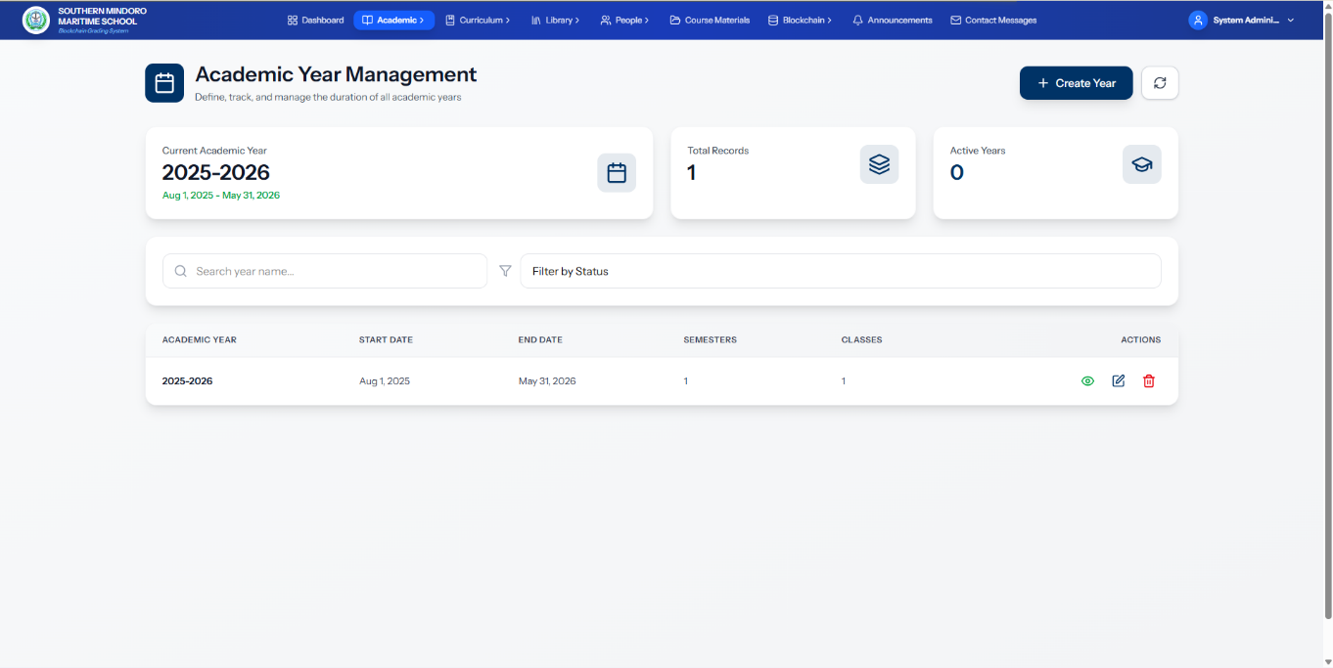
Figure 13. Academic Year Management Interface
Figure 13 shows the Academic Year Management interface of the ChainSight platform. Administrators can create, view, and manage academic years. The interface displays the current academic year, total records, and active years. A table lists academic years with their start and end dates, associated semesters, and classes. Administrators can create new academic years, search and filter records, and perform view, edit, and delete actions. This interface supports organizing the academic calendar and maintaining historical records.

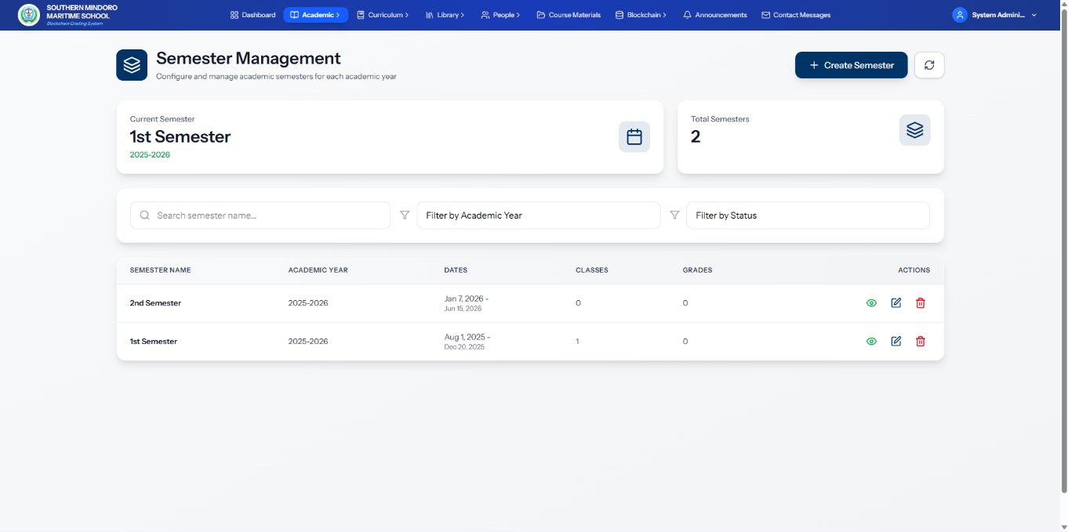
Figure 14. Semester Management Interface
Figure 14 shows the Semester Management interface of the ChainSight platform. Administrators can configure and manage academic semesters. The interface displays the current semester, total semesters, and a table listing all semesters with their names, academic years, date ranges, associated classes, and grades. Administrators can create new semesters, search by semester name, and filter by academic year and status. Each semester record includes view, edit, and delete actions. This interface supports organizing the academic calendar and linking semesters to classes and grade records.
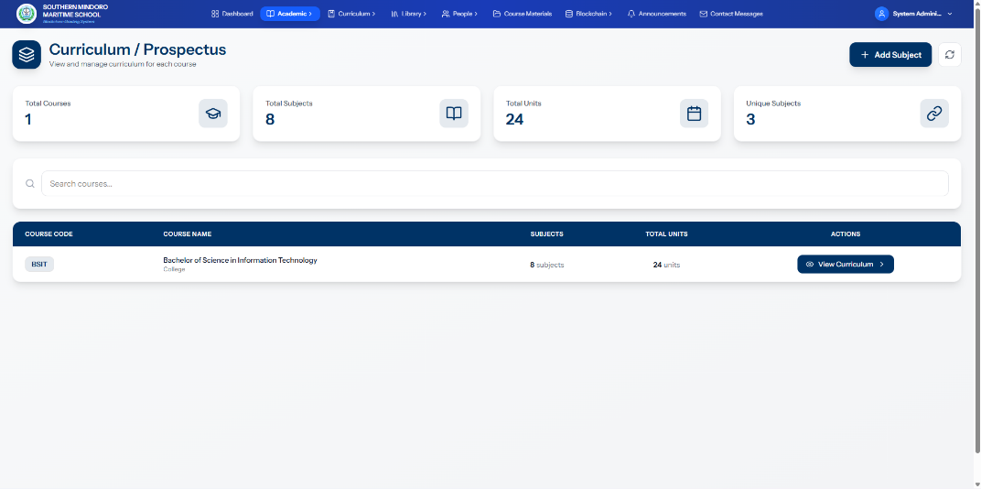
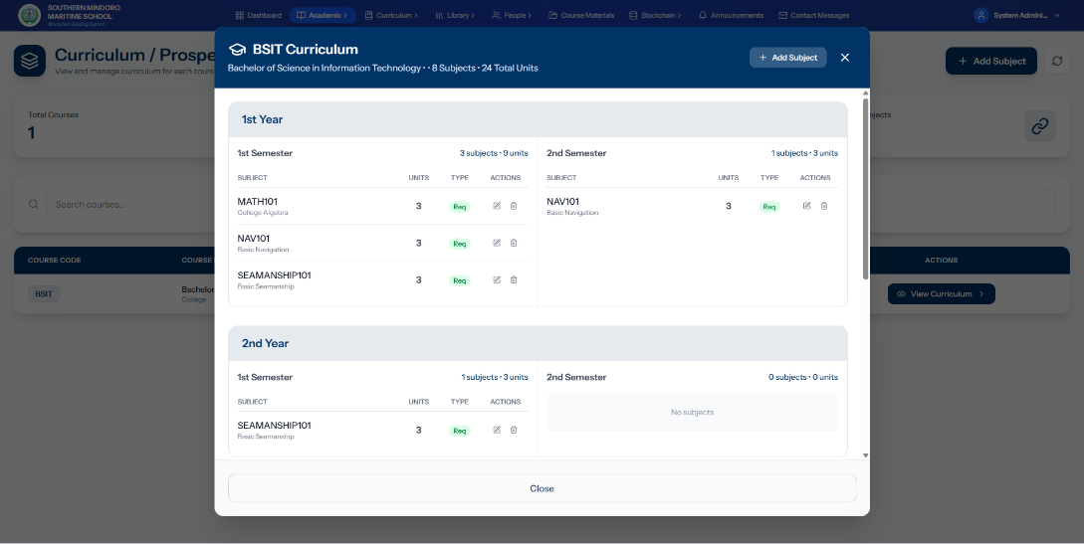
Figure 15. Curriculum Management Interface
Figure 15 shows the Curriculum Management interface of the ChainSight platform. Administrators can view and manage the curriculum for each course. The interface displays summary statistics including total courses, subjects, units, and unique subjects. A table lists all courses with their codes, names, subject counts, and total units. Administrators can view the detailed curriculum for each course through a modal that organizes subjects by academic year and semester, showing subject codes, names, units, and requirement status. The interface supports adding subjects to courses, editing existing curriculum entries, and managing the academic structure. This interface facilitates the organization and oversight of academic programs and their course requirements.
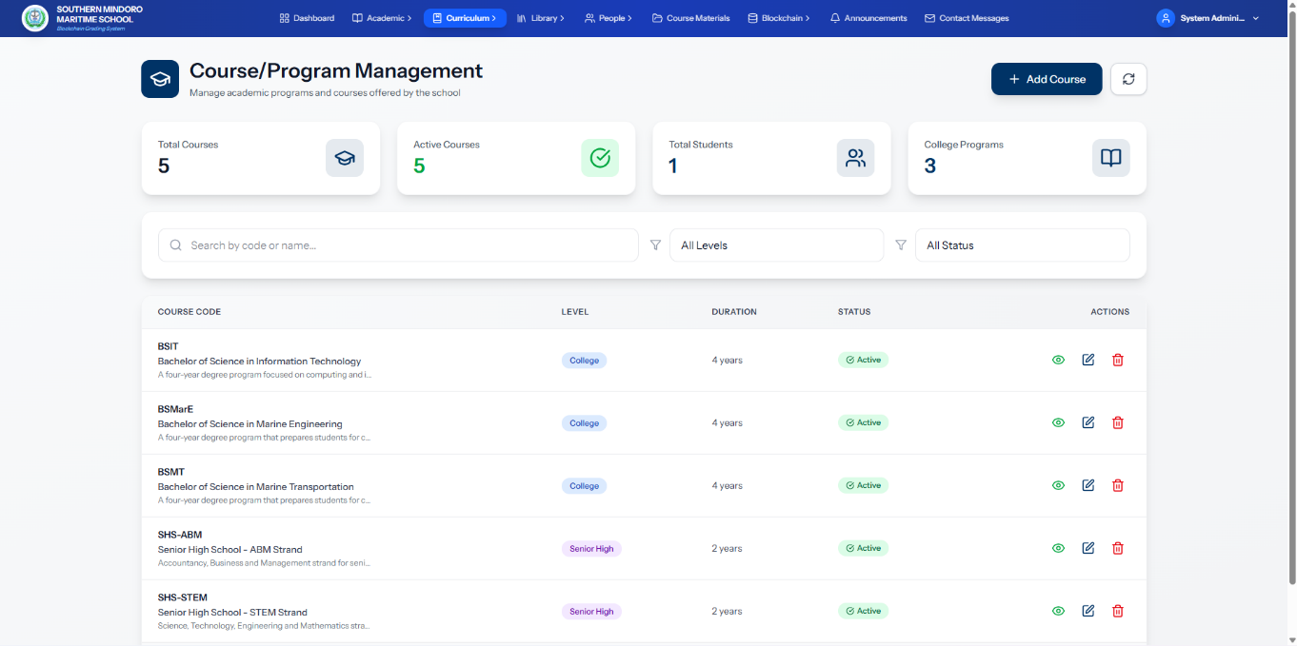
Figure 16. Course/Program Management Interface
Figure 16 shows the Course/Program Management interface of the ChainSight platform. Administrators can manage academic programs and courses. The interface displays summary statistics including total courses, active courses, total students enrolled, and program counts by level. A table lists all courses with their codes, levels (College, Senior High), duration, and status. Administrators can create new courses, search and filter by course code, name, level, and status, and perform view, edit, and delete actions on existing courses. This interface supports maintaining the institution's academic offerings and structure.
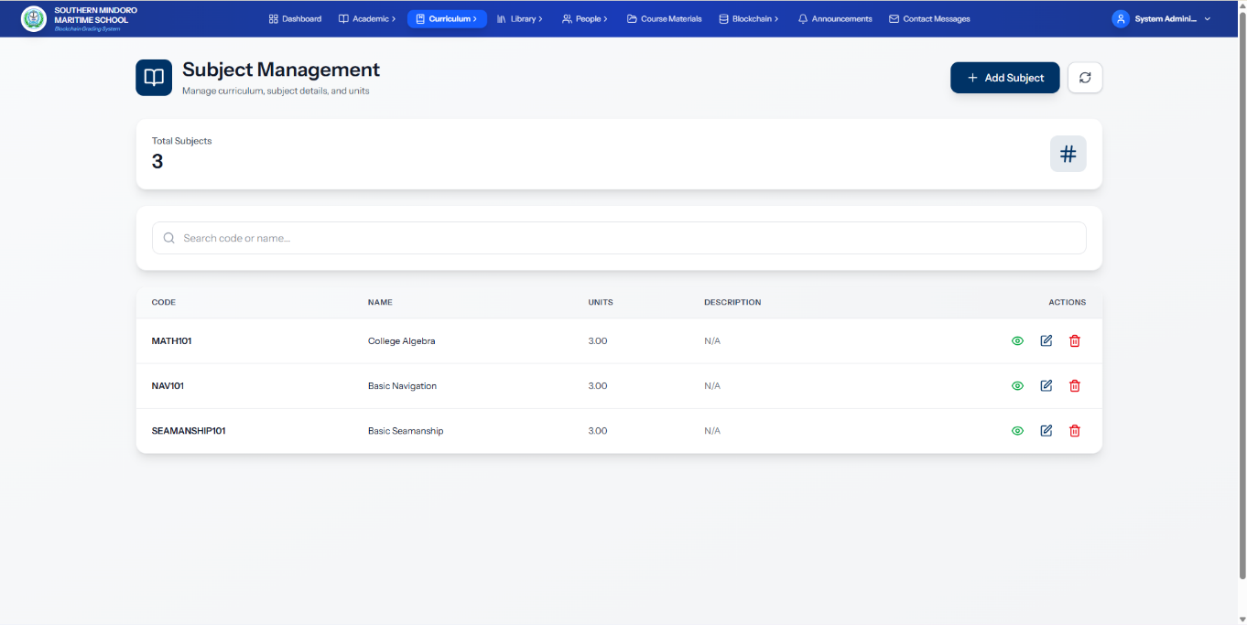
Figure 17. Subject Management Interface
Figure 17 shows the Subject Management interface of the ChainSight platform. Administrators can manage academic subjects. The interface displays the total number of subjects and a search bar to filter by code or name. A table lists all subjects with their codes, names, units, and descriptions. Administrators can create new subjects, and each subject entry includes view, edit, and delete actions. This interface supports maintaining the academic catalog and structuring the curriculum.
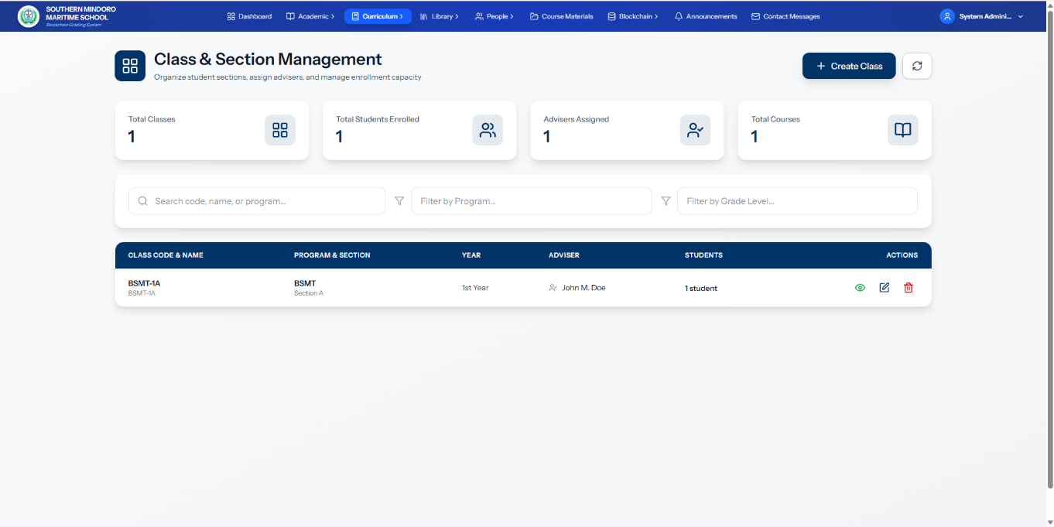
Figure 18. Class and Section Management Interface
Figure 18 shows the Class and Section Management interface of the ChainSight platform. Administrators can organize student sections, assign advisers, and manage enrollment capacity. The interface displays summary statistics including total classes, enrolled students, assigned advisers, and total courses. A table lists all classes with their codes, names, programs, sections, year levels, assigned advisers, and student counts. Administrators can create new classes, search by class code, name, or program, and filter by program or grade level. Each class entry includes view, edit, and delete actions. This interface supports structuring the academic year and managing student placements.

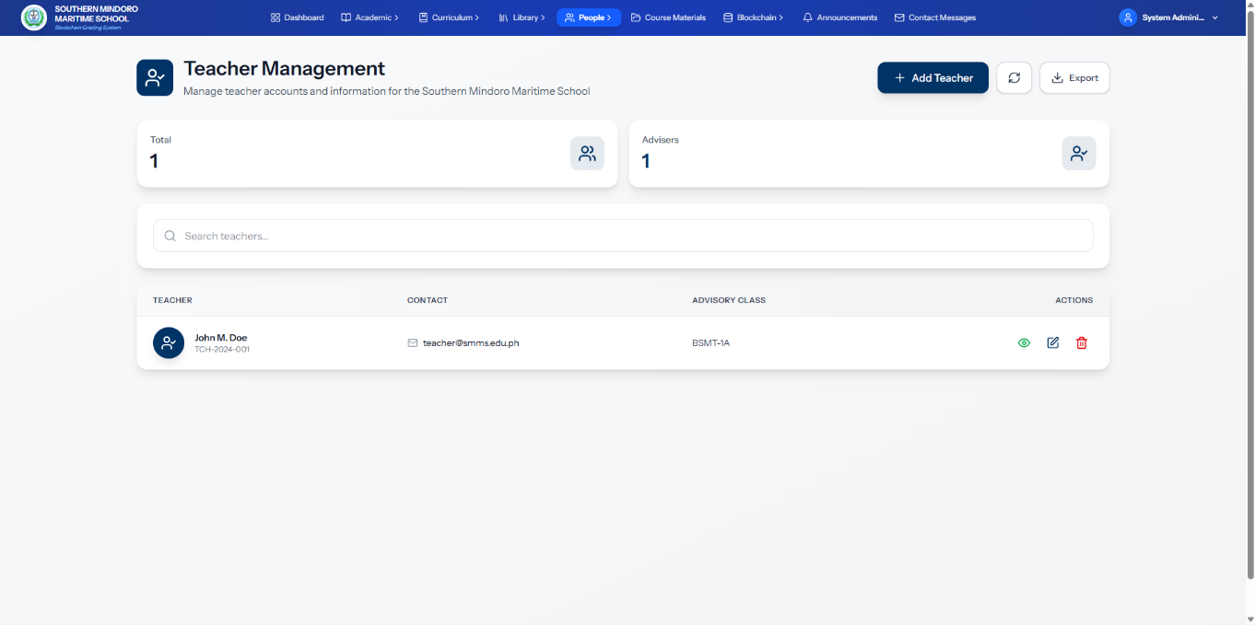
Figure 19. Teacher Management Interface
Figure 19 shows the Teacher Management interface of the ChainSight platform. Administrators can manage teacher accounts and their information. The interface displays summary statistics including total teachers and assigned advisers. A table lists all teachers with their names, contact information, assigned advisory classes, and available actions. Administrators can create new teacher accounts, search and filter teacher records, and perform view, edit, and delete operations. This interface supports managing teaching staff and their academic assignments within the system.
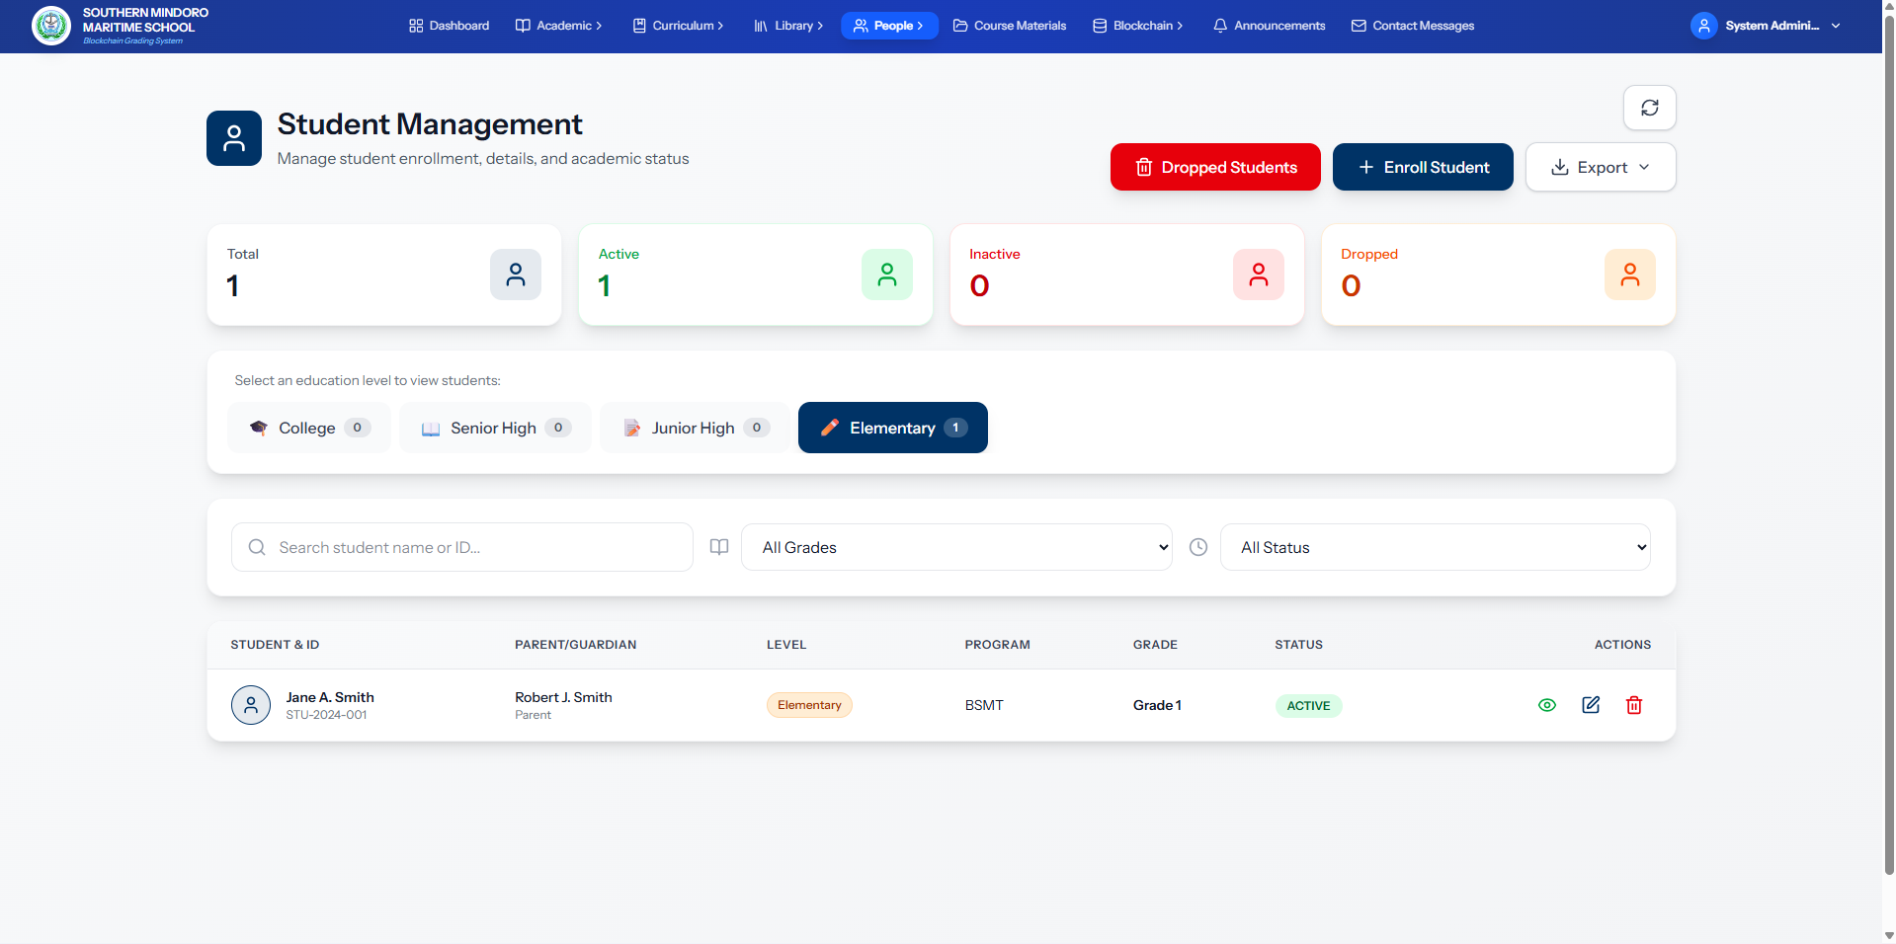
Figure 20. Student Management Interface
Figure 20 shows the Student Management interface of the ChainSight platform. Administrators can manage student enrollment, details, and academic status. The interface displays summary statistics including total students, active students, inactive students, and dropped students. A table lists all student records with their names, IDs, parent/guardian information, education level, program, grade, and status. Administrators can enroll new students, search and filter by name, ID, grade, and status, view dropped students, and perform view, edit, and delete operations. This interface serves as the central hub for student administration.
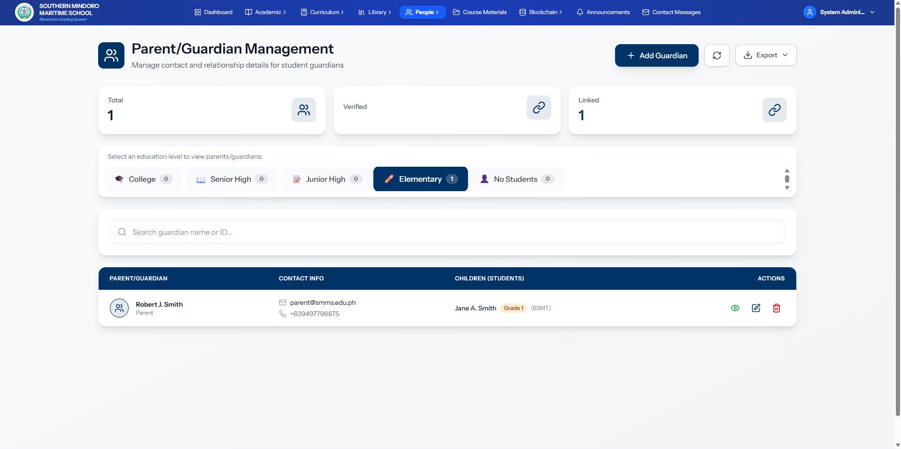
Figure 21. Parent/Guardian Management Interface
Figure 21 shows the Parent/Guardian Management interface of the ChainSight platform. Administrators can manage contact and relationship details for student guardians. The interface displays summary statistics including total guardians and linked guardians. A table lists all guardians with their names, contact information, and associated children with their grades and programs. Administrators can create new guardian accounts, search and filter by education level, name, or ID, and perform view, edit, and delete operations. This interface supports maintaining accurate parent-student relationships and communication within the system.
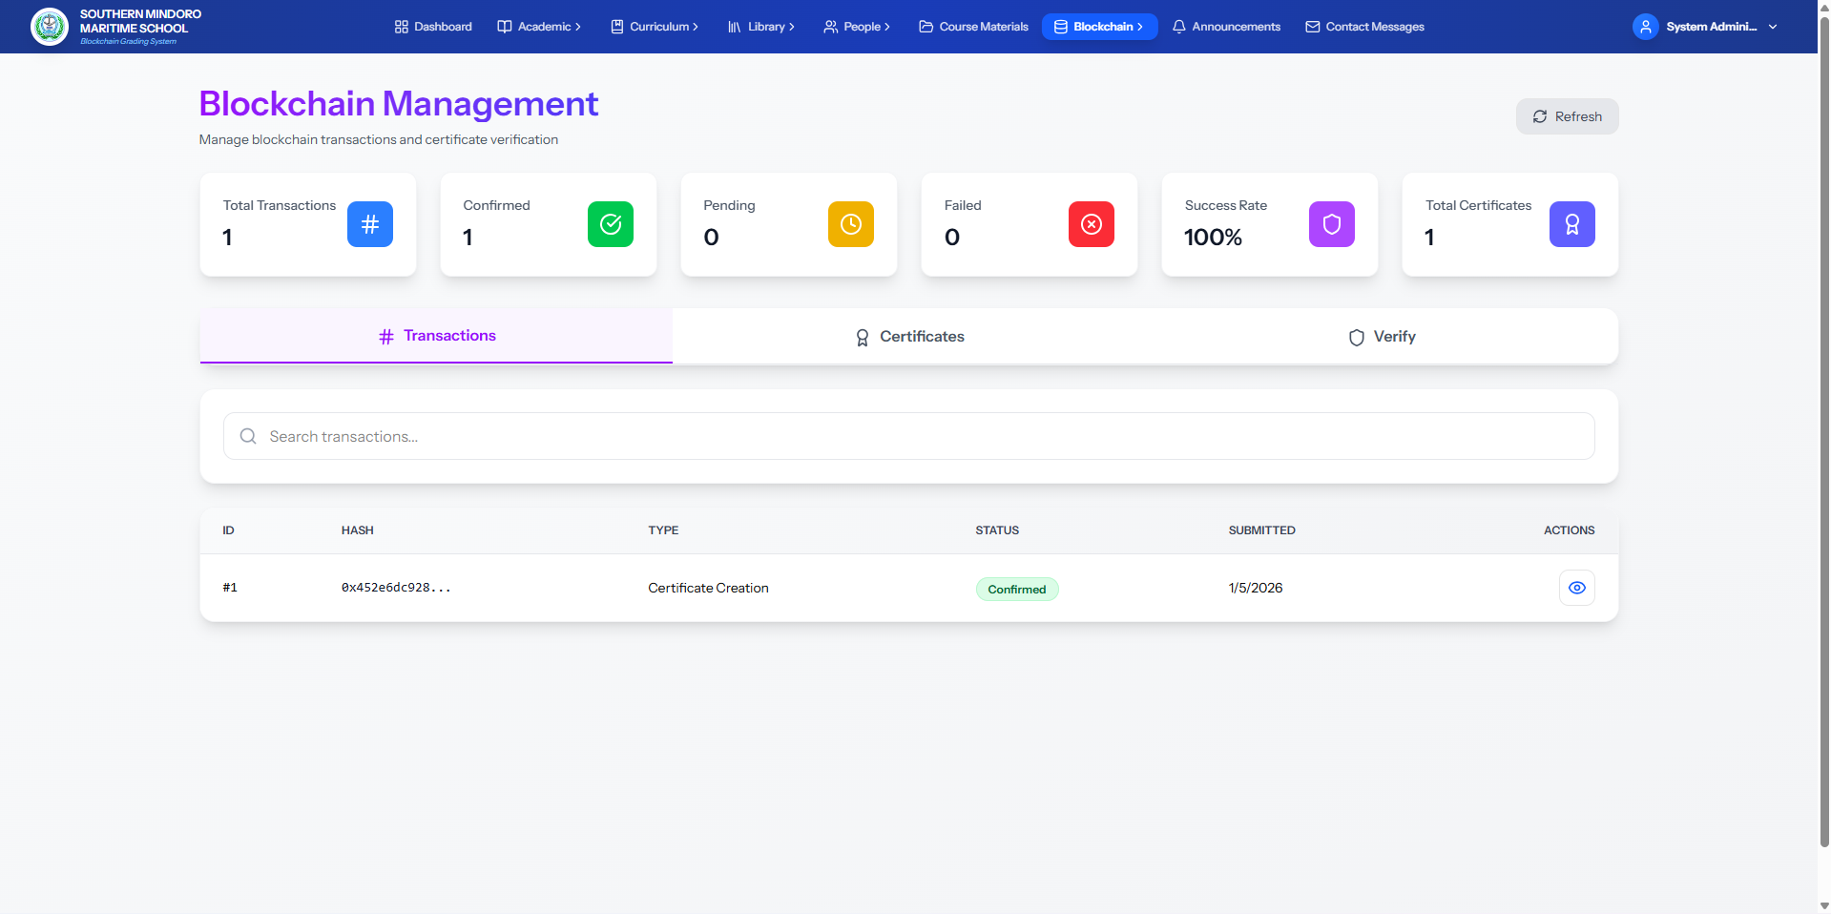
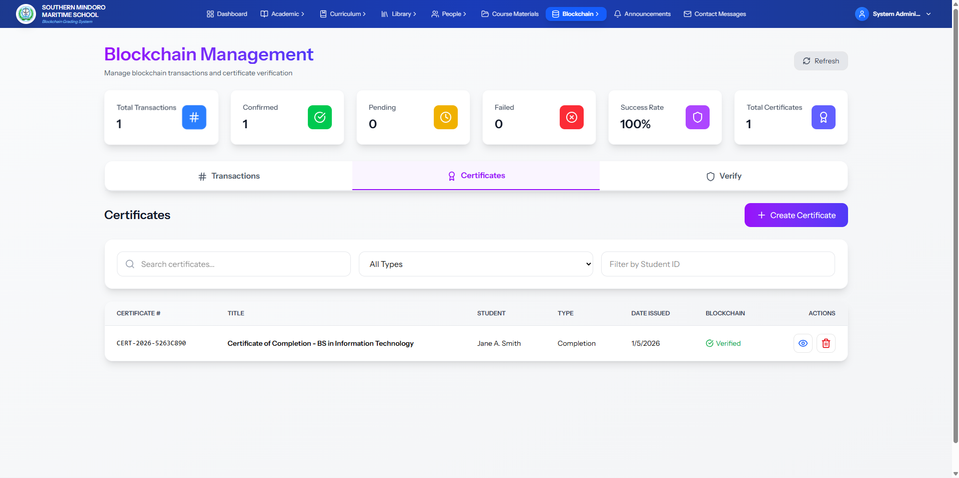
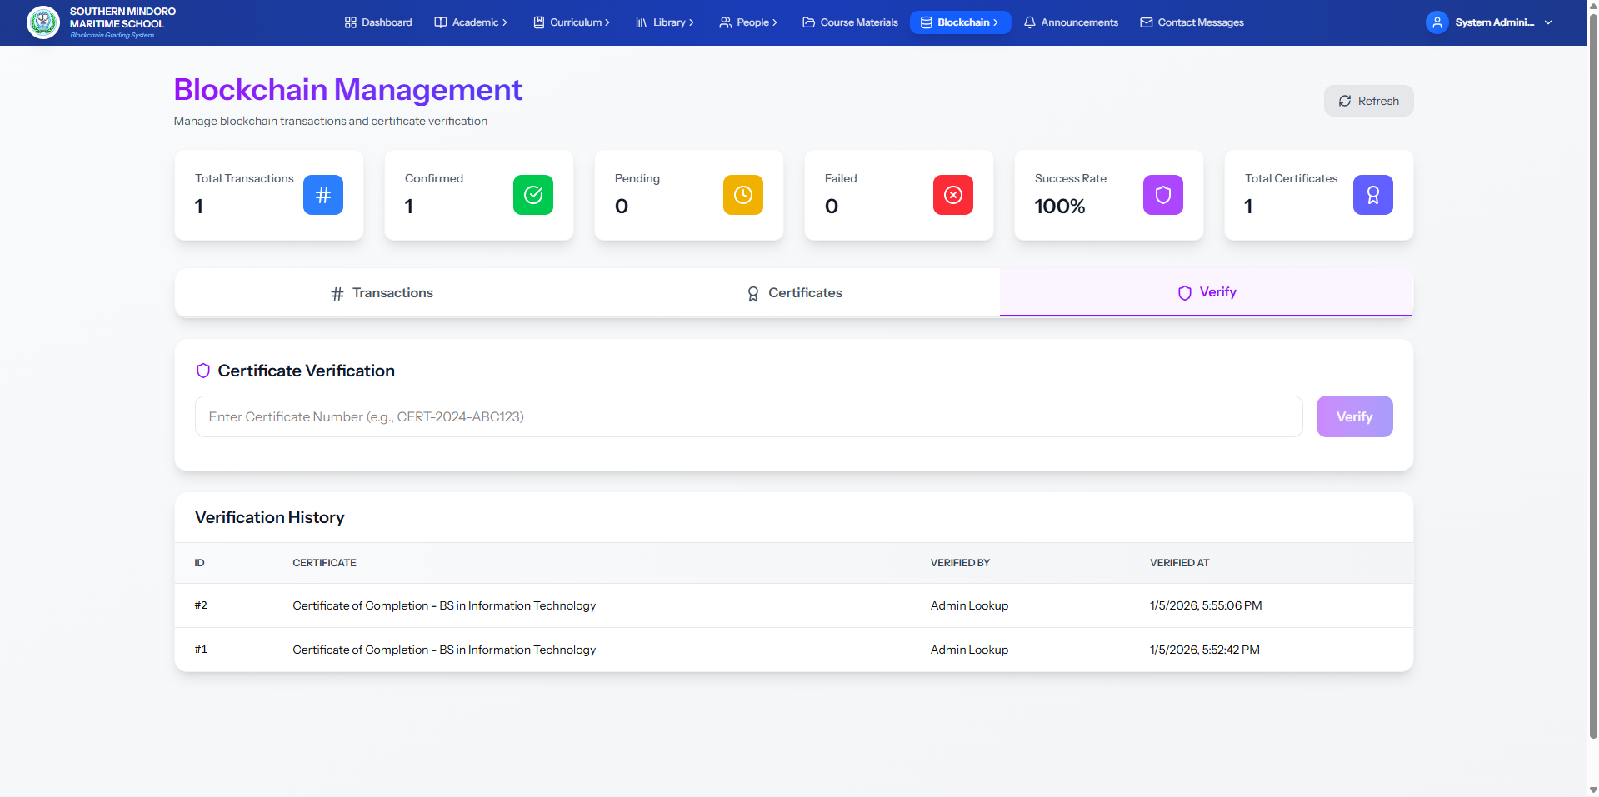
Figure 22. Blockchain Management Interface
Figure 22 shows the Blockchain Management interface of the ChainSight platform. Administrators can monitor and manage blockchain transactions and certificate verification. The interface displays summary metrics including total transactions, confirmed transactions, pending transactions, failed transactions, success rate, and total certificates. A tabbed interface provides access to three sections: Transactions, which lists all blockchain transactions with their hashes, types, statuses, and submission dates; Certificates, which displays all issued certificates with their numbers, titles, student names, types, issue dates, and blockchain verification status; and verify, which allows administrators to verify certificate authenticity by entering certificate numbers and view verification history. This interface supports monitoring blockchain activity and ensuring the integrity and authenticity of academic records secured on the blockchain.
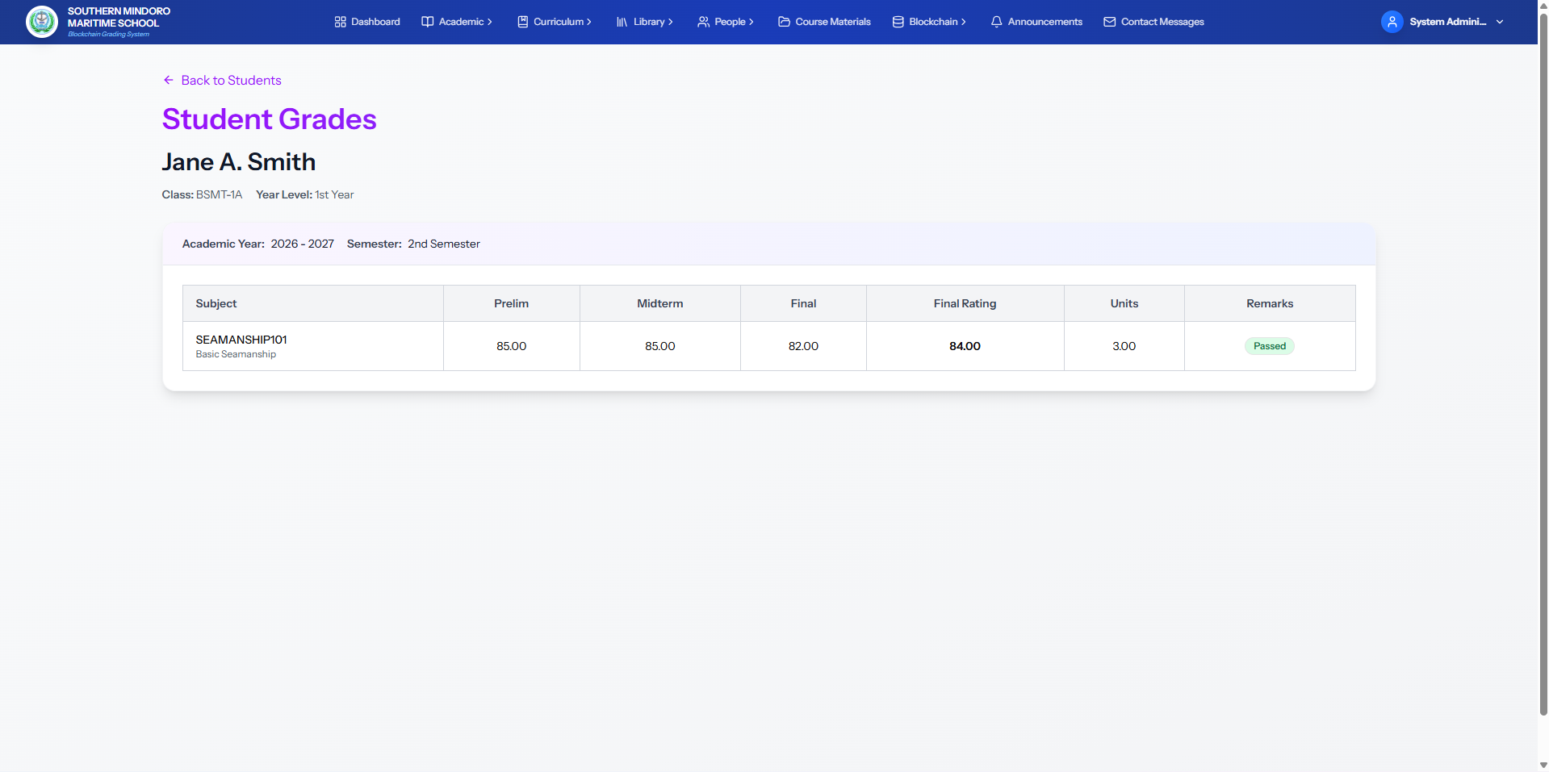
Figure 23. Student Grades Interface

Figure 23 shows the Student Grades interface of the ChainSight platform. Administrators can view a student's academic performance. The interface displays the student's name, class, year level, and current academic year and semester. A table lists all subjects with preliminary grades, midterm grades, final grades, computed final ratings using the weighted averaging method, units, and pass/fail remarks. This interface provides a clear overview of a student's academic progress and performance across all enrolled subjects.
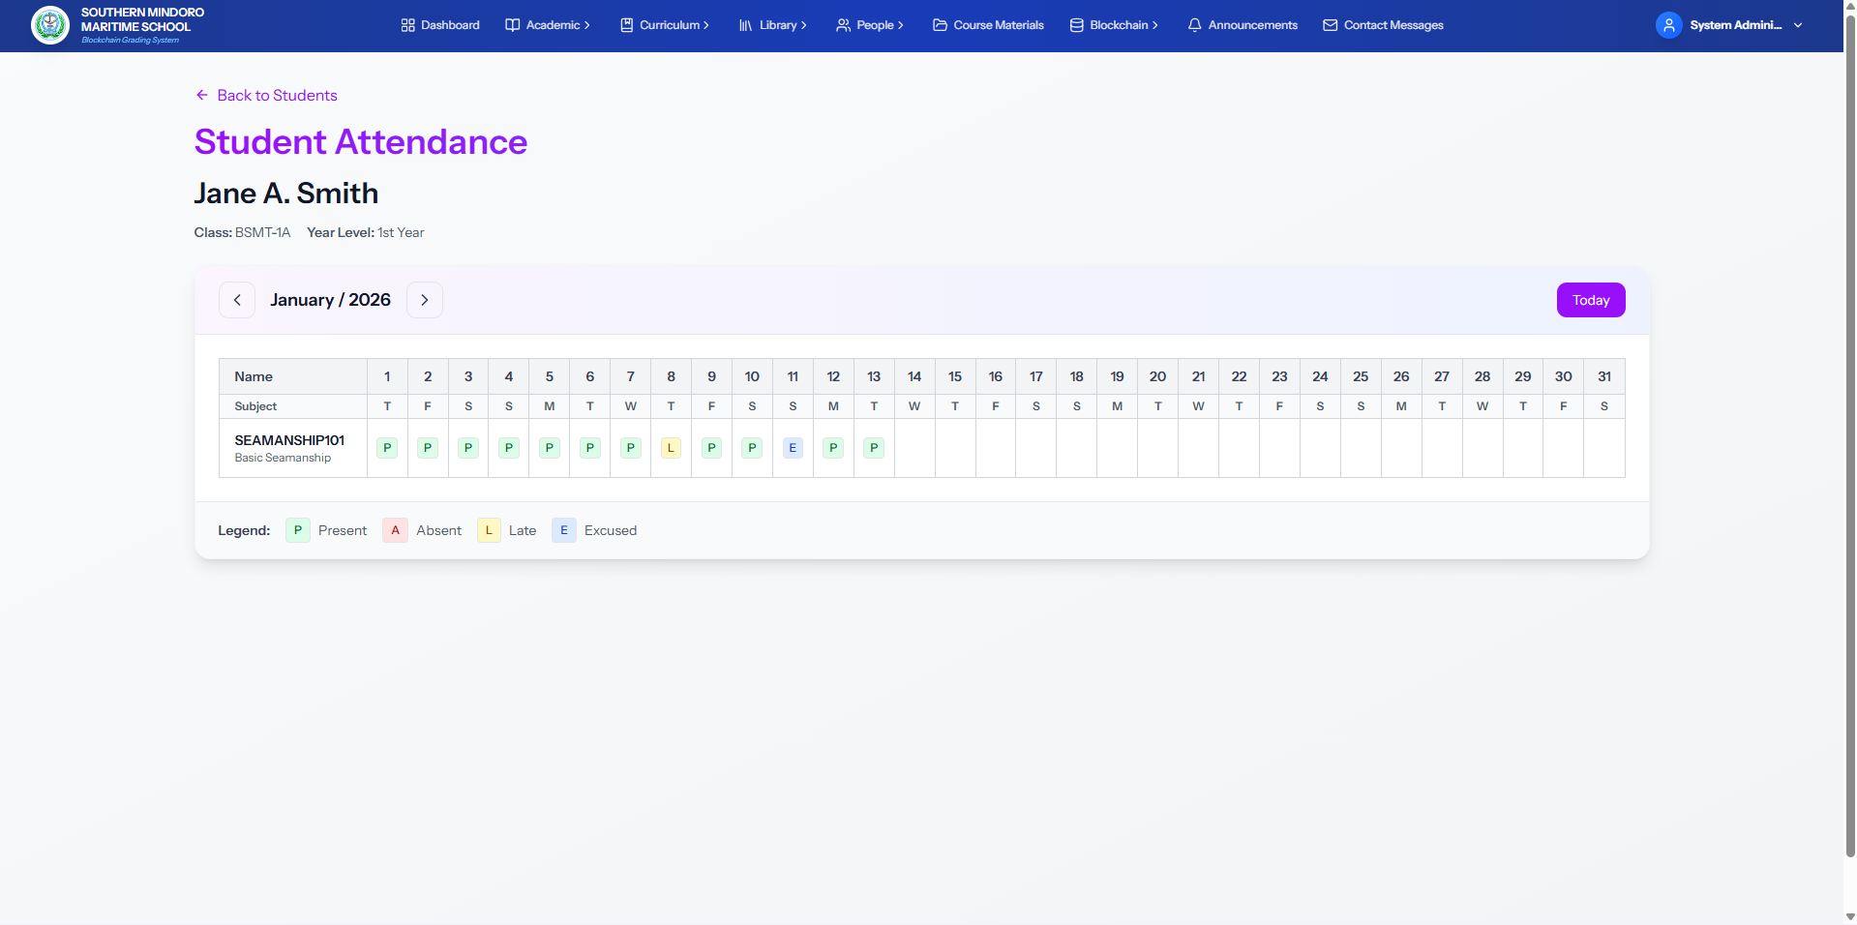
Figure 24. Student Attendance Interface
Figure 24 shows the Student Attendance interface of the ChainSight platform. Administrators can view a student's attendance records. The interface displays the student's name, class, and year level. A calendar view shows daily attendance for each subject by month and year, with status indicators for Present, Absent, Late, and Excused. This interface provides a clear overview of a student's attendance history for academic monitoring and tracking.
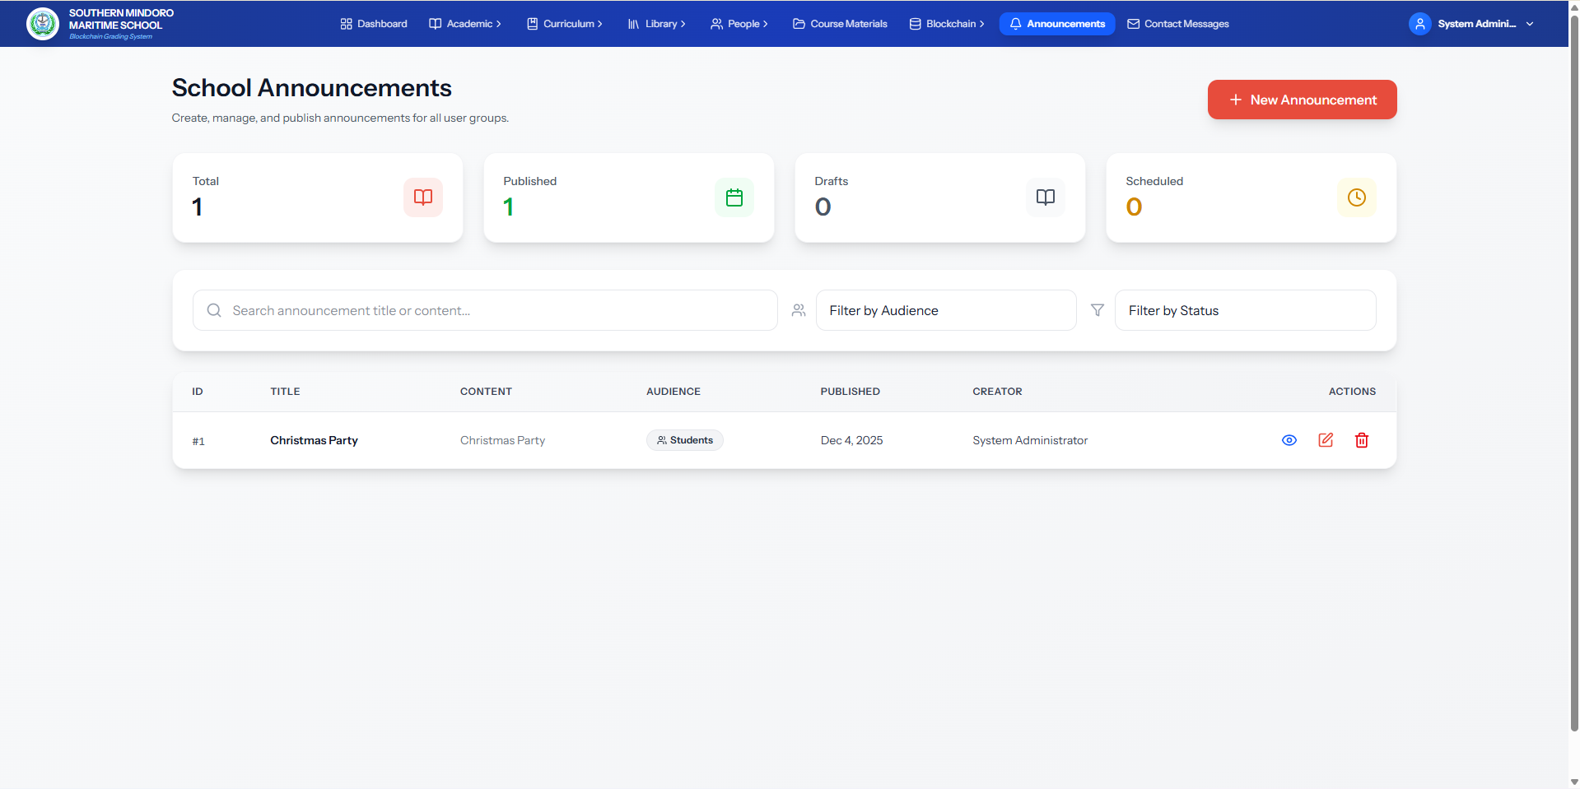
Figure 25. School Announcements Interface
Figure 25 shows the School Announcements interface of the ChainSight platform. Administrators can create, manage, and publish announcements for different user groups. The interface displays summary statistics including total announcements, published announcements, drafts, and scheduled announcements. A table lists all announcements with their titles, target audiences, publication dates, and creators. Administrators can create new announcements, search and filter by title, content, audience, and status, and perform view, edit, and delete operations. This interface supports managing school-wide communications and keeping stakeholders informed.
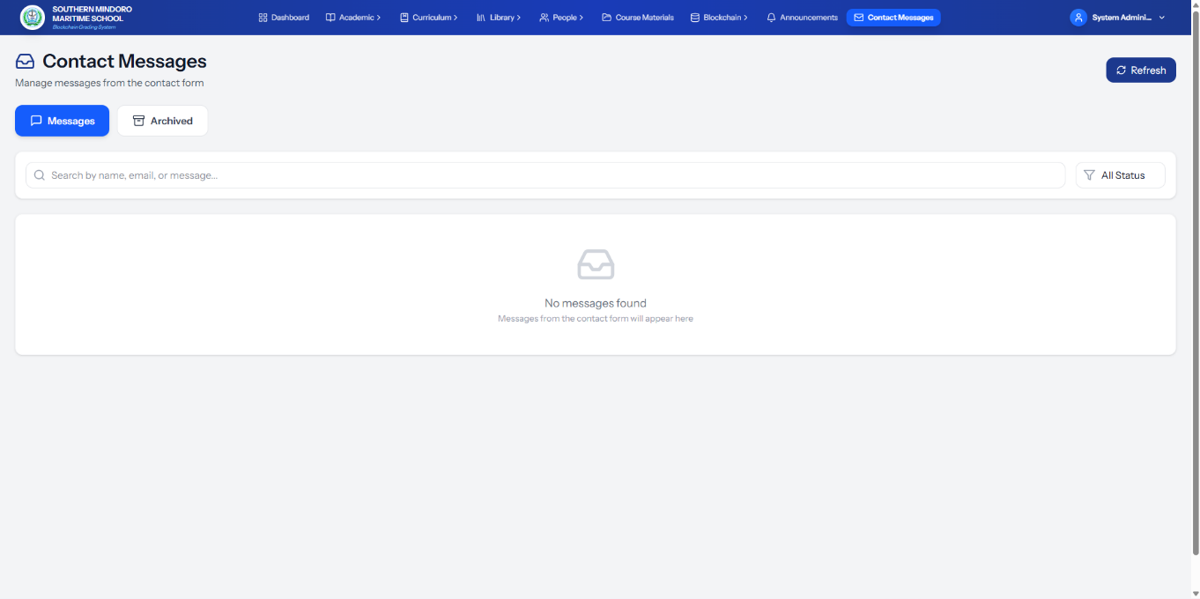
Figure 26. Contact Messages Interface
Figure 26 shows the Contact Messages interface of the ChainSight platform. Administrators can manage messages received through the system's contact form. The interface includes tabs for active messages and archived messages. Administrators can search messages by name, email, or content, and filter by status. This interface supports managing inquiries and communications from external users and stakeholders.

Teacher Side
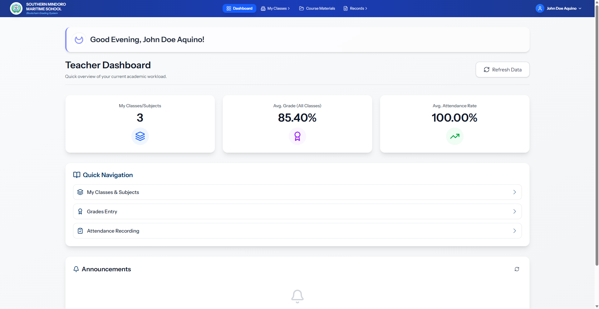
Figure 27. Teacher Dashboard
Figure 27 shows the Teacher Dashboard interface of the ChainSight platform. It provides teachers with an overview of their academic workload and access to key functionalities. The dashboard displays summary metrics including the number of classes/subjects assigned, average grade across all classes, and average attendance rate. Quick navigation links provide direct access to My Classes & Subjects, Grades Entry, and Attendance Recording. The dashboard also includes an announcements section where teachers can view school-wide announcements. This interface serves as a central hub for teachers to monitor their teaching load and access relevant academic management tools.
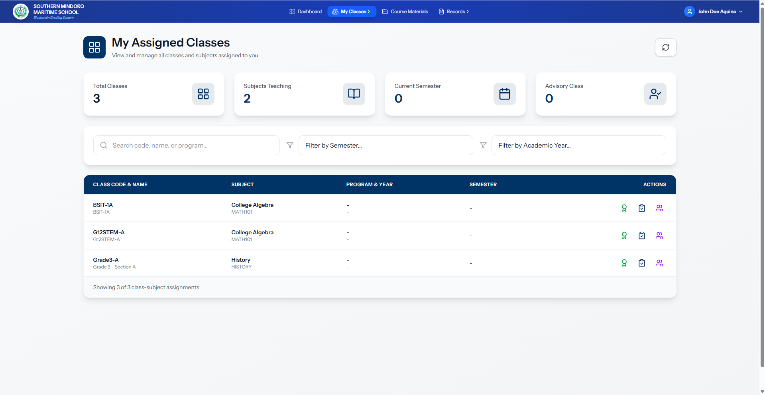
Figure 28. Teacher's My Assigned Classes Interface
Figure 28 shows the My Assigned Classes interface of the ChainSight platform. Teachers can view and manage all classes and subjects assigned to them. The interface displays summary metrics including total classes, subjects teaching, current semester, and advisory class assignments. A table lists all assigned classes with their codes, names, subjects, programs, years, and semesters. Teachers can search and filter by class code, name, program, semester, and academic year. Each class entry includes actions to view details, manage grades, and view students. This interface helps teachers organize and access their teaching assignments.
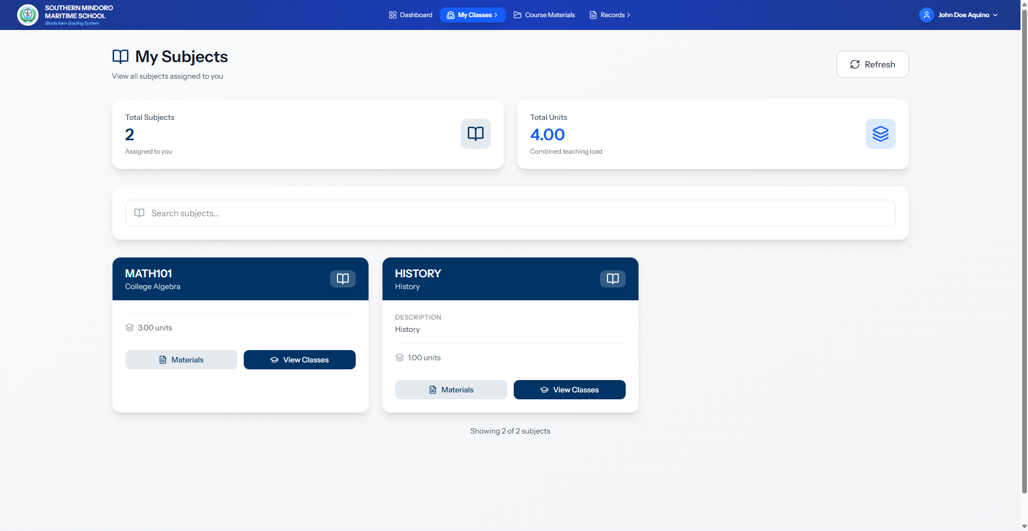
Figure 29. Teacher's My Subjects Interface
Figure 29 shows the My Subjects interface of the ChainSight platform. Teachers can view their assigned subjects. The interface displays summary metrics including total subjects and total units for the teaching load. Subject cards list each assigned subject with its code, name, and units. Teachers can access course materials and view classes for each subject. This interface helps teachers manage their subject assignments and teaching responsibilities.
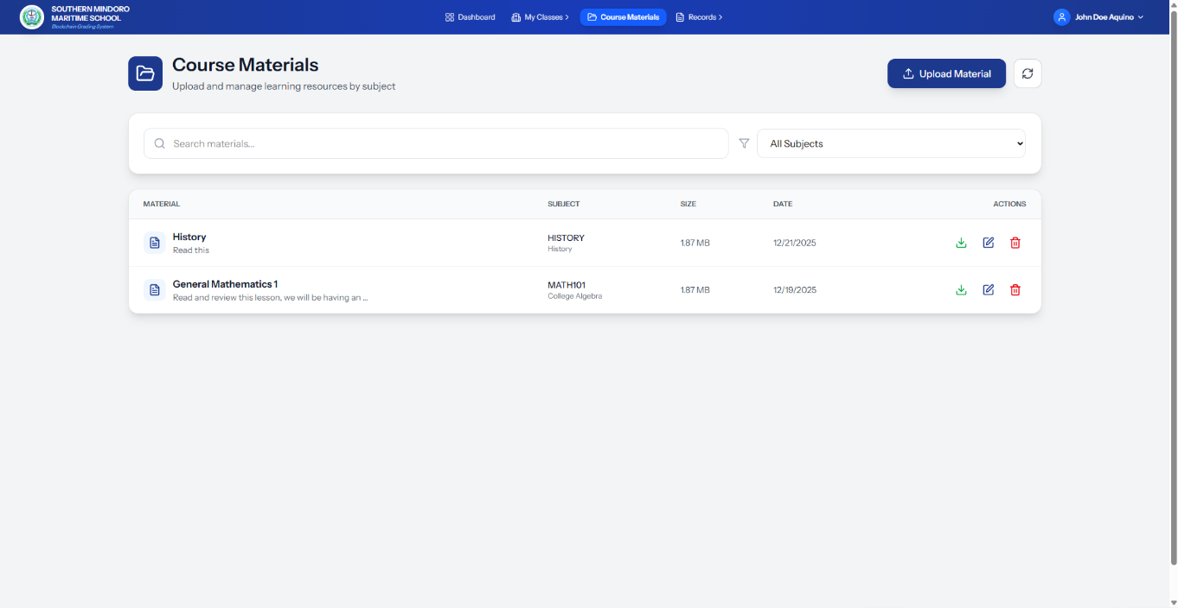
Figure 30. Course Materials Management Interface
Figure 30 shows the Course Materials Management interface of the ChainSight platform. Teachers can upload, manage, and organize learning resources by subject. The interface displays a table listing all course materials with their titles, descriptions, associated subjects, file sizes, and upload dates. Teachers can upload new materials, search and filter by subject, and perform download, edit, and delete operations on existing materials. This interface provides a centralized system for managing and distributing educational content to students.
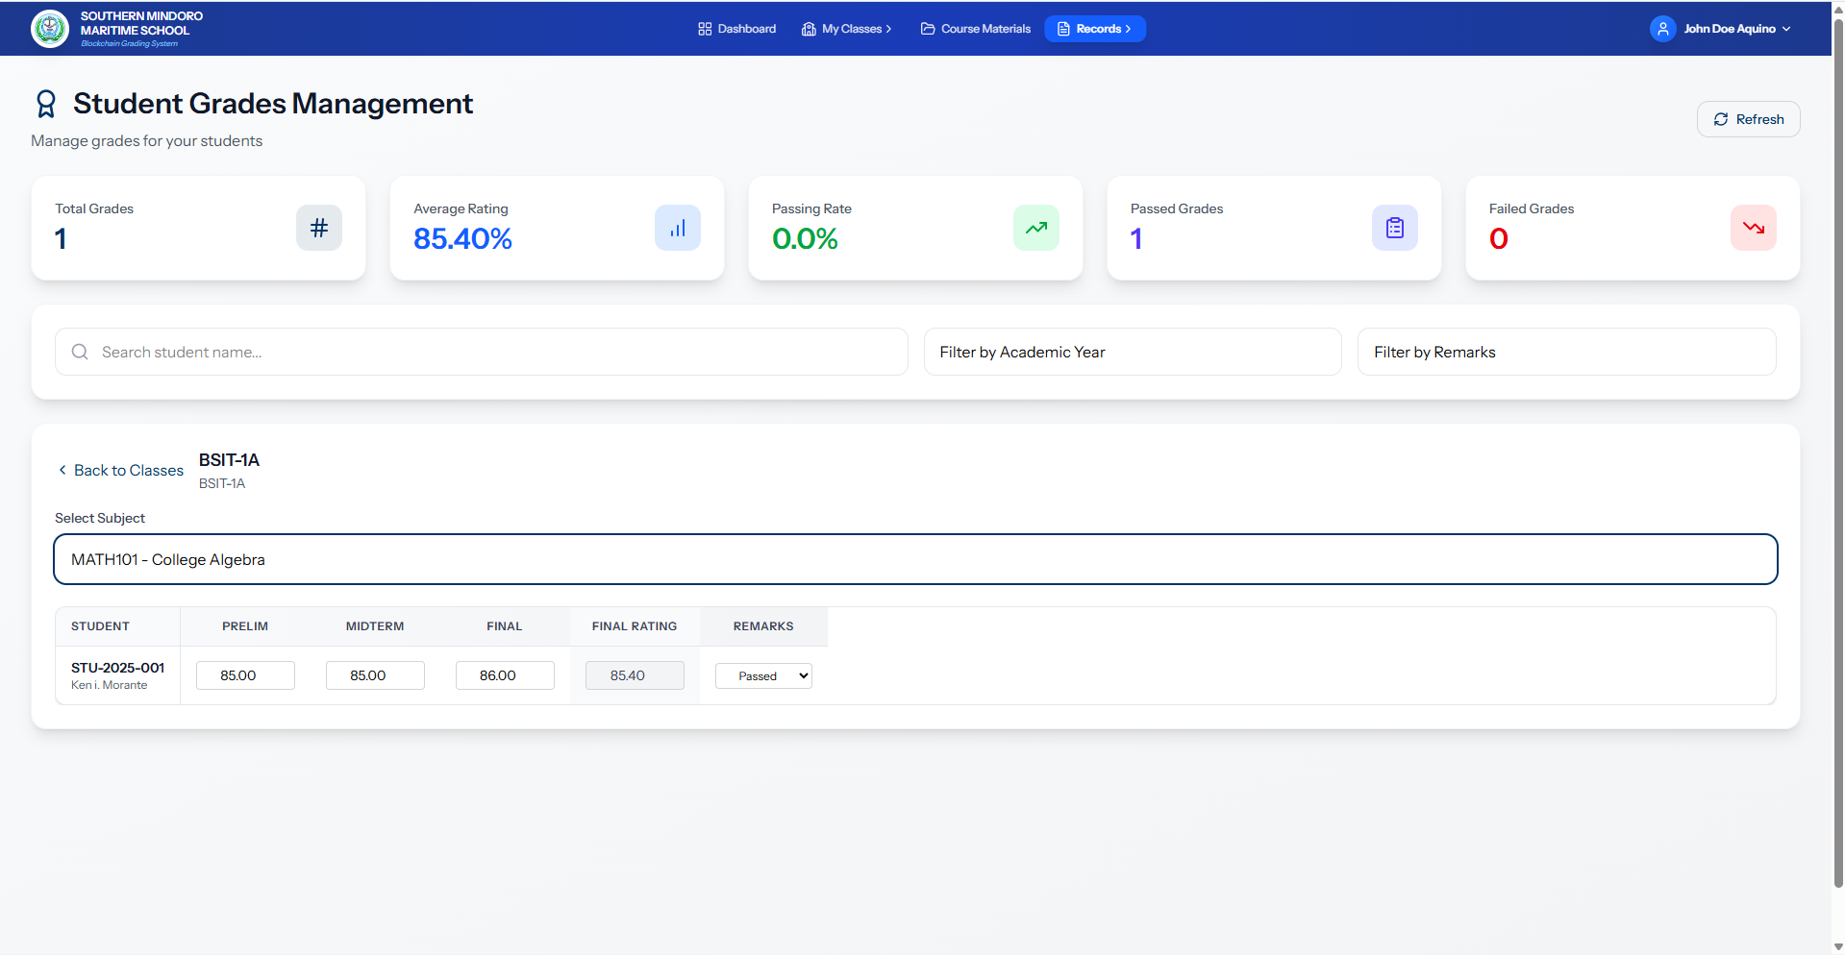
Figure 31. Student Grades Management Interface
Figure 31 shows the Student Grades Management interface of the ChainSight platform. Teachers can manage student academic performance. The interface displays summary metrics including total grades, average rating, passing rate, passed grades, and failed grades. A table lists all student grades with preliminary, midterm, and final grades, along with computed final ratings using the weighted averaging method and pass/fail remarks. Teachers can select specific classes and subjects, search and filter by student name, academic year, and remarks, and input or update grades. This interface enables teachers to efficiently manage student grades for their assigned classes and subjects.
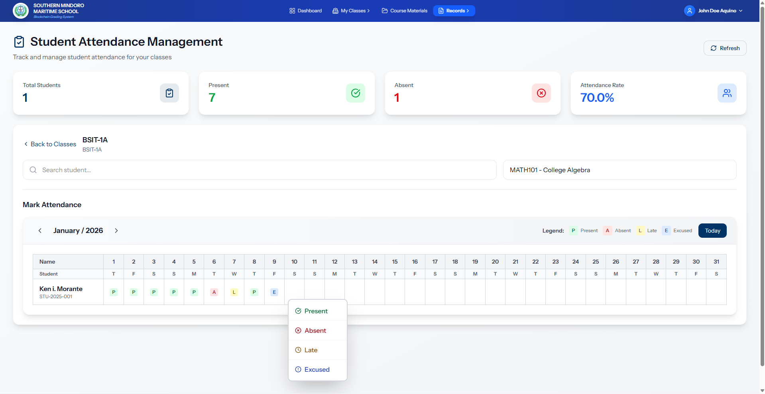
Figure 32. Student Attendance Management Interface
Figure 32 shows the Student Attendance Management interface of the ChainSight platform. Teachers can track and manage student attendance for their classes. The interface displays summary statistics including total students, present, absent, and overall attendance rate. A calendar-style table allows teachers to mark and view daily attendance for each student, with status indicators for Present, Absent, Late, and Excused. Teachers can select specific classes and subjects, and record attendance for individual students on specific dates. This interface supports efficient attendance recording and monitoring for academic tracking.

Student Side
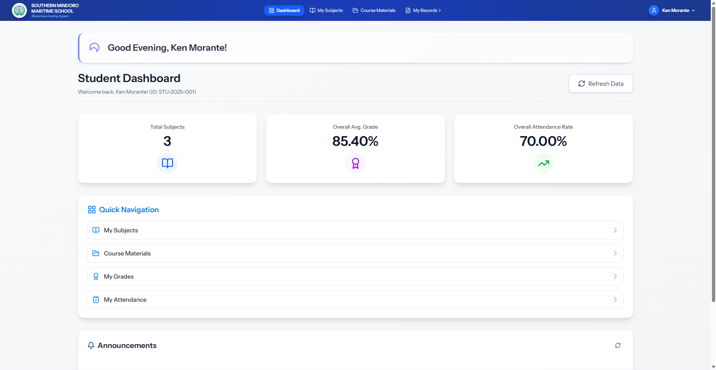
Figure 33. Student Dashboard
Figure 33 shows the Student Dashboard interface of the ChainSight platform. It provides students with a personalized overview of their academic progress. The dashboard displays summary metrics including total subjects enrolled, overall average grade, and overall attendance rate. Quick navigation links provide direct access to My Subjects, Course Materials, My Grades, and My Attendance. The dashboard also includes an announcements section where students can view school-wide announcements. This interface serves as a central hub for students to monitor their academic performance and access relevant resources.
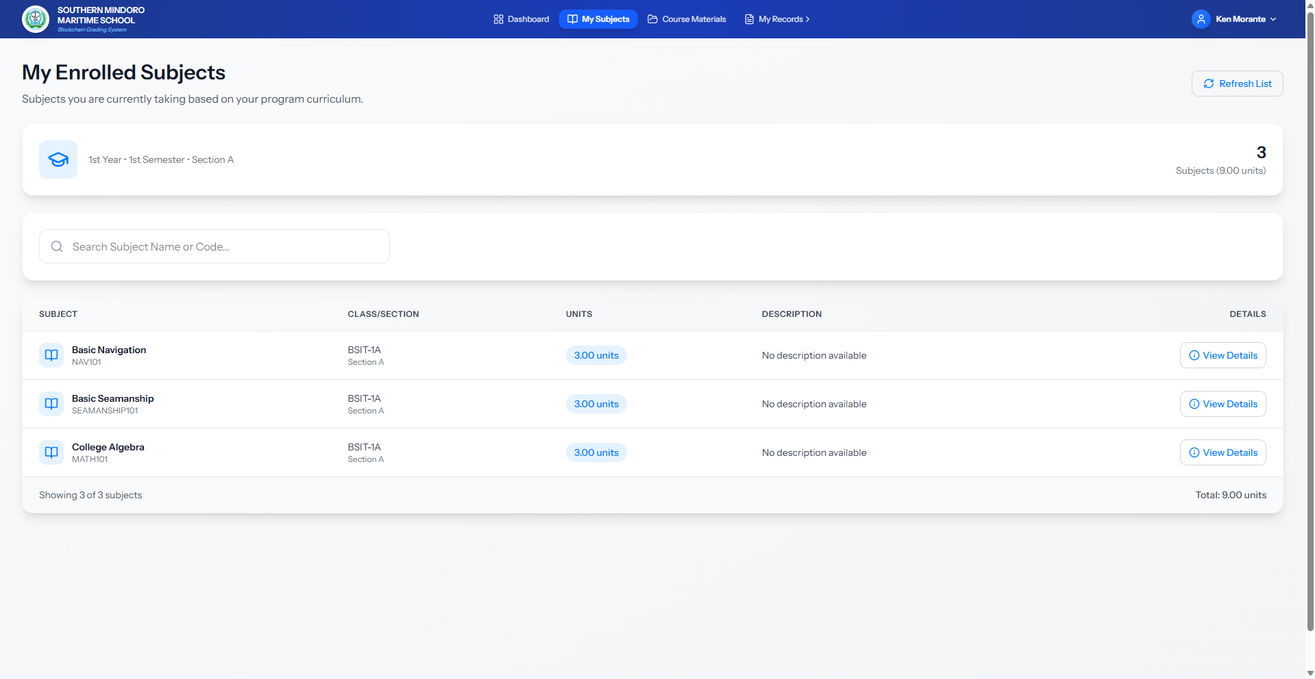
Figure 34. Student's My Enrolled Subjects Interface
Figure 34 shows the My Enrolled Subjects interface of the ChainSight platform. Students can view their current academic enrollment. The interface displays the current academic period including year level, semester, and section, along with summary metrics showing total enrolled subjects and units. A table lists all enrolled subjects with their codes, names, class/section assignments, units, and descriptions. Students can search subjects by name or code and view detailed information for each subject. This interface provides a clear overview of a student's current academic load and course enrollment based on their program curriculum.
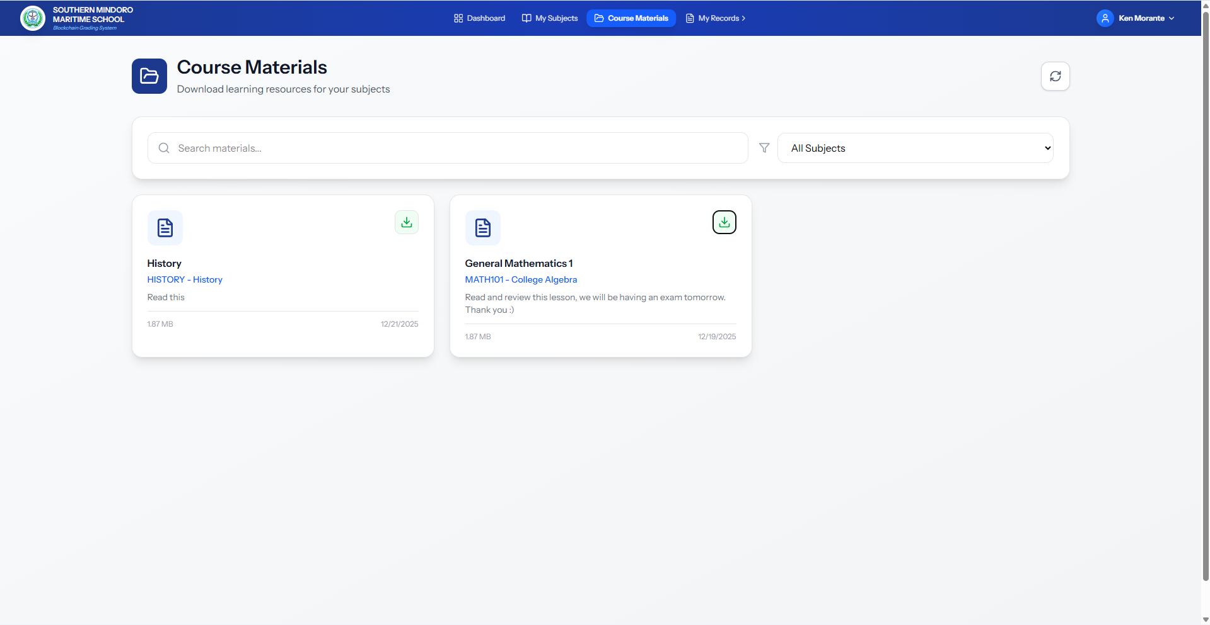
Figure 35. Course Materials Interface
Figure 35 shows the Course Materials interface of the ChainSight platform. Students can download learning resources for their enrolled subjects. The interface displays course material cards with titles, associated subjects, descriptions, file sizes, and upload dates. Students can search materials and filter by subject. Each material card includes a download option for accessing resources. This interface provides a centralized repository for students to access their learning materials.
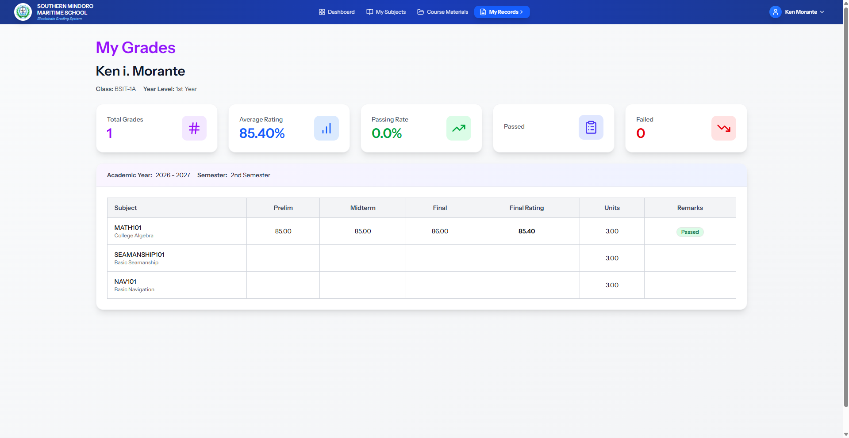Figure 36. Student's My Grades Interface
Figure 36 shows the My Grades interface of the ChainSight platform. Students can view their academic performance. The interface displays the student's name, class, and year level, along with summary statistics including total grades, average rating, passing rate, and failed subjects. A table lists all enrolled subjects with preliminary, midterm, and final grades, computed final ratings using the weighted averaging method, units, and pass/fail remarks. Students can filter grades by academic year and semester. This interface allows students to monitor their academic progress and understand their performance in each subject.
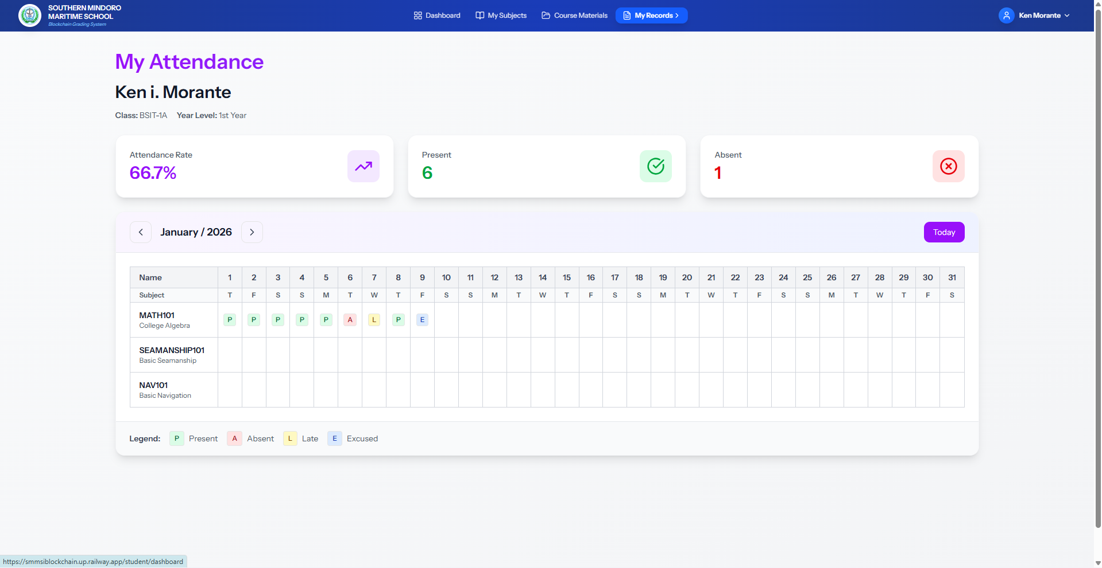
Figure 37. Student Attendance Interface
Figure 37 shows the Student Attendance interface of the ChainSight platform. Students can view their attendance records. The interface displays summary statistics including attendance rate, days present, and days absent. A calendar-style table shows daily attendance for each enrolled subject by month and year, with status indicators for Present, Absent, Late, and Excused. Students can navigate between months to view their attendance history. This interface allows students to monitor their attendance history and track their presence in enrolled subjects.

Parent Side
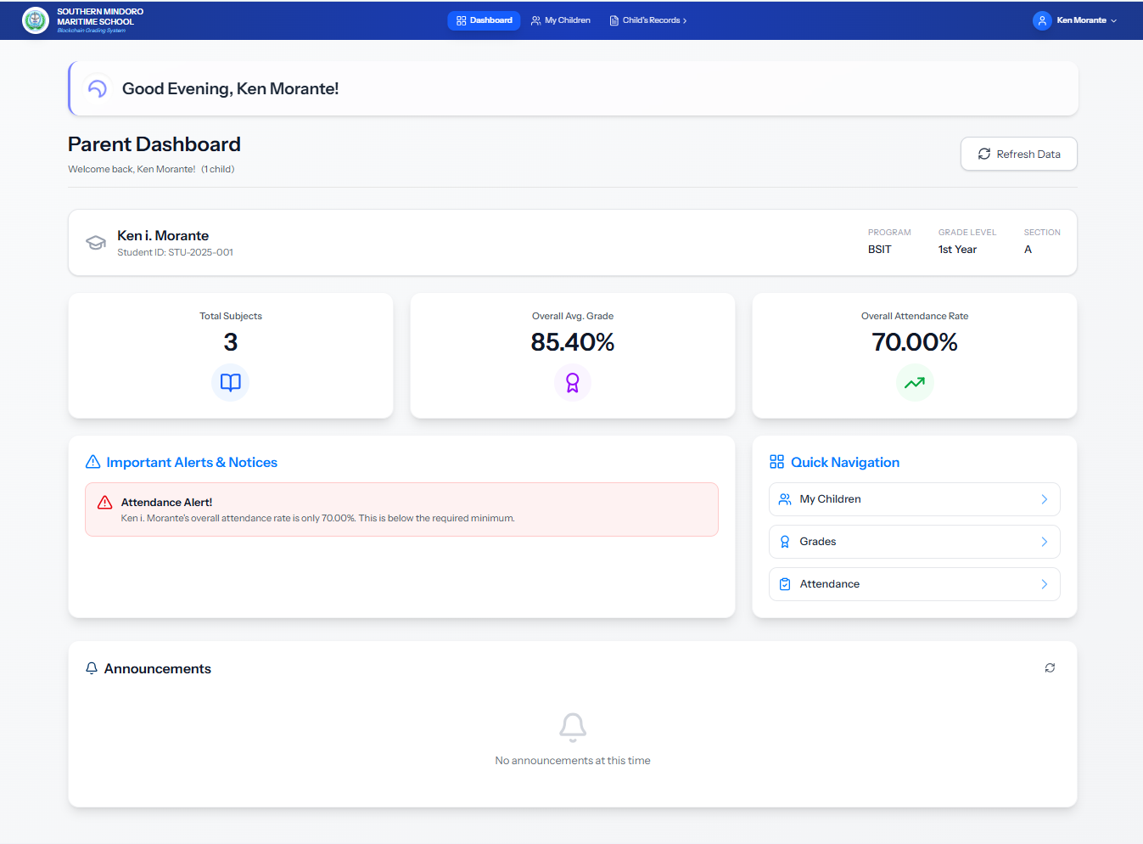
Figure 38. Parent Dashboard
Figure 38 shows the Parent Dashboard interface of the ChainSight platform. It provides parents with an overview of their child's academic status. The dashboard displays the child's information including name, student ID, program, grade level, and section. Summary metrics show total subjects enrolled, overall average grade, and overall attendance rate. The interface includes an alerts section that highlights important notices such as low attendance rates. Quick navigation links provide direct access to My Children, Grades, and Attendance sections. The dashboard also includes an announcements section where parents can view school-wide announcements. This interface provides parents with essential real-time information about their child's academic performance and alerts.
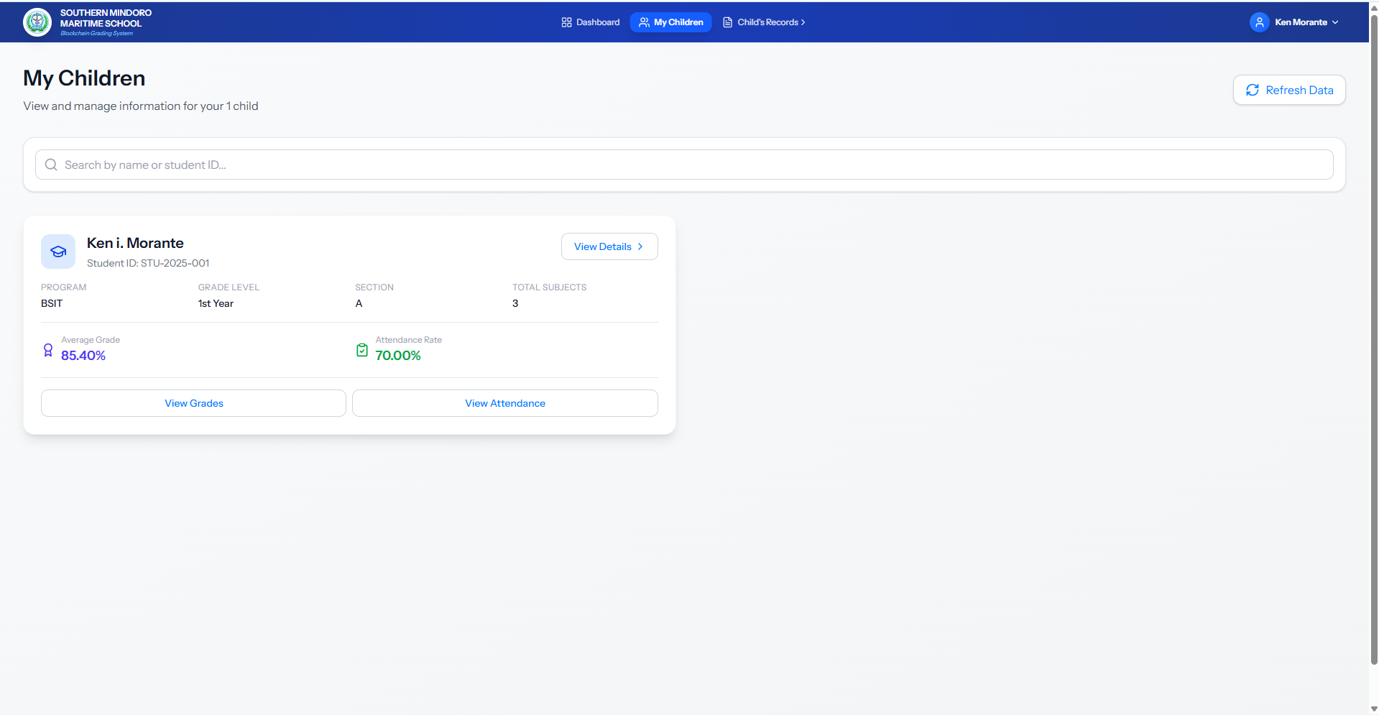
Figure 39. Parent's My Children Interface
Figure 39 shows the My Children interface of the ChainSight platform. Parents can view and manage information for their enrolled children. The interface displays a card for each child showing their student ID, program, grade level, section, total subjects, average grade, and attendance rate. Parents can search children by name or student ID and access detailed views including View Details, View Grades, and View Attendance for each child. This interface allows parents to monitor and access their children's academic information from a single location.
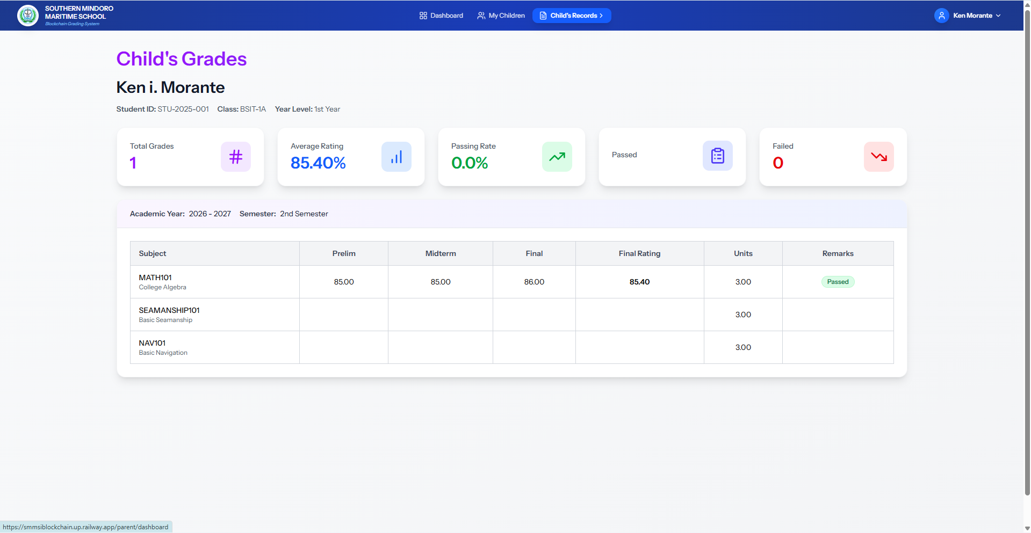
Figure 40. Child's Grades Interface
Figure 40 shows the Child's Grades interface of the ChainSight platform. Parents can view their child's academic performance. The interface displays the child's name, student ID, class, and year level, along with the current academic year and semester. Summary statistics include total grades, average rating, passing rate, and number of failed subjects. A table lists all enrolled subjects with preliminary, midterm, and final grades, computed final ratings using the weighted averaging method, units, and pass/fail remarks. Parents can filter grades by academic year and semester. This interface allows parents to monitor their child's academic progress and performance in each subject.
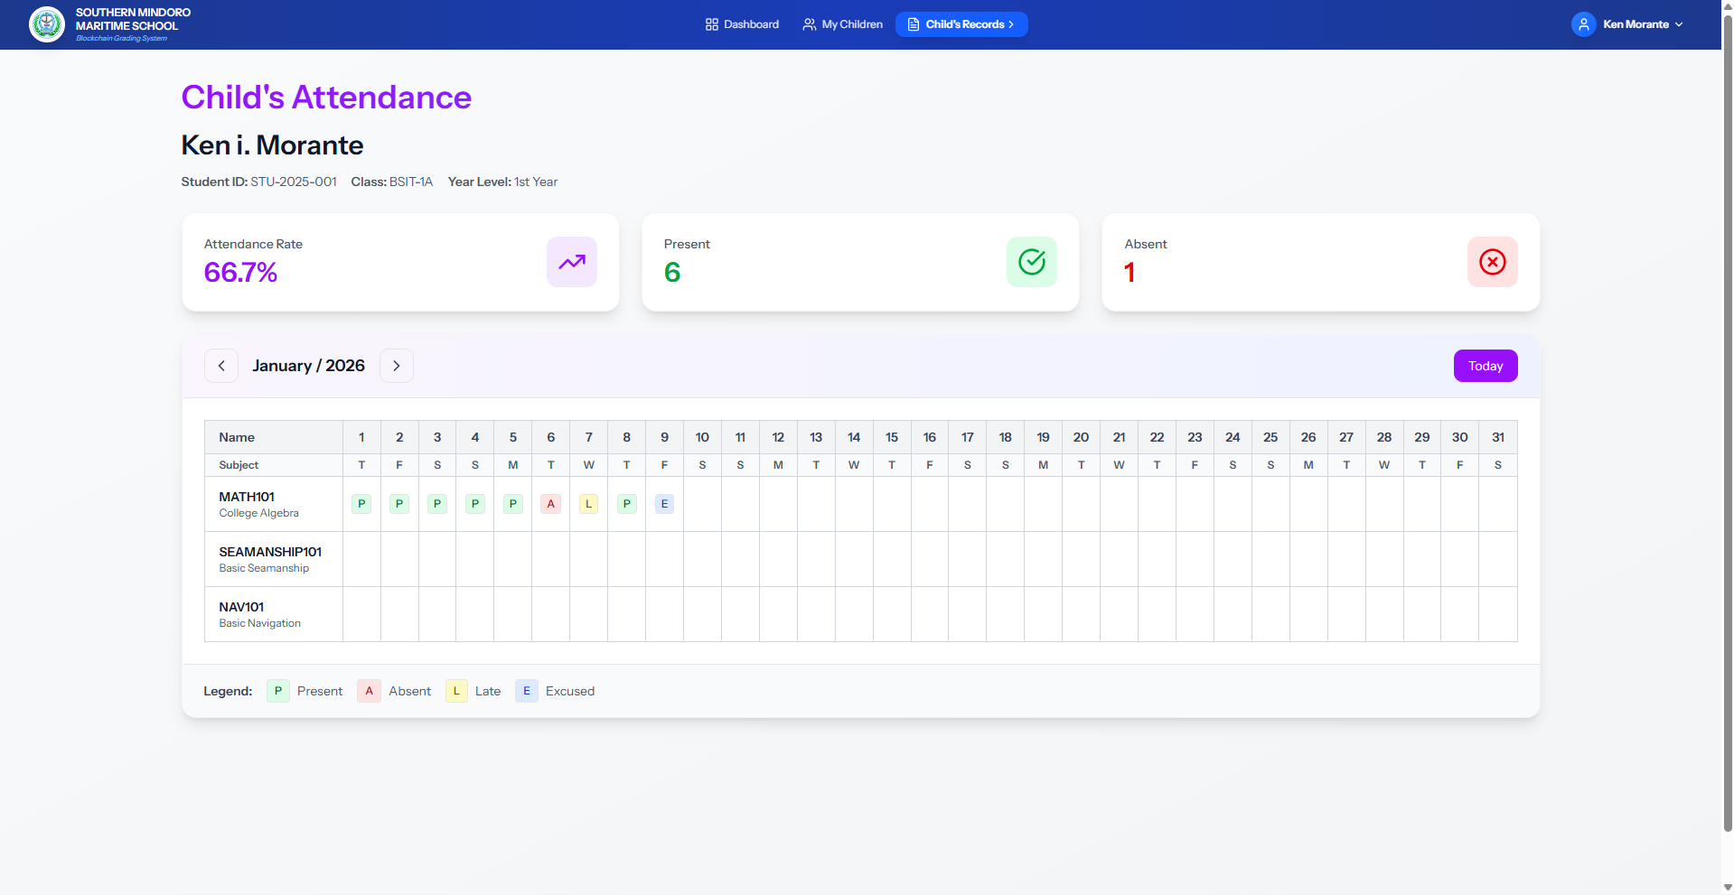
Figure 41. Child's Attendance Interface
Figure 41 shows the Child's Attendance interface of the ChainSight platform. Parents can view their child's attendance records. The interface displays the child's name, student ID, class, and year level. Summary statistics include overall attendance rate, total days present, and total days absent. A calendar-style table shows daily attendance for each enrolled subject by month and year, with status indicators for Present, Absent, Late, and Excused. Parents can navigate between months to view attendance history. This interface allows parents to monitor their child's attendance history and track their presence in enrolled subjects.

Evaluation of the Systems
This chapter presented the analysis and evaluation of Chainsight, the criteria that will be used to evaluate the system are functional suitability, performance efficiency, compatibility, interaction capability, reliability, security, maintainability, flexibility, and safety to help future improvement and enhancement of the system.

Table 8. Functional Suitability of the System
Table shows the mean and verbal interpretation of the proposed system in terms of functional suitability.
Functional Suitability | Mean | Rank | Verbal Interpretation
1. The system includes all necessary functions for school operations, such as student enrollment, grading, and record-keeping. | 3.89 | 1 | Strongly Agree
2. The system accurately records and reflects real-time updates to student information and academic records on the blockchain. | 3.54 | 3 | Strongly Agree
3. The blockchain features are suitable for generating verifiable digital credentials (e.g., diplomas or transcripts) that prevent forgery. | 3.71 | 2 | Strongly Agree
Overall Mean | 3.72 |  | Strongly Agree

The table results show a positive perception of the system's functional suitability. The highest rank with a mean score of 3.89 indicates users strongly agree that the system includes all necessary functions for school operations, such as student enrollment, grading, and record-keeping. The second rank with a mean score of 3.71 reflects strong agreement that blockchain features are suitable for generating verifiable digital credentials that prevent forgery. The lowest rank with a mean score of 3.54, although still interpreted as strongly agree, suggests that while the system accurately records and reflects real-time updates to student information and academic records on the blockchain, there is slight room for improvement. With an overall mean of 3.72, respondents strongly agreed that the system is reliable, accurate, and fully functional in supporting user needs and business processes.

Table 9. Performance Efficiency of the System
Table shows the mean and verbal interpretation of the proposed system in terms of performance efficiency.
Performance Efficiency | Mean | Rank | Verbal Interpretation
1. The time taken to record a grade or update a student record on the blockchain is fast and within institutional limits. | 3.75 | 1 | Strongly Agree
2. The system loads quickly and runs smoothly on standard devices without consuming excessive hardware or network resources. | 3.67 | 2 | Strongly Agree
3. The system can handle a large number of simultaneous users during enrollment or grading periods without slowing down or crashing. | 3.54 | 3 | Strongly Agree
Overall Mean | 3.65 |  | Strongly Agree

The table results show a positive perception of the system's performance efficiency. The highest rank with a mean score of 3.75 indicates that users strongly agree that the time taken to record a grade or update a student record on the blockchain is fast and within institutional limits. The second rank with a mean score of 3.67 reflects strong agreement that the system loads quickly and runs smoothly on standard devices without consuming excessive hardware or network resources. The lowest rank with a mean score of 3.54, although still interpreted as strongly agree, suggests that while the system can handle a large number of simultaneous users during enrollment or grading periods without slowing down or crashing, there is slight room for improvement. With an overall mean of 3.65, respondents strongly agreed that the system performs efficiently and meets performance expectations for operational use.

Table 10. Compatibility of the System
Table shows the mean and verbal interpretation of the proposed system in terms of compatibility.
Compatibility | Mean | Rank | Verbal Interpretation
1. The system successfully and securely communicates with external educational databases or government portals. | 3.47 | 2 | Strongly Agree
2. The blockchain backend runs smoothly alongside the web server and school database without resource conflicts. | 3.55 | 1 | Strongly Agree
3. The system's architecture is designed to easily integrate with new third-party APIs or external institutional services. | 3.33 | 3 | Strongly Agree
Overall Mean | 3.45 |  | Strongly Agree

The table results show a positive perception of the system's compatibility. The highest rank with a mean score of 3.55 indicates that users strongly agree that the blockchain backend runs smoothly alongside the web server and school database without resource conflicts. The second rank with a mean score of 3.47 reflects strong agreement that the system successfully and securely communicates with external educational databases or government portals. The lowest rank with a mean score of 3.33, although still interpreted as strongly agree, suggests that while the system's architecture is designed to easily integrate with new third-party APIs or external institutional services, there is slight room for improvement. With an overall mean of 3.45, respondents strongly agreed that the system demonstrates good compatibility with existing infrastructure and external systems.

Table 11. Interaction Capability of the System
Table shows the mean and verbal interpretation of the proposed system in terms of interaction capability.
Interaction Capability | Mean | Rank | Verbal Interpretation
1. New users (students, teachers, or staff) can quickly and easily learn how to navigate and use the system’s core blockchain features. | 3.79 | 1 | Strongly Agree
2. The system’s interface is clear, logically organized, and visually appealing for both administrative and student views. | 3.54 | 3 | Strongly Agree
3. The system provides clear status notifications when a transaction is being validated or "mined" on the blockchain. | 3.67 | 2 | Strongly Agree
Overall Mean | 3.67 |  | Strongly Agree

The table results show a positive perception of the system's interaction capability. The highest rank with a mean score of 3.79 indicates that users strongly agree that new users (students, teachers, or staff) can quickly and easily learn how to navigate and use the system's core blockchain features. The second rank with a mean score of 3.67 reflects strong agreement that the system provides clear status notifications when a transaction is being validated or "mined" on the blockchain. The lowest rank with a mean score of 3.54, although still interpreted as strongly agree, suggests that while the system's interface is clear, logically organized, and visually appealing for both administrative and student views, there is slight room for improvement. With an overall mean of 3.67, respondents strongly agreed that the system offers excellent interaction capability and user experience.
Table 12. Reliability of the System
Table shows the mean and verbal interpretation of the proposed system in terms of reliability.
Reliability | Mean | Rank | Verbal Interpretation
1. The system rarely experiences critical errors, failures, or unexpected shutdowns during normal school operations. | 3.56 | 2 | Strongly Agree
2. The decentralized management system is available and ready for use at all times when needed by the institution. | 3.46 | 3 | Strongly Agree
3. In the event of a network failure, the system can quickly and accurately restore all student records and blockchain transaction data. | 3.62 | 1 | Strongly Agree
Overall Mean | 3.55 |  | Strongly Agree

The table results show a positive perception of the system's reliability. The highest rank with a mean score of 3.62 indicates that users strongly agree that in the event of a network failure, the system can quickly and accurately restore all student records and blockchain transaction data. The second rank with a mean score of 3.56 reflects strong agreement that the system rarely experiences critical errors, failures, or unexpected shutdowns during normal school operations. The lowest rank with a mean score of 3.46, although still interpreted as strongly agree, suggests that while the decentralized management system is available and ready for use at all times when needed by the institution, there is slight room for improvement. With an overall mean of 3.55, respondents strongly agreed that the system is reliable and dependable for institutional operations.

Table 13. Security of the System
Table shows the mean and verbal interpretation of the proposed system in terms of security.
Security | Mean | Rank | Verbal Interpretation
1. The system ensures that student records are immutable and protected against unauthorized tampering once saved to the ledger. | 3.80 | 1 | Strongly Agree
2. The system securely manages sensitive student data and private blockchain keys using robust encryption protocols. | 3.70 | 2 | Strongly Agree
3. Only authorized school personnel are able to log in to the administrative interface and modify critical academic settings. | 3.62 | 3 | Strongly Agree
Overall Mean | 3.71 |  | Strongly Agree

The table results show a positive perception of the system's security. The highest rank with a mean score of 3.80 indicates that users strongly agree that the system ensures student records are immutable and protected against unauthorized tampering once saved to the ledger. The second rank with a mean score of 3.70 reflects strong agreement that the system securely manages sensitive student data and private blockchain keys using robust encryption protocols. The lowest rank with a mean score of 3.62, although still interpreted as strongly agree, suggests that while only authorized school personnel are able to log in to the administrative interface and modify critical academic settings, there is slight room for improvement. With an overall mean of 3.71, respondents strongly agreed that the system provides robust security measures and data protection for academic records.
Table 14. Maintainability of the System
Table shows the mean and verbal interpretation of the proposed system in terms of maintainability.
Maintainability | Mean | Rank | Verbal Interpretation
1. An issue in a single service can be isolated, debugged, and fixed without requiring a restart of the entire management system. | 3.54 | 2 | Strongly Agree
2. The system provides sufficient and easy-to-access logs for developers to diagnose the cause of any reported failures. | 3.38 | 3 | Strongly Agree
3. Individual modules (e.g., Enrollment or Grading) can be updated and tested independently of other blockchain services. | 3.72 | 1 | Strongly Agree
Overall Mean | 3.55 |  | Strongly Agree

The table results show a positive perception of the system's maintainability. The highest rank with a mean score of 3.72 indicates that users strongly agree that individual modules (e.g., Enrollment or Grading) can be updated and tested independently of other blockchain services. The second rank with a mean score of 3.54 reflects strong agreement that an issue in a single service can be isolated, debugged, and fixed without requiring a restart of the entire management system. The lowest rank with a mean score of 3.38, although still interpreted as strongly agree, suggests that while the system provides sufficient and easy-to-access logs for developers to diagnose the cause of any reported failures, there is slight room for improvement. With an overall mean of 3.55, respondents strongly agreed that the system is maintainable and can be effectively updated and managed over time.

Table 15. Flexibility of the System
Table shows the mean and verbal interpretation of the proposed system in terms of flexibility.
Flexibility | Mean | Rank | Verbal Interpretation
1. The system applications can be easily updated to newer framework versions without requiring major architectural rework. | 3.66 | 1 | Strongly Agree
2. Specific services can be deployed across multiple server instances independently to handle a sudden surge in user demand. | 3.54 | 2 | Strongly Agree
3. Is the system modular enough to allow switching to a different blockchain protocol with minimal changes to other services. | 3.54 | 2 | Strongly Agree
Overall Mean | 3.58 |  | Strongly Agree

The table results show a positive perception of the system's flexibility. The highest rank with a mean score of 3.66 indicates that users strongly agree that the system applications can be easily updated to newer framework versions without requiring major architectural rework. The second rank with a mean score of 3.54 reflects strong agreement that specific services can be deployed across multiple server instances independently to handle a sudden surge in user demand, and that the system is modular enough to allow switching to a different blockchain protocol with minimal changes to other services. With an overall mean of 3.58, respondents strongly agreed that the system demonstrates high flexibility in adapting to changes and scaling operations.
Table 16. Safety of the System
Table shows the mean and verbal interpretation of the proposed system in terms of safety.
Safety | Mean | Rank | Verbal Interpretation
1. The system is modular enough to allow switching to a different blockchain protocol with minimal changes to other services. | 3.60 | 2 | Strongly Agree
2. The system provides alerts that quickly identify and flag potential security risks or unauthorized access attempts. | 3.78 | 1 | Strongly Agree
3. If the connection to the blockchain network is lost, the system gracefully reverts to a safe operational state without losing data. | 3.52 | 3 | Strongly Agree
Overall Mean | 3.64 |  | Strongly Agree

The table results show a positive perception of the system's safety. The highest rank with a mean score of 3.78 indicates that users strongly agree that the system provides alerts that quickly identify and flag potential security risks or unauthorized access attempts. The second rank with a mean score of 3.60 reflects strong agreement that the system is modular enough to allow switching to a different blockchain protocol with minimal changes to other services. The lowest rank with a mean score of 3.52, although still interpreted as strongly agree, suggests that while if the connection to the blockchain network is lost, the system gracefully reverts to a safe operational state without losing data, there is slight room for improvement. With an overall mean of 3.64, respondents strongly agreed that the system demonstrates high safety in its operations and protects against potential risks.

Table 17. Summary Results of Evaluation
Table shows the mean of sub criteria rated by evaluations.

Criteria | Mean | Rank | Interpretation
1. Functional  Suitability | 3.72 | 1 | Strongly Agree
2. Performance  Efficiency | 3.65 | 4 | Strongly Agree
3. Compatibility | 3.45 | 8 | Strongly Agree
4. Interaction Capability | 3.67 | 3 | Strongly Agree
5. Reliability | 3.55 | 7 | Strongly Agree
6. Security | 3.71 | 2 | Strongly Agree
7. Maintainability | 3.55 | 7 | Strongly Agree
8. Flexibility | 3.58 | 6 | Strongly Agree
9. Safety | 3.64 | 5 | Strongly Agree

Overall Mean 3.61 Strongly Agree

This table presents a comprehensive evaluation of the Chainsight system based on the ISO 25010 quality model. Among the evaluated criteria, Security obtained the highest rank with a mean score of 3.72, indicating that respondents strongly trust the system’s ability to protect data and ensure safe transactions. On the other hand, Compatibility recorded the lowest mean scores of 3.45, suggesting that while the system works well across different platforms, there is still room for improvement in enhancing its adaptability. Overall, the consistently high mean scored 3.61, demonstrate that the system strongly meets user expectations, proving it to be functional, secure, reliable, and user-friendly.

Table 18. Performance Expectancy of the System
Table shows the mean and verbal interpretation of the proposed system in terms of performance expectancy.
Performance Expectancy | Mean | Rank | Verbal Interpretation
1. Using Chainsight helps me complete my academic or administrative tasks more quickly. | 3.58 | 3 | Strongly Agree
2. The system improves my efficiency in managing student records, grades, and announcements. | 3.88 | 1 | Strongly Agree
3. ChainSight helps me manage academic information  and school-related transactions more effectively. | 3.68 | 2 | Strongly Agree
Overall Mean | 3.71 |  | Strongly Agree

This table shows the results of the evaluation in terms of performance expectancy. The highest score of 3.88 shows that users strongly agree that the system improves their efficiency in managing student records, grades, and announcements. The system also helps users manage academic information and school-related transactions more effectively with a mean score of 3.68. The lowest mean score of 3.58, which relates to using ChainSight to complete academic or administrative tasks more quickly, still reflects strong agreement, indicating that the system positively supports task accomplishment. With an overall mean of 3.71, the results confirm that users strongly agree that ChainSight enhances their work efficiency, management, and overall performance.

Table 19. Effort Expectancy of the System
Table shows the mean and verbal interpretation of the proposed system in terms of effort expectancy.
Effort Expectancy | Mean | Rank | Verbal Interpretation
1. Learning to use Chainsight is easy for me. | 3.74 | 1 | Strongly Agree
2 The system is easy to understand and navigate. | 3.70 | 3 | Strongly Agree
3. I can use the system without much effort. | 3.90 | 2 | Strongly Agree
Overall Mean | 3.78 |  | Strongly Agree

This table shows the results of the evaluation in terms of effort expectancy. The highest score of 3.90 shows that users strongly agree that they can use the ChainSight system without much effort. The system also helps users learn to use ChainSight easily with a mean score of 3.74. The lowest mean score of 3.70, which relates to the system being easy to understand and navigate, still reflects strong agreement, indicating that the system is generally easy to comprehend and navigate. With an overall mean of 3.78, the results confirm that users strongly agree that ChainSight is easy to use and requires minimal effort.
Table 20. Social Influence of the System
Table shows the mean and verbal interpretation of the proposed system in terms of effort expectancy.
Social Influence | Mean | Rank | Verbal Interpretation
1. People important to me think that I should use Chainsight. | 3.54 | 3 | Strongly Agree
2. School administrators, teachers, or peers encourage me to use the system. | 3.92 | 1 | Strongly Agree
3 Using Chainsight is accepted and supported within the school community. | 3.90 | 2 | Strongly Agree
Overall Mean | 3.79 |  | Strongly Agree

This table shows the results of the evaluation in terms of social influence. The highest score of 3.92 shows that users strongly agree that school administrators, teachers, or peers encourage them to use the ChainSight system. The system also shows that using ChainSight is accepted and supported within the school community with a mean score of 3.90. The lowest mean score of 3.54, which relates to people important to them thinking they should use ChainSight, still reflects strong agreement, indicating that social influence positively supports system adoption. With an overall mean of 3.79, the results confirm that users strongly agree that the ChainSight system is positively influenced by social factors.

Table 21. Facilitating Conditions of the System
Table shows the mean and verbal interpretation of the proposed system in terms of facilitating conditions.
Facilitating Conditions | Mean | Rank | Verbal Interpretation
1. I have the resources needed to use Chainsight. | 3.42 | 1 | Strongly Agree
2. I have the knowledge necessary to use the system. | 3.32 | 3 | Strongly Agree
3 The system is compatible with my way of working. | 3.40 | 2 | Strongly Agree
Overall Mean | 3.38 |  | Strongly Agree

This table shows the results of the evaluation in terms of facilitating conditions. The highest score of 3.42 shows that users strongly agree that they have the resources needed to use the ChainSight system. The system also reflects strong agreement that it is compatible with their way of working with a mean score of 3.40. The lowest mean score of 3.32, which relates to users having the knowledge necessary to use the system, still reflects strong agreement, indicating that facilitating conditions positively support system use. With an overall mean of 3.38, the results confirm that users strongly agree that ChainSight provides facilitating conditions for its use.

Table 22. Behavioral Intention of the System
Table shows the mean and verbal interpretation of the proposed system in terms of behavioral Intentions.
Behavioral Intentions | Mean | Rank | Verbal Interpretation
1. I intend to use Chainsight regularly. | 3.56 | 3 | Strongly Agree
2. I plan to continue using the system in the future. | 3.66 | 2 | Strongly Agree
3. I would recommend chainsight to others. | 3.86 | 1 | Strongly Agree
Overall Mean | 3.69 |  | Strongly Agree

This table shows the results of the evaluation in terms of behavioral intention. The highest score of 3.86 shows that users strongly agree that they would recommend ChainSight to others. The system also indicates that users plan to continue using the system in the future with a mean score of 3.66. The lowest mean score of 3.56, which relates to intending to use ChainSight regularly, still reflects strong agreement, indicating a positive intent for consistent usage. With an overall mean of 3.69, the results confirm that users strongly agree that ChainSight is positively perceived for future use and recommendation.
Table 23. Summary Results of Evaluation
Table shows the mean of sub criteria rated by evaluations.
Criteria | Mean | Rank | Interpretation
1. Performance Expectancy | 3.71 | 3 | Strongly Agree
2. Effort Expectancy | 3.78 | 2 | Strongly Agree
3. Social Influence | 3.79 | 1 | Strongly Agree
4. Facilitating Conditions | 3.38 | 5 | Strongly Agree
5. Behavioral Intention | 3.69 | 4 | Strongly Agree
Overall Mean | 3.67 |  | Strongly Agree
This table shows the summary results of the evaluation. The highest score of 3.79 for Social Influence shows that users strongly agree that school administrators, teachers, or peers encourage them to use the ChainSight system. The second highest score of 3.78 for Effort Expectancy reflects strong agreement that users can use the ChainSight system without much effort. The lowest mean score of 3.38 for Facilitating Conditions, which relates to users having the resources needed to use the ChainSight system, still reflects strong agreement, indicating positive facilitating conditions for system use. With an overall mean of 3.67, the results confirm that users strongly agree with the overall evaluation of the system across all measured factors.

Implementation Results
The implementation of ChainSight has modernized academic record management at Southern Mindoro Maritime School Inc. through blockchain-secured technology and data-driven processes. The system addresses challenges in grade management, attendance tracking, record integrity, and stakeholder communication. The initial implementation involved deploying a web-based platform accessible on desktop and mobile devices, supported by a centralized database and blockchain integration (Polygon Mumbai Testnet). Core modules such as grade management with weighted averaging, attendance tracking, announcement management, certificate issuance, course material management, and blockchain transaction recording were integrated.

The results of the implementation were favorable. During the trial period, the system showed clear benefits, including improved grade accuracy, reduced manual calculation errors, and better monitoring of student performance. Teachers reported increased efficiency in managing grades and attendance due to automated calculations and blockchain-secured recording, which minimized errors and improved record integrity. Students and parents benefited from real-time access to academic information, ensuring transparency and timely updates on academic progress. The blockchain integration provided tamper-proof verification of academic records, enabling certificate authenticity verification. User feedback indicated high satisfaction, particularly highlighting the system's ease of use, security features, and reliability.

ChainSight demonstrated that a blockchain-secured platform with integrated academic management can effectively support and enhance school operations. The system showed potential to improve data integrity, streamline administrative processes, and expand accessibility for all stakeholders. With further enhancements such as advanced analytics, expanded blockchain features, and additional integration capabilities, ChainSight has strong potential for wider adoption and long-term impact. Its successful implementation highlights its capability to deliver both operational and security benefits while promoting digital transformation within the academic institution.

Chapter V

SUMMARY, CONCLUSION AND RECOMMENDATION

This chapter presents the summary of the study, the conclusions drawn from the findings, and recommendations for future improvements and enhancements of the Chainsight system
.
Summary
The study focused on the design and development of ChainSight: A Cloud-Based Support System for Southern Mindoro Maritime School Inc. with Blockchain Technology. The platform was created to address challenges in academic record management at Southern Mindoro Maritime School Inc., including grade management, attendance tracking, record integrity, and stakeholder communication.

The developers used modern web technologies including React.js with TypeScript and Inertia.js for the frontend, Laravel (PHP) for the backend, and MySQL/PostgreSQL for the database. The system integrated blockchain technology using Web3.php and Polygon Mumbai Testnet for securing academic records. The system was deployed using cloud-based hosting services, with Railway hosting both the application and database. Using these materials and software, it was found suitable in the development of the proposed system.

The researchers designed and developed the project for Southern Mindoro Maritime School Inc. using the Rapid Application Development (RAD) methodology. They underwent the following phases: Requirement Planning, Analysis and Quick Design, Prototyping Cycle Phase, Demonstration, Refine, Evaluations, Customer Approval, Development, Testing Phase, and Deployment. They also evaluated the system with 50 respondents consisting of administrators, teachers, students, and parents to determine the acceptability of the developed system.

The overall mean in terms of Functional Suitability was 3.72 described as Strongly Agree. The overall mean in terms of Performance Efficiency was 3.65 described as Strongly Agree. The overall mean in terms of Compatibility was 3.45 described as Strongly Agree. The overall mean in terms of Interaction Capability was 3.67 described as Strongly Agree. The overall mean in terms of Reliability was 3.55 described as Strongly Agree. The overall mean in terms of Security was 3.71 described as Strongly Agree. The overall mean in terms of Maintainability was 3.55 described as Strongly Agree. The overall mean in terms of Flexibility was 3.58 described as Strongly Agree. The overall mean in terms of Safety was 3.64 described as Strongly Agree. The overall mean in terms of Performance Expectancy was 3.71 described as Strongly Agree. The overall mean in terms of Effort Expectancy was 3.78 described as Strongly Agree. The overall mean in terms of Social Influence was 3.79 described as Strongly Agree. The overall mean in terms of Facilitating Conditions was 3.38 described as Strongly Agree. The overall mean in terms of Behavioral Intention was 3.69 described as Strongly Agree.

Conclusions
- ChainSight successfully stores grades, attendance, and certificates on the blockchain using cryptographic hashes, ensuring immutability, transparency, and verifiability of academic records. The integration with Polygon Mumbai Testnet enables secure record verification and prevents unauthorized tampering.
- The system implements role-based access control for administrators, teachers, students, and parents, with role-specific dashboards and permissions. Each user type has appropriate access to manage and view academic information based on their responsibilities.
- The system records and manages grades (preliminary, midterm, final) using a weighted averaging method (30%, 30%, 40%), tracks attendance, calculates final ratings, and maintains blockchain-backed audit trails for all academic transactions. These features improve accuracy and provide an immutable record of academic activities.
- The system includes modules for managing academic years, semesters, courses, subjects, classes, course materials, and library resources within a unified platform. This centralizes academic management and supports efficient curriculum organization.
- Communication tools for announcements and messaging, along with grading workflows, support collaboration between administrators, teachers, students, and parents. These features improve information sharing and coordination.
- Reporting and analytics dashboards generate insights on academic performance, system statistics, and blockchain transaction monitoring through an intuitive user interface. These dashboards help administrators make data-driven decisions and monitor system health.

Recommendations
- Deploy the blockchain integration to a live production network once funding is secured. The system already includes real-time transaction confirmation capabilities; transitioning from testing mode to production will require sufficient blockchain network funding for transaction fees and ongoing maintenance.
- Enhance role-based access control by implementing more granular permissions and audit logging for administrative actions, improving security and accountability within the system.
- Improve grade calculation features by adding customizable weighting schemes for different subjects or programs, and enhance attendance tracking with automated notifications for low attendance rates.
- Extend academic management modules to include schedule management, room assignment, and class capacity planning, providing a more comprehensive academic administration solution.
- Enhance communication tools by adding real-time notifications for grade updates and attendance alerts, and integrate with external communication platforms such as email or SMS services for improved stakeholder engagement.
- Expand reporting and analytics capabilities by adding predictive analytics for student performance, automated report generation, and exportable data visualizations that can be shared with stakeholders or used for accreditation purposes.

